

Analyzing Technological Trends in Autonomous Vehicles through Patent Text Mining and Predictive Modeling

CS7610 – CAPSTONE PROJECT
REPORT

Submitted by
Aniket Shinde – 24MSP3038

In partial fulfilment for the award of the degree of
POST GRADUATE PROGRAMME
INTERNATIONAL CENTRE FOR HIGHER EDUCATION AND RESEARCH
VIT BANGALORE

June, 2025



BONAFIDE CERTIFICATE
Certified that this project report “Analyzing Technological Trends in Autonomous Vehicles through Patent Text Mining and Predictive Modeling
” is the bonafide record of work done by “Aniket Shinde – 24MSP3038” who carried out the project work under my supervision.

Signature of the Supervisor Signature of Director

Prof. Ramya Mohanakrishnan  Assistant Professor,  ICER  VIT Bangalore | Prof. Prema M  Director,  ICER  VIT Bangalore.
Evaluation Date:



ACKNOWLEDGEMENT

I express my sincere gratitude to our director of ICER Prof. Prema M. for their support and for providing the required facilities for carrying out this study.
I wish to thank my faculty supervisor(s), Prof. Ramya Mohanakrishnan, Assistant Professor, ICER for extending help and encouragement throughout the project. Without his/her continuous guidance and persistent help, this project would not have been a success for me.
I am grateful to all the members of ICER, my beloved parents, and friends for extending the support, who helped us to overcome obstacles in the study.

TABLE OF CONTENTS
CHAPTER NO. | TITLE | PAGE NO.
 | ABSTRACT
1 | INTRODUCTION | 1
2 | LITERATURE REVIEW | 2
3 | OBJECTIVE | 2
4 | PROPOSED METHODOLOGY | 3
5 | TOOLS AND TECHNIQUES | 5
6 | IMPLEMENTATION | 6
7 | RESULTS AND DISCUSSIONS | 13
8 | CONCLUSION | 28
9 | FUTURE ENHANCEMENT | 29
10 | APPENDICES | 30
 | Appendix-1: Code – Full Code
 | Appendix-2: Plagiarism Report
11 | REFERENCES | 149

ABSTRACT
This project presents a comprehensive analysis of the autonomous vehicle (AV) industry through patent intelligence, leveraging a novel unstructured-to-structured data pipeline that transforms raw patent text into actionable insights. Using 667 carefully filtered US AV patents from leading companies, I constructed an end-to-end NLP-to-ML framework encompassing semantic clustering, innovation trend analysis, technology emergence detection, and innovation outlier identification. The pipeline integrates advanced natural language processing techniques with machine learning models to reveal critical industry patterns including emerging technologies, declining innovations, company positioning, and strategic pivots. Through semantic clustering and temporal analysis, combined with LLM-enhanced data structuring, this work demonstrates how patent data can be systematically transformed to provide strategic intelligence for understanding technological evolution and competitive dynamics in the rapidly advancing autonomous vehicle sector.

CHAPTER 1
  - INTRODUCTION
  - Introduction to the Research Topic
The autonomous vehicle (AV) industry is one of the fastest-evolving sectors in technology, where cutting-edge innovations in AI, sensing, computation, and connectivity converge. With a high volume of patents being filed by global tech leaders, patents serve as a rich resource for tracing technological progress, identifying strategic priorities, and forecasting future trends.
  - Background and Rationale
Understanding innovation dynamics in AVs is challenging due to the volume and complexity of patent data. Conventional analytics often fall short in revealing semantic relationships, emerging technologies, or innovation leadership. This research bridges that gap using advanced NLP and machine learning techniques to semantically cluster patents, analyze innovation trends, detect outliers, and extract structured knowledge with the help of LLMs. The motivation is to develop an AI-powered framework that can generate actionable insights for researchers, strategists, and policymakers tracking AV innovation.
  - Research Questions
What are the major technological clusters present in the AV patent landscape?
Which concepts and terms are emerging, declining, or persistently dominant over time?
Can structured insights like novelty and problem statements be extracted at scale using LLMs?
Who are the innovation leaders, and what strategic shifts or outlier technologies are they pursuing?
  - Scope and Limitations
The study focuses on a filtered subset of 667 US patents filed by top companies in the AV domain from 2014 to 2022. The scope includes semantic clustering, trend analysis, LLM-assisted structuring, and outlier detection. Limitations include potential API constraints, imperfect NLP interpretations, and challenges in fully resolving noise in unstructured data.
- LITERATURE REVIEW
Trappey et al. (2020) established foundational work in intelligent patent summarization using ML and NLP techniques, demonstrating automated transformation of unstructured patent text into structured insights. Cho et al. (2021) specifically examined autonomous driving patents through citation analysis, validating strategic importance of AV patent intelligence. Kim & Bae (2017) introduced forecasting methodologies for identifying promising technologies through patent analysis, aligning with my trend analysis components. Lattimer et al. (2023) contributed advanced NLP techniques for processing long documents, relevant to my full-text patent analysis pipeline. My work extends these foundations by integrating semantic clustering, LLM-enhanced structuring, and emergence detection into a comprehensive NLP-to-ML framework, moving beyond citation-based analysis to capture deeper technological relationships and innovation patterns in the AV domain.
- OBJECTIVE
The primary objective of this research is to develop an end-to-end NLP-to-ML pipeline that can transform large-scale, unstructured patent text from the autonomous vehicle (AV) domain into structured, actionable intelligence. This system is intended to support deeper strategic analysis and decision-making by uncovering hidden patterns, emerging technologies, and innovation leaders in the AV space.
To achieve this, several specific objectives were pursued:
- Data Infrastructure Development: Assemble a curated dataset of 667 US patents relevant to AV technologies. This involved full-text retrieval via the Lens.org API, extensive metadata preprocessing, and structured JSONL formatting to support advanced natural language processing workflows.
- Semantic Pattern Discovery: Use NLP models like Sentence-BERT and clustering techniques (e.g., UMAP + HDBSCAN) to identify coherent semantic groupings of patents. These clusters reveal hidden relationships, thematic overlaps, and corporate focus areas.
- Temporal Innovation Analysis: Track technological evolution over time through curated term extraction and trend analysis. This allowed detection of both emerging and declining concepts using domain-specific insights.
- LLM-Enhanced Structuring: Employ the Gemini API to derive structured features such as novelty, problems addressed, and proposed solutions from free-text patent content.
- Strategic Intelligence Extraction: Apply machine learning methods including Prophet, DBSCAN, and anomaly detection to uncover innovation outliers, identify emerging technologies, and analyze shifts in competitive positioning.
- PROPOSED METHODOLOGY
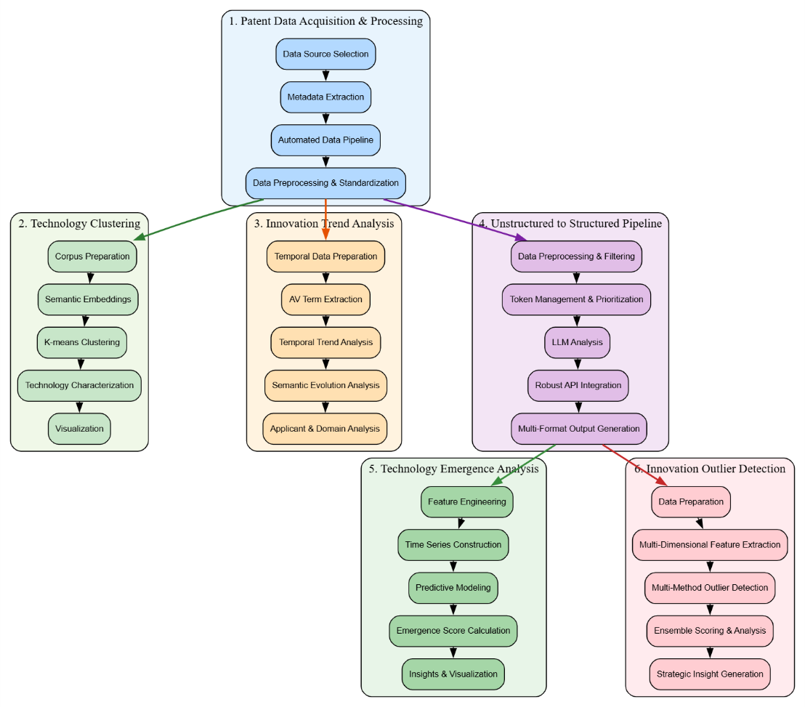
Fig 4.1 Methodology

Data Acquisition and Processing
Patent data was sourced from Lens.org, targeting 667 US patents from major AV industry players (Baidu, Ford, Amazon, Toyota, Google, etc.) published between 2020-2025. Strategic filters focused on machine learning and neural network technologies (CPC codes G06N3/08, G06N20/00) while excluding computer vision classifications. Complete patent records were retrieved via Lens.org REST API and stored in JSONL format. Raw data underwent preprocessing to remove unnecessary attributes, flatten nested structures, and standardize nine core fields: lens_id, publication date, claims, description, applicant name, CPC symbols, title, and abstract.
Technology Clustering Analysis
Patent texts (titles, abstracts, claims) were preprocessed and truncated to 500 words for semantic analysis. The Sentence-BERT model (all-MiniLM-L6-v2) generated 384-dimensional embeddings to capture contextual meaning beyond keyword matching. Optimal cluster numbers were determined using silhouette scores, Calinski-Harabasz indices, and elbow method analysis. K-means clustering grouped patents by semantic similarity, with clusters characterized through TF-IDF keyword extraction and validated via coherence analysis.
Innovation Trend Analysis
Meaningful technical terms were extracted using multi-layered NLP approaches: spaCy for noun phrase identification, regex patterns for AV-specific terminology, and n-gram analysis for compound terms. Generic patent language was filtered using comprehensive stopword lists. Temporal trends were analyzed through term frequency normalization, Pearson correlation analysis, and semantic evolution using SBERT embeddings to identify technological shifts over time.
Structured Data Transformation
Unstructured patent text was transformed into structured data using Gemini 1.5 Flash API with intelligent token management (3,000 tokens per patent). Each patent was analyzed for core innovation, conceptual categories, and AV technology area classification. The pipeline implemented robust error handling, progressive checkpointing every 50 patents, and multi-format output generation for downstream ML applications.
Emergence and Outlier Detection
Technology emergence scores integrated growth rates, applicant diversity, market concentration, and innovation quality metrics using Prophet and ensemble ML models. Outlier detection employed four complementary methods (Isolation Forest, Autoencoders, DBSCAN, statistical methods) to identify radical innovations through ensemble scoring, with the top 15% classified as breakthrough patents.

- TOOLS AND TECHNIQUES
- Sentence-BERT (SentenceTransformer): A state-of-the-art transformer-based model for generating semantic embeddings that capture contextual meaning in patent text. The 'all-MiniLM-L6-v2' model was employed to create 384-dimensional vector representations enabling sophisticated similarity analysis beyond traditional keyword matching.
- Scikit-learn: A comprehensive machine learning library providing clustering algorithms (K-means, DBSCAN, Agglomerative Clustering), dimensionality reduction techniques (PCA, t-SNE), and evaluation metrics (silhouette scores, Calinski-Harabasz indices). Additional modules included TF-IDF vectorization for text analysis and ensemble methods for outlier detection.
- UMAP (Uniform Manifold Approximation and Projection): An advanced dimensionality reduction technique used for creating interpretable 2D visualizations of high-dimensional semantic embeddings, preserving both local and global structure in the patent technology landscape.
- spaCy: An industrial-strength NLP library employed for sophisticated text preprocessing, named entity recognition, part-of-speech tagging, and compound term extraction from patent documents.
- TensorFlow/Keras: Deep learning frameworks utilized for building autoencoder neural networks for anomaly detection and LSTM models for time series forecasting in technology emergence analysis.
- Google Gemini API: Large language model integration for transforming unstructured patent text into structured data through intelligent content analysis and categorization.
- NLTK (Natural Language Toolkit): Comprehensive NLP library providing tokenization, stemming, lemmatization, and stopword filtering capabilities for text preprocessing and meaningful term extraction.
- Prophet (Facebook's Time Series Library): Specialized forecasting tool for decomposing patent filing trends, detecting seasonality patterns, and predicting future technology emergence trajectories.
- Plotly: Interactive visualization library enabling creation of dynamic, multi-dimensional plots for exploring patent landscapes, technology clusters, and temporal trends with enhanced user interactivity.
- Isolation Forest: An unsupervised anomaly detection algorithm specifically designed for identifying outliers in high-dimensional spaces, crucial for detecting radical innovation patents.
- Ensemble Methods: Integration of Random Forest and Gradient Boosting regressors for robust predictive modeling, combining multiple weak learners to improve forecasting accuracy and reduce overfitting.
- Statistical Analysis Tools: SciPy's statistical functions for Pearson correlation analysis, hypothesis testing, and advanced statistical validation of trend patterns and emergence scores.

6 IMPLEMENTATION
6.1 DATA ACQUISITION AND PROCESSING PIPELINE
6.1.1 PATENT DATA SOURCE AND COLLECTION
The patent data was sourced from Lens.org, a comprehensive global patent database providing access to over 130 million patent records worldwide. Strategic filtering was applied to focus specifically on autonomous vehicle technologies from major industry players. The filtering criteria included:
Publication Period: 2020-2025 to capture recent technological developments Patent Status: Only granted US patents with complete documentation
Legal Status: Active patents to ensure current relevance
Target Companies: Baidu USA LLC, Ford Global Tech LLC, Amazon Tech INC, Qualcomm INC, Toyota Motor CO LTD, Intel CORP, Google LLC, and Nvidia CORP
Classification Codes: CPC codes targeting machine learning (G06N3/08, G06N20/00, G06N3/045) while excluding certain computer vision classifications
This strategic filtering process yielded a curated dataset of 667 patents from hundreds of thousands of available records, ensuring high relevance for autonomous vehicle technology analysis.
6.1.2 API INTEGRATION AND DATA RETRIEVAL
Initial metadata export from Lens.org provided essential identifiers in CSV format (lens-export.csv), particularly the critical Lens IDs required for comprehensive data retrieval. However, this export lacked detailed patent information such as full claims and technical descriptions.
To obtain complete patent records, API access was requested and granted for Lens.org's REST API. A systematic automated pipeline was developed to:
- Fetch complete patent records using collected Lens IDs
- Handle API rate limiting and error responses
- Store raw data in JSONL format (av_patentdata.jsonl) for efficient processing
- Maintain data integrity across large-scale retrieval operations
6.1.3 DATA PREPROCESSING AND STANDARDIZATION
Raw API data contained extensive nested attributes and irrelevant metadata including patent families, legal agents, and administrative details. A comprehensive preprocessing pipeline was implemented to:
Data Cleaning: Remove unnecessary attributes and metadata not relevant to technical analysis
Structure Flattening: Convert nested JSON structures to accessible top-level keys Attribute Standardization: Ensure consistent availability of core attributes across all patent records
Quality Validation: Verify completeness of essential fields for downstream analysis
The final standardized schema included nine core attributes essential for NLP and clustering analysis:
- lens_id (unique identifier)
- date_published (temporal analysis)
- claims (technical specifications)
- description (detailed technical content)
- earliest_claim_date (priority timeline)
- applicant_name (company attribution)
- cpc_symbols (classification codes)
- invention_title_text (innovation summary)
- abstract_text (technical overview)
6.2 SEMANTIC CLUSTERING ANALYSIS
6.2.1 CORPUS PREPARATION AND TEXT PREPROCESSING
Patent documents were prepared for semantic analysis by combining three key textual components: invention titles, abstracts, and claims. This multi-component approach ensures comprehensive capture of both high-level innovation concepts and detailed technical specifications.
Text preprocessing operations included:
- Cleaning technical references (e.g., "Figure 1" → "figure")
- Removing excessive whitespace and formatting artifacts
- Truncating documents to 500 words to optimize processing efficiency
- Filtering documents with insufficient content (<100 characters)
- Preserving technical terminology and domain-specific language
6.2.2 SEMANTIC EMBEDDING GENERATION
The Sentence-BERT (SBERT) model was employed to transform patent texts into high-dimensional semantic embeddings that capture contextual meaning beyond traditional keyword matching approaches.
Model Specification: 'all-MiniLM-L6-v2' architecture
Embedding Dimensions: 384-dimensional vectors with L2 normalization Similarity Measurement: Cosine similarity calculations for semantic relationships Advantage: Captures nuanced technological relationships that TF-IDF methods typically miss
This approach enables identification of patents with similar technological concepts even when using different terminology or technical language.
6.2.3 CLUSTERING PARAMETER OPTIMIZATION
Multiple clustering quality metrics were employed to determine optimal cluster configurations:
Silhouette Analysis: Measures intra-cluster cohesion versus inter-cluster separation
Calinski-Harabasz Index: Evaluates cluster variance ratios for optimal separation Elbow Method: Identifies diminishing returns in inertia reduction
Visualization: Metric plots guide informed decision-making for cluster number selection
6.2.4 K-MEANS CLUSTERING IMPLEMENTATION
K-means clustering was applied to group patents based on semantic similarity in the embedding space. The implementation included:
- Cluster quality validation through silhouette scoring
- Coherence analysis measuring average cosine similarity within clusters
- Alternative method validation using hierarchical clustering and DBSCAN
- TF-IDF-based keyword extraction for cluster characterization
6.3 INNOVATION TREND ANALYSIS
6.3.1 TECHNICAL TERM EXTRACTION
A multi-layered approach was implemented to extract technically relevant terms from patent documents:
NLP-based Extraction:
- spaCy library for noun phrase identification
- Compound term detection preserving grammatical structures
- Part-of-speech tagging for technical relevance validation
Domain-specific Pattern Matching:
- Regex patterns targeting AV-specific terminology
- Coverage across perception systems, localization, path planning
- V2X communication and safety standards terminology
Technical N-gram Analysis:
- 2-3 word combinations with technical relevance
- POS tagging pattern validation
- Compound technical term preservation
6.3.2 TERM FILTERING AND QUALITY CONTROL
Comprehensive filtering mechanisms ensure extraction of meaningful technical terms:
- Generic patent language removal using extensive stopword lists
- Boilerplate term filtering specific to patent documentation
- Technical keyword relevance scoring
- Proper phrase structure validation
- Awkward phrase detection and elimination
6.3.3 TEMPORAL TREND ANALYSIS
Time-based analysis segments were created to track innovation evolution:
- Yearly/quarterly segmentation with minimum patent thresholds
- Term frequency normalization by patent count for fair comparison
- Pearson correlation analysis for trending term identification
- Statistical significance testing for trend validation
- Semantic evolution analysis using SBERT embeddings
6.4 UNSTRUCTURED TO STRUCTURED DATA TRANSFORMATION
6.4.1 LLM-BASED ANALYSIS PIPELINE
A sophisticated pipeline was developed to transform unstructured patent text into structured analytical data using Google's Gemini 1.5 Flash API.
Content Prioritization System:
- Token limit management (3,000 tokens per patent)
- Hierarchical content inclusion: title (always) → abstract → claims (truncated if necessary)
- Intelligent truncation preserving critical technical information
6.4.2 STRUCTURED EXTRACTION FRAMEWORK
Each patent underwent comprehensive analysis extracting four key analytical components:
Core Innovation Analysis:
- Problem identification and technical challenges addressed
- Proposed solution methodology and approach
- Novelty aspects and technological advancement
- Technical implementation details
Conceptual Categorization:
- Primary technology classification with confidence scoring
- Secondary category identification for cross-domain innovations
- Technology convergence pattern recognition
AV Technology Domain Classification:
- Systematic classification into predefined autonomous vehicle domains
- Coverage of perception, localization, control systems, communication
- Multi-domain patent identification for convergence analysis
6.4.3 ROBUST API INTEGRATION
The implementation included comprehensive error handling and reliability mechanisms:
- Exponential backoff for server errors and temporary failures
- Rate limit respect and automatic retry mechanisms
- Conservative request delays preventing API exhaustion
- Progressive checkpointing every 50 patents for resumption capability
- Multi-format output generation (CSV, Excel, JSON, Pickle)
6.5 TECHNOLOGY EMERGENCE AND OUTLIER DETECTION
6.5.1 EMERGENCE SCORING METHODOLOGY
A composite scoring system was developed to identify emerging technologies within the autonomous vehicle patent landscape:
Growth Rate Analysis: Recent versus historical patent activity comparison Acceleration Metrics: Second derivative calculations of patent trend trajectories Market Diversity: Applicant diversity and competitive landscape analysis Innovation Quality: Average technical complexity and token density measurements
Classification Confidence: Technology categorization certainty scores
6.5.2 PREDICTIVE MODELING FRAMEWORK
Two complementary forecasting approaches were implemented:
Prophet Time Series Analysis:
- Automatic seasonality detection and trend decomposition
- Holiday and irregular event impact modeling
- Uncertainty interval estimation for predictions
Ensemble Machine Learning:
- Random Forest and Gradient Boosting regressors
- Feature engineering including lagged variables and rolling statistics
- Cross-validation for model robustness across different time periods
6.5.3 MULTI-METHOD OUTLIER DETECTION
Four complementary algorithms were employed for comprehensive outlier identification:
Isolation Forest: General anomaly detection through random partitioning Autoencoder Neural Networks: Reconstruction-based outlier identification DBSCAN Clustering: Identification of patents in sparse density regions
Statistical Methods: Mahalanobis distance for multivariate outlier detection
Results from all methods were normalized and combined using weighted averaging to create robust outlier scores, with the top 15% of patents classified as radical innovations.
6.6 VISUALIZATION AND REPORTING FRAMEWORK
6.6.1 DIMENSIONALITY REDUCTION AND VISUALIZATION
Advanced visualization techniques were implemented to create interpretable representations:
- UMAP and t-SNE dimensionality reduction for 2D technology landscape visualization
- Interactive clustering visualizations showing patent distributions
- Temporal evolution animations for trend identification
- Multi-dimensional scatter plots for emergence-growth analysis
6.6.2 COMPREHENSIVE REPORTING SYSTEM
The implementation generates detailed analytical reports including:
- Technology cluster characterization and market analysis
- Innovation trend timelines with statistical significance
- Competitive landscape analysis and market concentration metrics
- Emergence ranking with composite scoring explanations
- Strategic insights for technology investment decisions
7. RESULTS AND DISCUSSIONS
7.1 Technology Clustering (NLP)
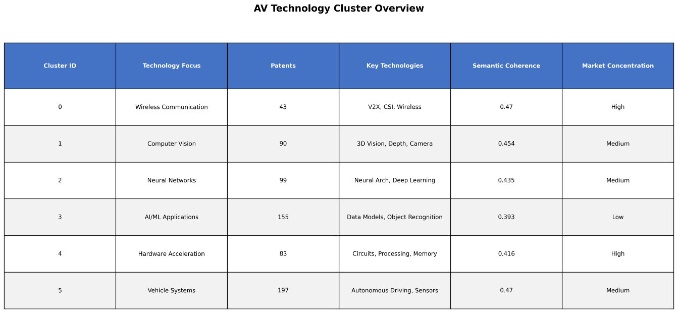
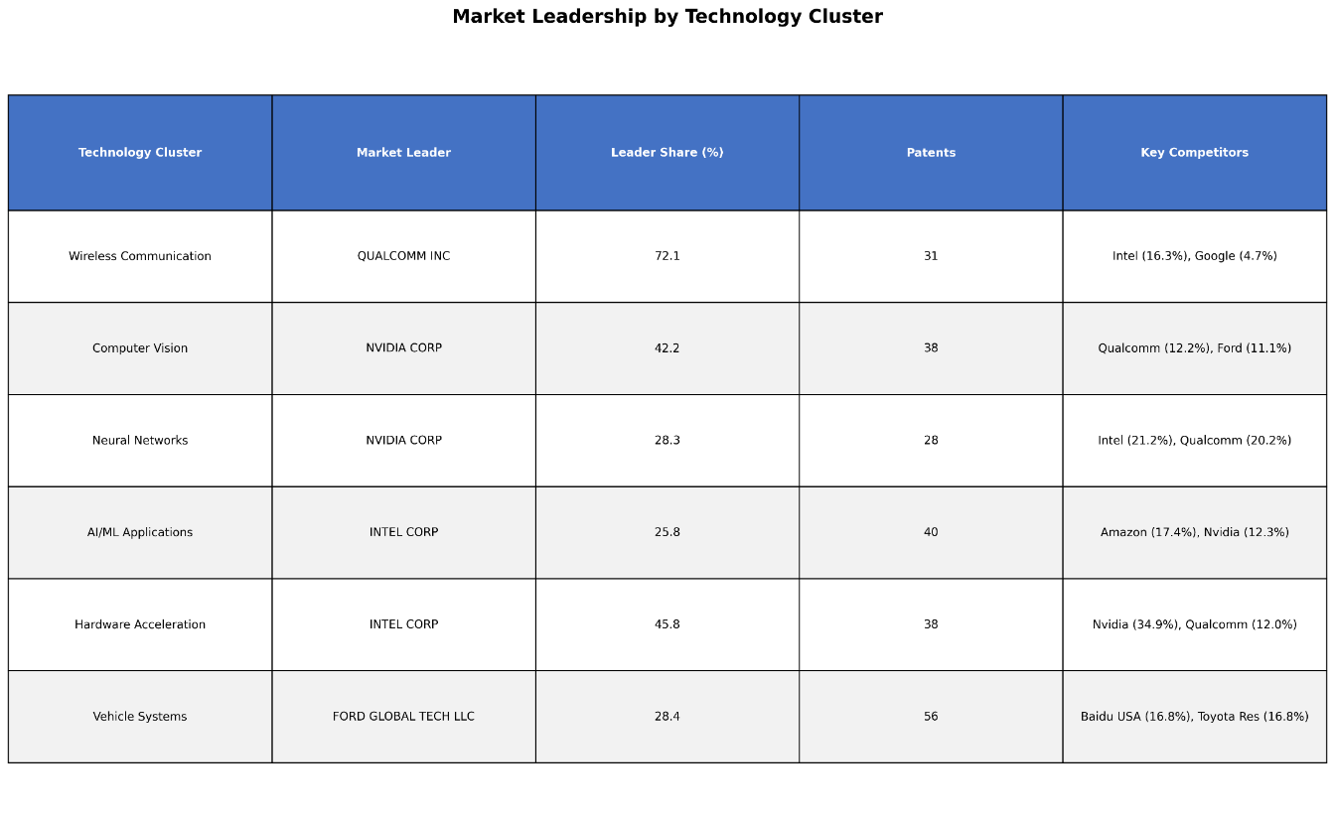
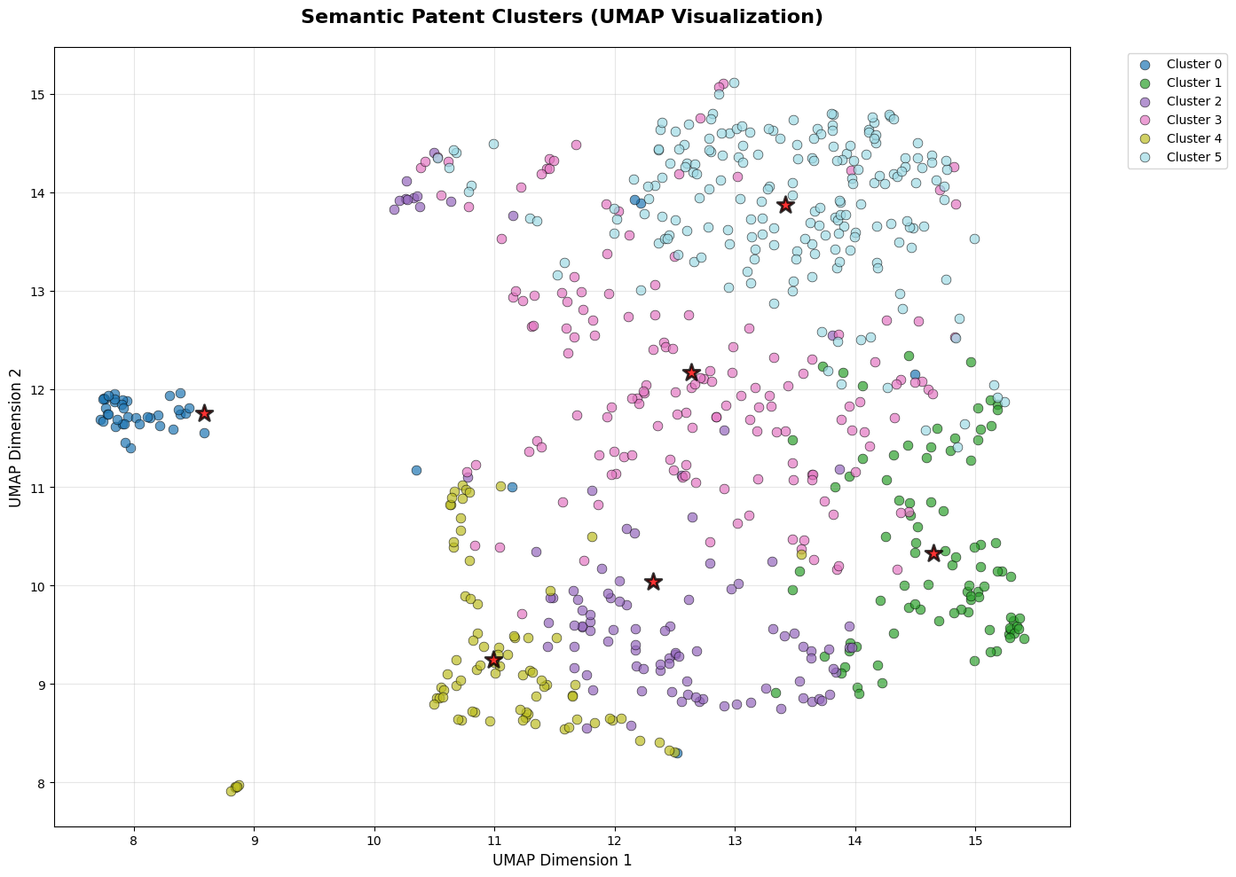
The UMAP visualization displays distinct, well-separated clusters with minimal overlap, indicating good differentiation between semantic groups of patents, while the presence of some internal scatter within clusters suggests a degree of semantic breadth within each defined topic.

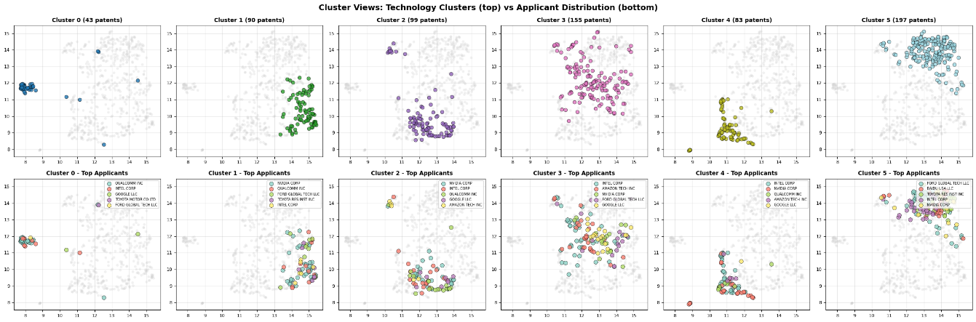
The multiple UMAP plots reveal that different top applicants (e.g., Intel, Nvidia, Ford) dominate distinct semantic spaces, suggesting specialized innovation focuses across the identified patent clusters.

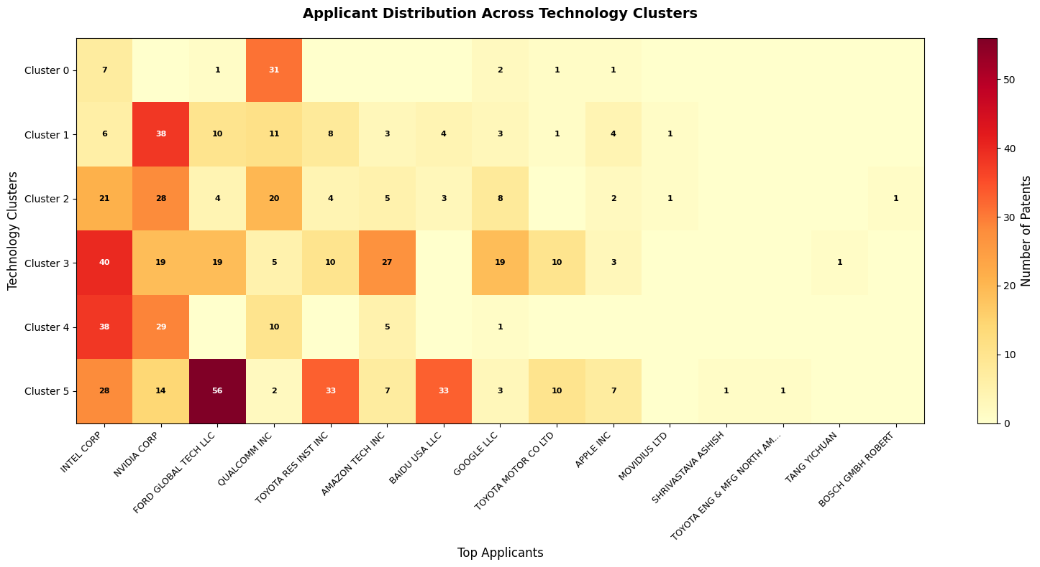
The heatmap reveals that while Intel and Nvidia are broadly present across multiple clusters, Ford Global Tech LLC exhibits a particularly strong concentration in Cluster 5, and Toyota Research Institute Inc. shows a notable presence in Cluster 0 and 5, suggesting distinct areas of specialized innovation for different applicants.
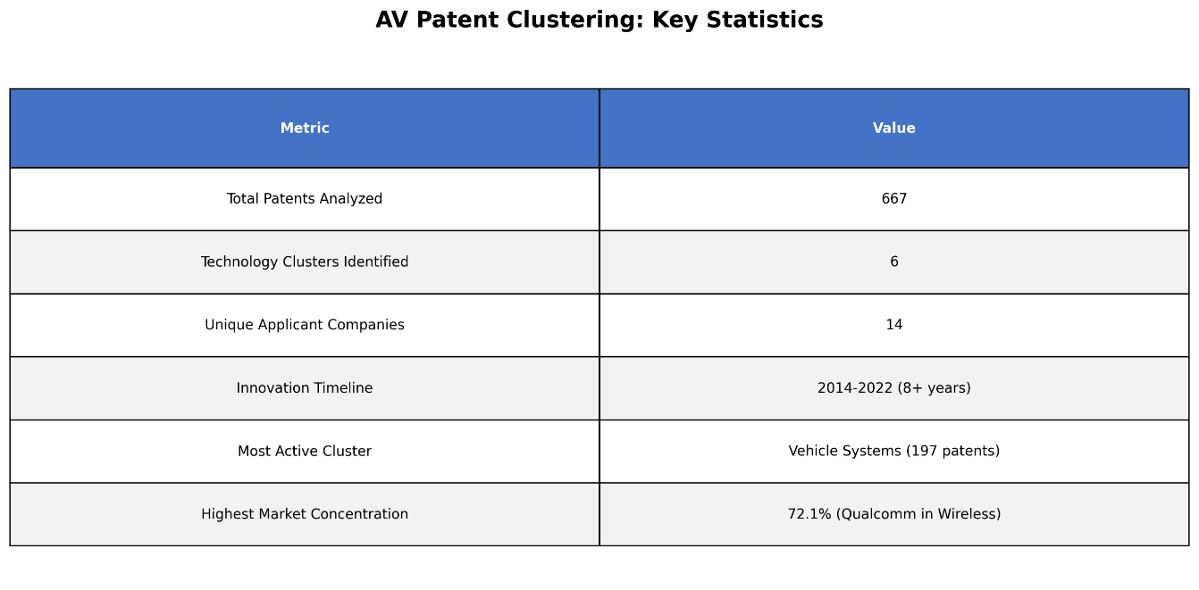
• 6 distinct AV technology clusters identified across 667 patents
• Vehicle Systems largest cluster (197 patents, 29.5% of total)
• Intel most diversified player (active in all 6 clusters)
• Wireless & Hardware show highest market concentration
• 8+ year innovation timeline (2014-2022) shows sustained R&D
• Technology areas range from low-level hardware to high-level AI applications
7.2 Innovation Trend Analysis (NLP)
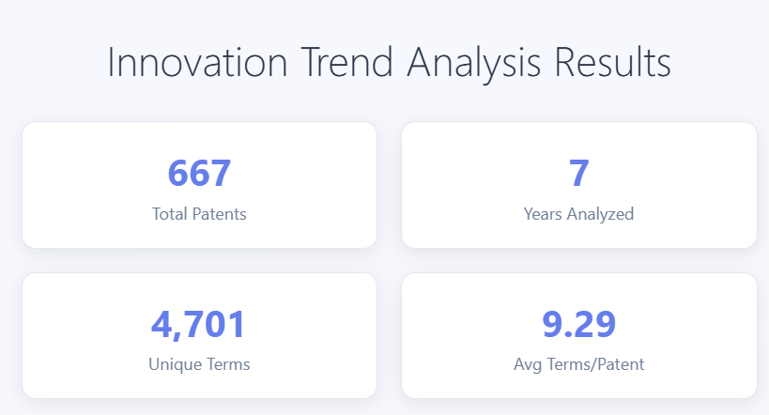
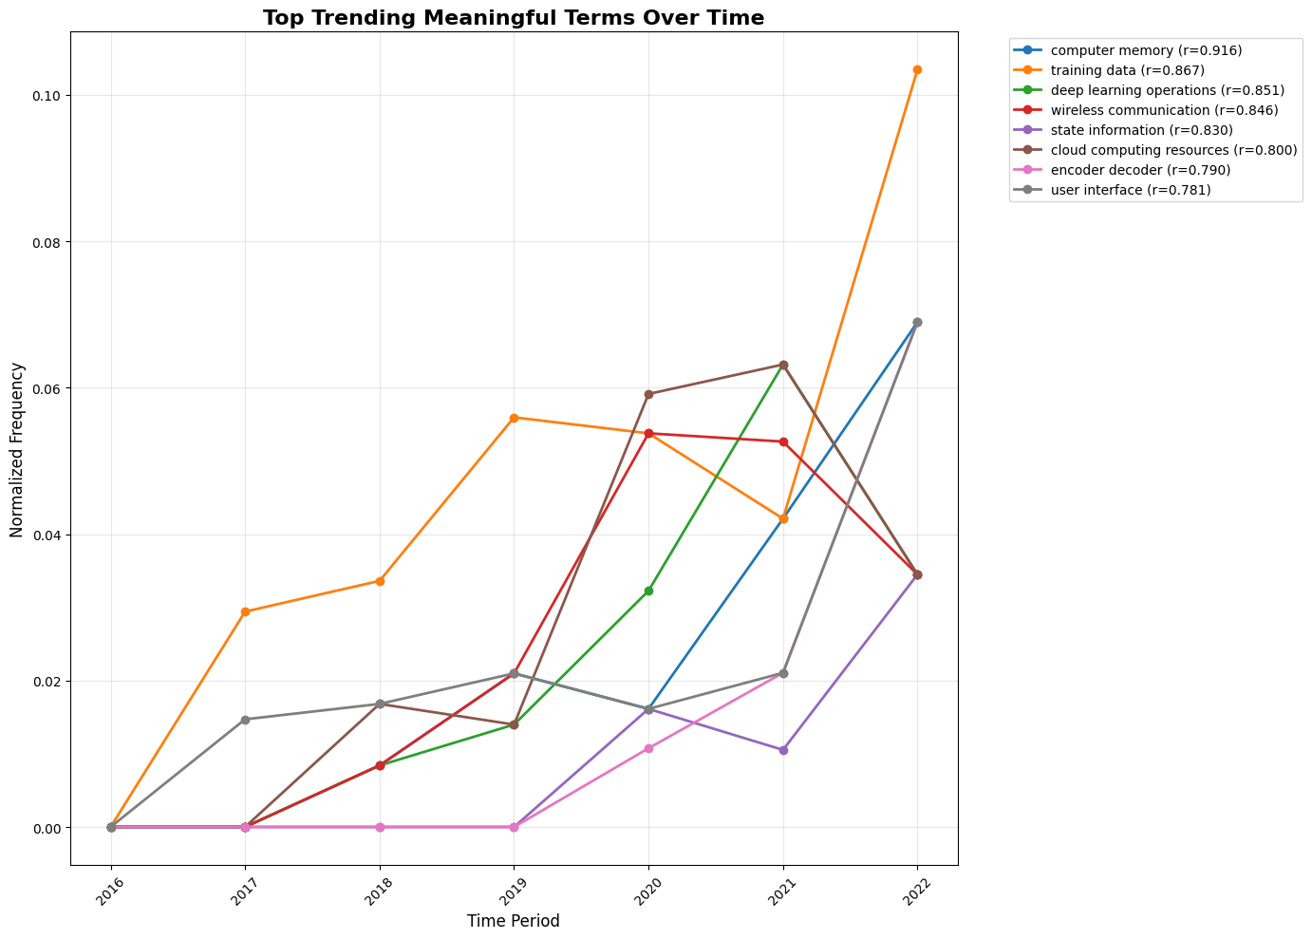
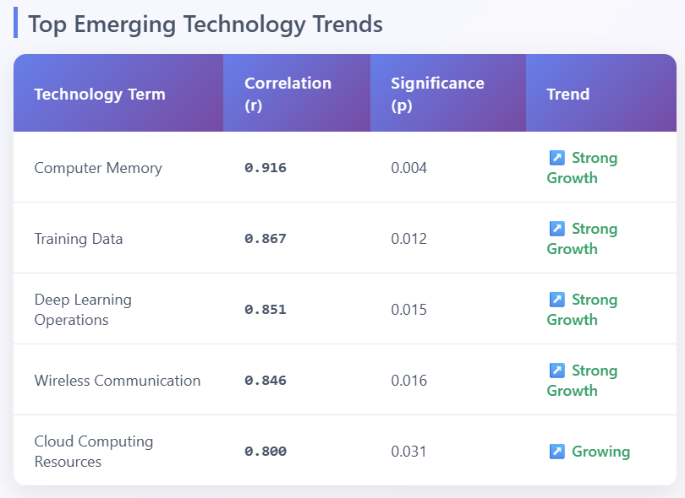
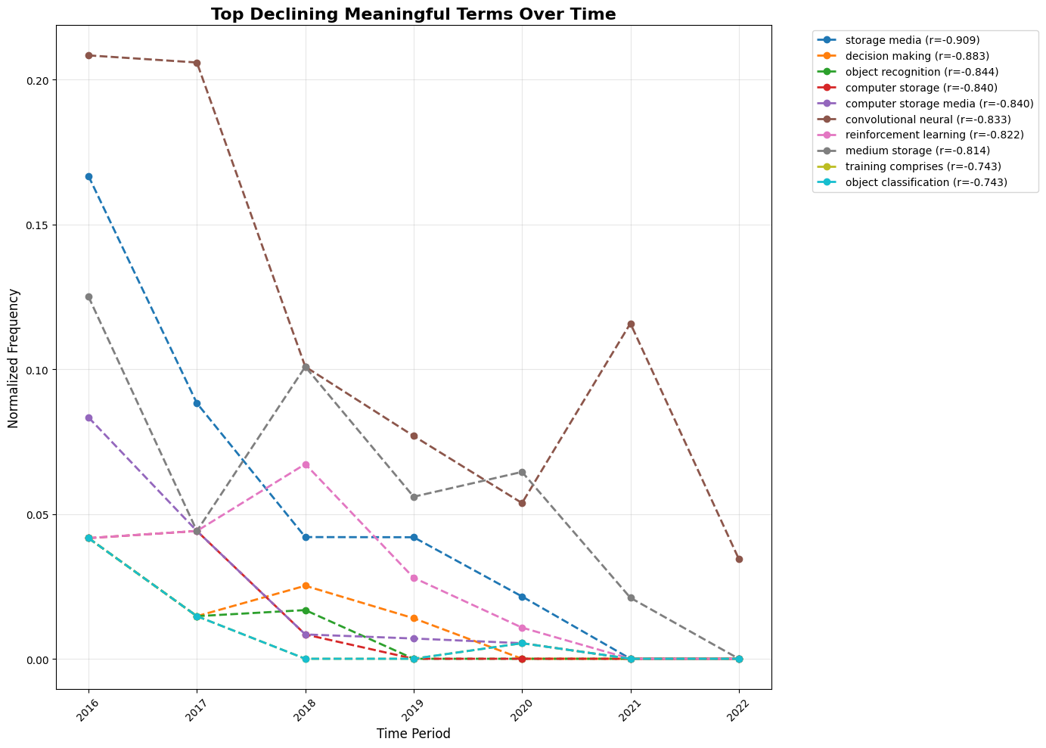
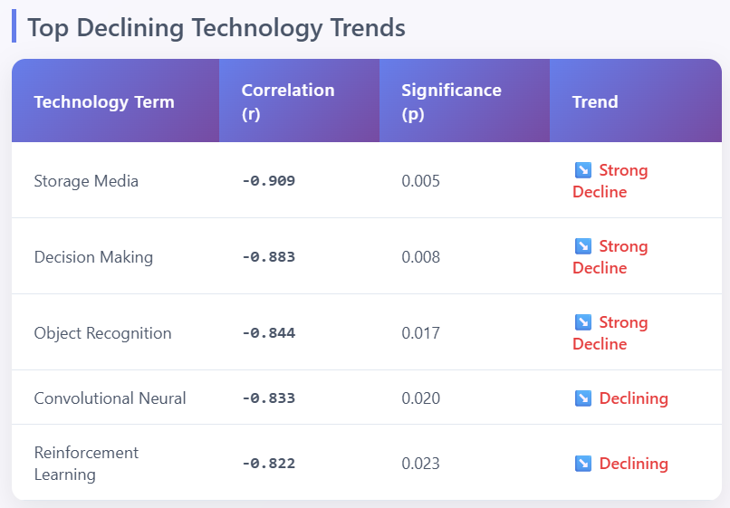
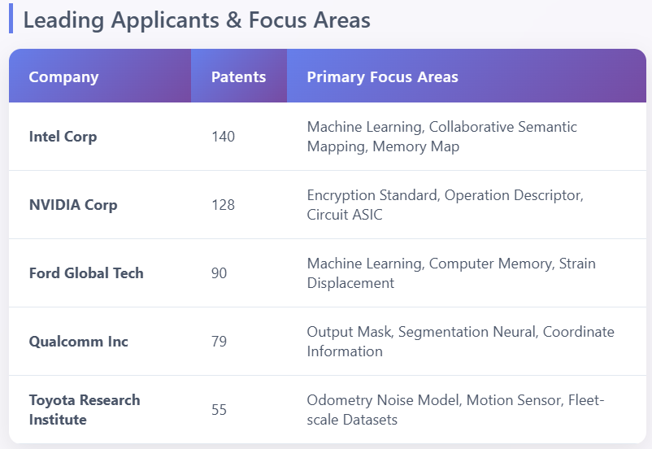
- "Computer memory" and "training data" show strongest growth (r>0.86)
- Traditional storage concepts declining as cloud/edge computing rises
- Clear shift from basic ML to specialized deep learning operations
- Intel and NVIDIA leading with 268 patents combined (40% of total)
7.3 Technology Emergence Analysis (ML)
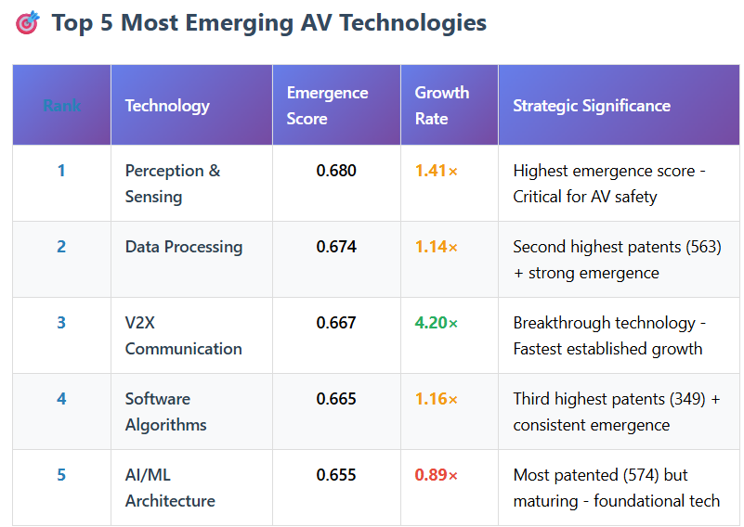
The table identifies Perception & Sensing as the most emergent and V2X Communication as the fastest-growing technology, indicating key areas of rapid advancement and strategic importance within autonomous vehicles.
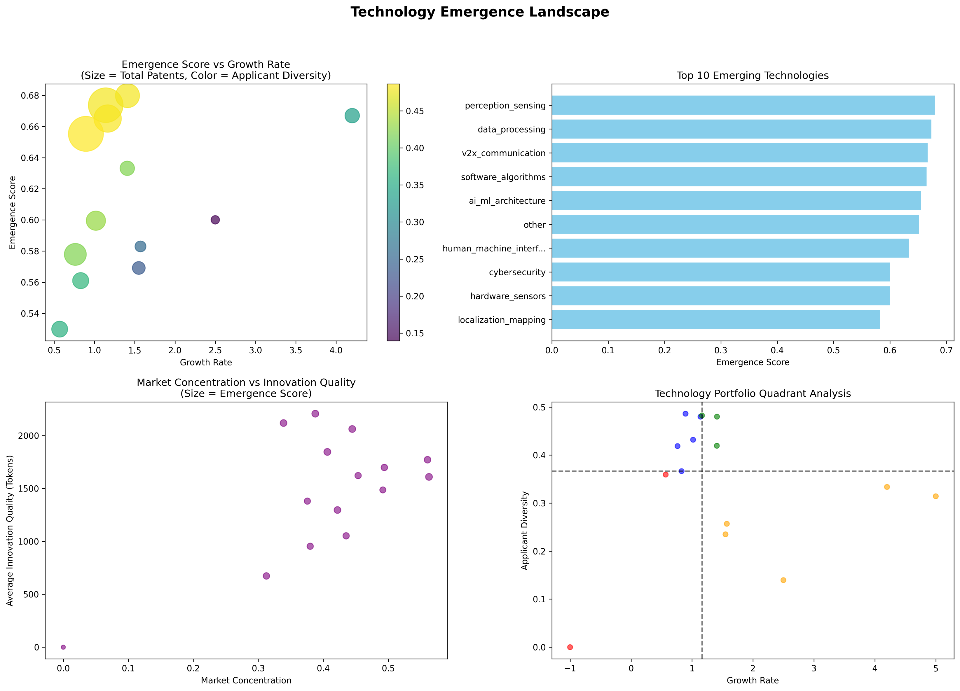
The scatter plot illustrates that technologies with higher emergence scores tend to have higher growth rates, and those with more total patents (larger bubble size) and higher applicant diversity (yellowish color) generally occupy the upper-right quadrant, indicating a positive correlation between these metrics.
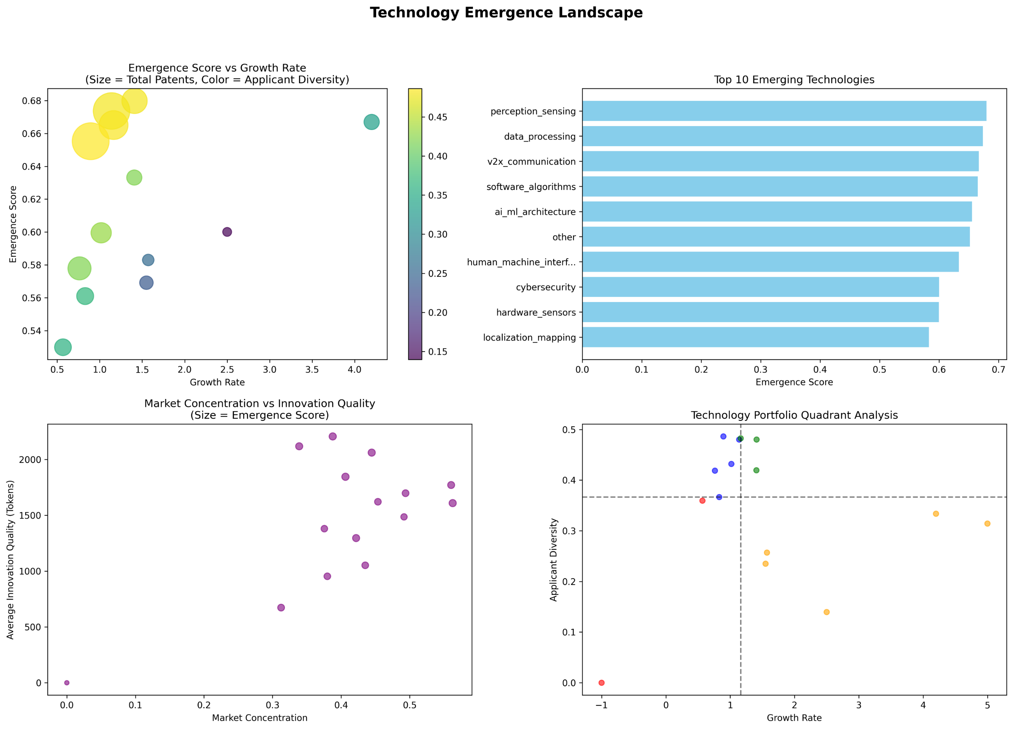
The Quadrant Analysis scatter plot, assessing technologies based on growth rate and applicant diversity, shows a varied distribution where some technologies demonstrate high applicant diversity, while others exhibit higher growth rates but lower diversity.
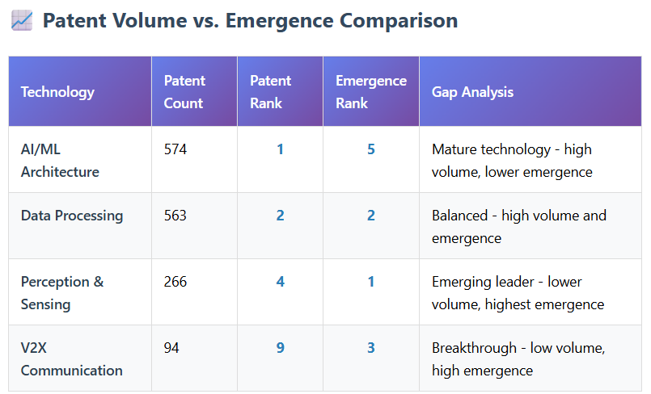
The table demonstrates a varied landscape where AI/ML Architecture represents a mature technology with high patent volume but lower emergence, while Perception & Sensing and V2X Communication, despite lower patent counts, are identified as highly emergent and breakthrough technologies, respectively.
7.4 Technology Emergence Analysis (NLP + ML)
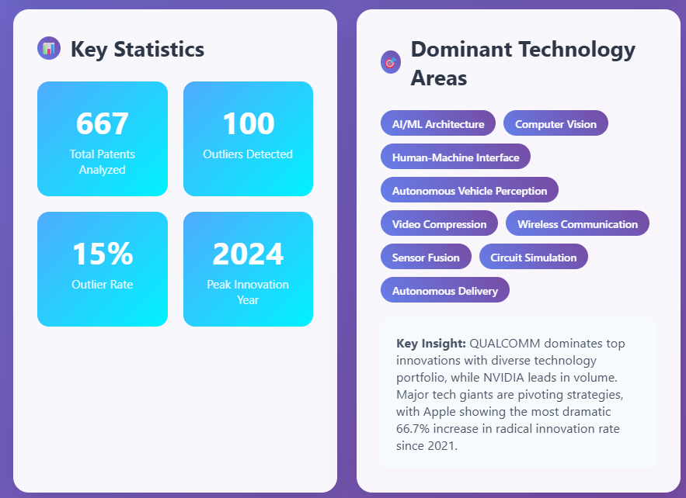
The outcome highlights that out of 667 analyzed patents, AI/ML Architecture, Computer Vision, and Autonomous Vehicle Perception are key technology areas, with 2024 being the peak innovation year, and Qualcomm and Nvidia leading in volume and strategic innovation.
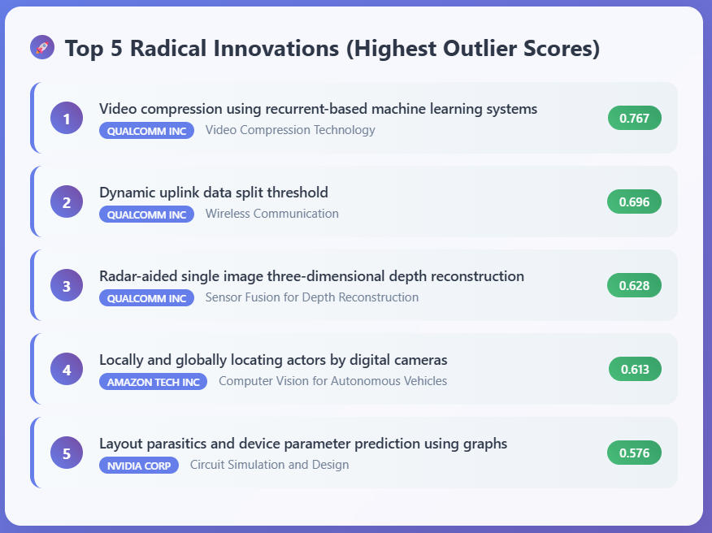
The outcome highlights Qualcomm Inc. as a dominant innovator in video compression and wireless communication, along with significant radical contributions from Amazon Tech Inc. in computer vision for autonomous vehicles and Nvidia Corp. in circuit simulation.
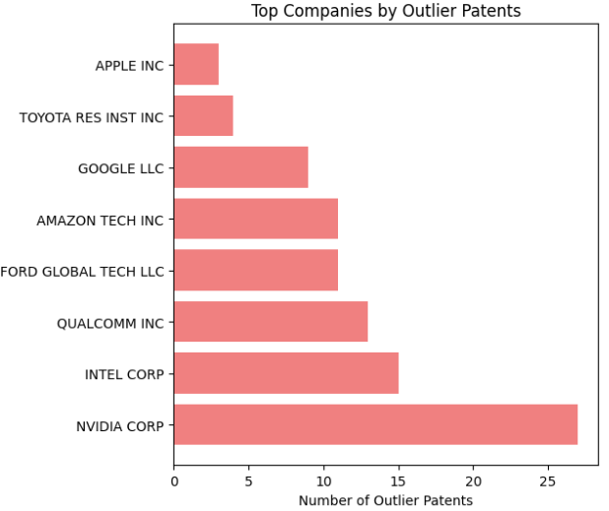
The outcome highlights Nvidia Corp. and Intel Corp. as the top patenting entities by volume, while significant increases in strategic pivots are observed for Apple Inc., Google LLC, and Amazon Tech, reflecting their evolving technological focuses.
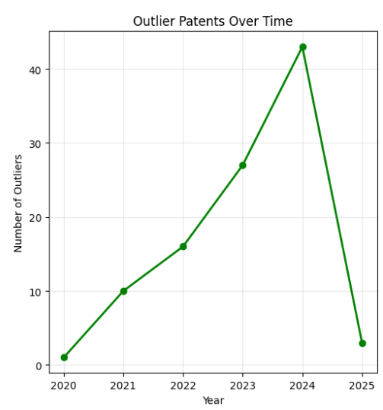
The line chart shows a steady increase in innovation with each year with a steep drop for 2025 due to the limited number of patents in the data for the current year.
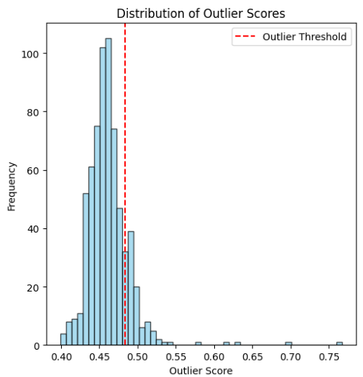
The histogram indicates that most patents have lower outlier scores, suggesting a clustering of conventional innovations, with a smaller tail of higher scores representing truly novel or "outlier" inventions exceeding the defined threshold.
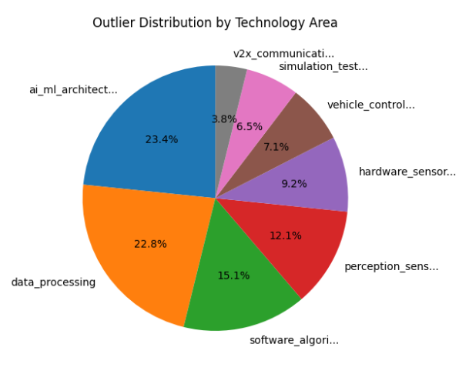
The pie chart reveals that AI/ML Architecture and Data Processing account for the largest proportions of novel or "outlier" patents, indicating these are highly innovative and rapidly evolving fields within autonomous vehicle technology.
8.CONCLUSION
This comprehensive analysis of 667 US autonomous vehicle patents successfully demonstrated the power of advanced NLP and machine learning techniques in extracting strategic intelligence from large-scale patent data. Through semantic clustering using Sentence-BERT embeddings, six distinct technology clusters were identified, with Vehicle Systems emerging as the dominant area (197 patents, 29.5% of total). The analysis revealed clear market differentiation, with Intel demonstrating the broadest innovation portfolio across all clusters, while Ford and Toyota showed specialized concentrations in specific technological domains.
The innovation trend analysis uncovered significant technological shifts within the autonomous vehicle landscape. Emerging technologies like "computer memory" and "training data" showed strong growth correlations (r>0.86), while traditional storage concepts declined as cloud and edge computing gained prominence. This analysis captured the fundamental transition from basic machine learning approaches to specialized deep learning operations, highlighting the industry's technological evolution.
The LLM-based transformation pipeline proved highly effective in converting unstructured patent text into structured analytical data, enabling comprehensive technology emergence analysis. Key findings identified Perception & Sensing as the most emergent technology area, while V2X Communication demonstrated the fastest growth rate, indicating critical strategic investment areas for autonomous vehicle development.
Outlier detection analysis revealed that AI/ML Architecture and Data Processing accounted for the largest proportions of radical innovations, with companies like Qualcomm, Nvidia, and Amazon leading breakthrough patent development. The methodology successfully identified strategic pivots by major players including Apple, Google, and Amazon, reflecting their evolving technological focuses within the autonomous vehicle ecosystem.
This project demonstrated that sophisticated NLP methodologies, when properly implemented with robust preprocessing pipelines and multi-method validation approaches, can unlock deep, actionable intelligence from complex patent databases. The combination of semantic analysis, temporal trend detection, and emergence scoring provides stakeholders with comprehensive insights for strategic technology investment and competitive intelligence decisions in rapidly evolving markets.

9. FUTURE ENHANCEMENT
Several opportunities exist to extend and improve this patent analysis framework. Methodological refinements could enhance result quality by implementing advanced noise reduction techniques in semantic clustering and incorporating ensemble approaches for more robust outlier detection. Pipeline automation represents a critical development area, requiring the creation of end-to-end workflows that streamline data acquisition, preprocessing, analysis, and visualization processes for real-time patent monitoring capabilities.
Advanced predictive modeling should be prioritized to strengthen technology emergence analysis through sophisticated time-series forecasting and cross-domain innovation prediction models. Additional enhancements could include multi-jurisdictional patent integration to capture global innovation patterns, real-time API monitoring for continuous patent landscape updates, and interactive dashboard development for stakeholder engagement. Furthermore, incorporating citation network analysis and inventor mobility tracking would provide deeper insights into knowledge transfer patterns and collaborative innovation networks within the autonomous vehicle ecosystem, ultimately delivering more comprehensive competitive intelligence for strategic decision-making.
10.APPENDICIES
10.1 FULL CODE
Technology Clustering (NLP):
import json
import pandas as pd
import numpy as np
from sentence_transformers import SentenceTransformer
from sklearn.cluster import KMeans, DBSCAN, AgglomerativeClustering
from sklearn.decomposition import PCA
from sklearn.manifold import TSNE
from sklearn.metrics import silhouette_score, calinski_harabasz_score
from sklearn.metrics.pairwise import cosine_similarity
import umap
import matplotlib.pyplot as plt
import seaborn as sns
from wordcloud import WordCloud
import re
import nltk
from nltk.corpus import stopwords
from nltk.tokenize import word_tokenize
from nltk.stem import WordNetLemmatizer
from collections import Counter, defaultdict
import plotly.express as px
import plotly.graph_objects as go
from plotly.subplots import make_subplots
import warnings
warnings.filterwarnings('ignore')

class SemanticPatentClusterer:
def __init__(self, jsonl_file_path, model_name='all-MiniLM-L6-v2'):
"""
Initialize with patent data and SBERT model

Popular model options:
- 'all-MiniLM-L6-v2': Fast, good general performance (384 dim)
- 'all-mpnet-base-v2': Better quality, slower (768 dim)
- 'all-distilroberta-v1': Good balance (768 dim)
"""
self.data = self.load_data(jsonl_file_path)
self.model_name = model_name
self.sbert_model = None
self.embeddings = None
self.cluster_labels = None
self.processed_texts = None

# Download required NLTK data
try:
nltk.data.find('tokenizers/punkt')
nltk.data.find('corpora/stopwords')
nltk.data.find('corpora/wordnet')
except LookupError:
nltk.download('punkt')
nltk.download('stopwords')
nltk.download('wordnet')

def load_data(self, file_path):
"""Load and parse JSONL file"""
data = []
with open(file_path, 'r', encoding='utf-8') as f:
for line in f:
data.append(json.loads(line.strip()))
return pd.DataFrame(data)

def preprocess_patent_text(self, text):
"""
Lighter preprocessing for SBERT - preserve more semantic context
SBERT handles context better, so we don't need aggressive preprocessing
"""
if pd.isna(text) or text == '':
return ''

# Basic cleaning while preserving technical terms
text = re.sub(r'\b(fig\.|figure)\s*\d+\b', 'figure', text, flags=re.IGNORECASE)
text = re.sub(r'\bclaim\s*\d+\b', 'claim', text, flags=re.IGNORECASE)

# Remove excessive whitespace and special chars but keep hyphens
text = re.sub(r'[^\w\s\-\.]', ' ', text)
text = re.sub(r'\s+', ' ', text).strip()

# Truncate very long texts (SBERT has token limits)
words = text.split()
if len(words) > 500: # Keep to ~500 words for better processing
text = ' '.join(words[:500])

return text

def prepare_semantic_corpus(self):
"""Prepare text corpus for semantic embedding"""
print("Preparing semantic corpus...")

# Combine claims into single text
self.data['claims_text'] = self.data['claims'].apply(
lambda x: ' '.join(x) if isinstance(x, list) else str(x)
)

# Create weighted combination prioritizing abstract and key claims
self.data['semantic_text'] = (
self.data['invention_title_text'].fillna('') + '. ' +
self.data['abstract_text'].fillna('') + '. ' +
self.data['claims_text'].fillna('')[:1000] # Limit claims length
)

# Light preprocessing
self.processed_texts = self.data['semantic_text'].apply(self.preprocess_patent_text)

# Filter out very short or empty documents - FIXED: Convert to numpy array
valid_mask = self.processed_texts.str.len() > 100
self.data = self.data[valid_mask].reset_index(drop=True)
self.processed_texts = self.processed_texts[valid_mask].reset_index(drop=True)

# Convert to list for consistent handling
self.processed_texts = self.processed_texts.tolist()

print(f"Prepared {len(self.processed_texts)} valid documents for semantic embedding")
return self.processed_texts

def load_sbert_model(self):
"""Load the SBERT model"""
print(f"Loading SBERT model: {self.model_name}")
self.sbert_model = SentenceTransformer(self.model_name)
print(f"Model loaded. Embedding dimension: {self.sbert_model.get_sentence_embedding_dimension()}")

def generate_embeddings(self, batch_size=32):
"""Generate semantic embeddings for all patents"""
if self.sbert_model is None:
self.load_sbert_model()

print("Generating semantic embeddings...")
print(f"Processing {len(self.processed_texts)} documents in batches of {batch_size}")

# Generate embeddings in batches to manage memory
# FIXED: Ensure processed_texts is a list
texts_list = self.processed_texts if isinstance(self.processed_texts, list) else self.processed_texts.tolist()

self.embeddings = self.sbert_model.encode(
texts_list,
batch_size=batch_size,
show_progress_bar=True,
convert_to_tensor=False,
normalize_embeddings=True # L2 normalization for cosine similarity
)

print(f"Generated embeddings shape: {self.embeddings.shape}")
return self.embeddings

def find_optimal_clusters_semantic(self, max_k=20, sample_size=None):
"""Find optimal number of clusters using matplotlib visualization"""
print("Finding optimal number of clusters using semantic embeddings...")

embeddings_array = np.array(self.embeddings)

if sample_size and len(embeddings_array) > sample_size:
indices = np.random.choice(len(embeddings_array), sample_size, replace=False)
sample_embeddings = embeddings_array[indices]
print(f"Using sample of {sample_size} documents for optimization")
else:
sample_embeddings = embeddings_array

k_range = range(5, min(max_k + 1, len(sample_embeddings) // 10))
silhouette_scores = []
calinski_scores = []
inertias = []

for k in k_range:
print(f"Testing k={k}...")
try:
kmeans = KMeans(n_clusters=k, random_state=42, n_init=10)
labels = kmeans.fit_predict(sample_embeddings)

if len(np.unique(labels)) > 1:
sil_score = silhouette_score(sample_embeddings, labels)
cal_score = calinski_harabasz_score(sample_embeddings, labels)
else:
sil_score = -1
cal_score = 0

silhouette_scores.append(sil_score)
calinski_scores.append(cal_score)
inertias.append(kmeans.inertia_)

except Exception as e:
print(f"Error with k={k}: {e}")
silhouette_scores.append(-1)
calinski_scores.append(0)
inertias.append(float('inf'))

# Create matplotlib visualization
try:
fig, axes = plt.subplots(1, 3, figsize=(18, 5))

# Silhouette Score
axes[0].plot(k_range, silhouette_scores, 'bo-', linewidth=2, markersize=8)
axes[0].set_title('Silhouette Score', fontsize=14, fontweight='bold')
axes[0].set_xlabel('Number of Clusters', fontsize=12)
axes[0].set_ylabel('Silhouette Score', fontsize=12)
axes[0].grid(True, alpha=0.3)
axes[0].tick_params(labelsize=10)

# Highlight the best score
if max(silhouette_scores) > -1:
best_k_sil = k_range[np.argmax(silhouette_scores)]
axes[0].axvline(x=best_k_sil, color='red', linestyle='--', alpha=0.7)
axes[0].text(best_k_sil, max(silhouette_scores), f'Best: {best_k_sil}',
ha='center', va='bottom', fontweight='bold', color='red')

# Calinski-Harabasz Score
axes[1].plot(k_range, calinski_scores, 'ro-', linewidth=2, markersize=8)
axes[1].set_title('Calinski-Harabasz Score', fontsize=14, fontweight='bold')
axes[1].set_xlabel('Number of Clusters', fontsize=12)
axes[1].set_ylabel('Calinski-Harabasz Score', fontsize=12)
axes[1].grid(True, alpha=0.3)
axes[1].tick_params(labelsize=10)

# Highlight the best score
if max(calinski_scores) > 0:
best_k_cal = k_range[np.argmax(calinski_scores)]
axes[1].axvline(x=best_k_cal, color='red', linestyle='--', alpha=0.7)
axes[1].text(best_k_cal, max(calinski_scores), f'Best: {best_k_cal}',
ha='center', va='bottom', fontweight='bold', color='red')

# Inertia (Elbow Method)
axes[2].plot(k_range, inertias, 'go-', linewidth=2, markersize=8)
axes[2].set_title('Inertia (Elbow Method)', fontsize=14, fontweight='bold')
axes[2].set_xlabel('Number of Clusters', fontsize=12)
axes[2].set_ylabel('Inertia', fontsize=12)
axes[2].grid(True, alpha=0.3)
axes[2].tick_params(labelsize=10)

# Find elbow point (simple method)
if len(inertias) > 2:
# Calculate the rate of change
differences = np.diff(inertias)
if len(differences) > 1:
second_diff = np.diff(differences)
if len(second_diff) > 0:
elbow_idx = np.argmax(second_diff) + 2 # +2 because of double diff
if elbow_idx < len(k_range):
elbow_k = k_range[elbow_idx]
axes[2].axvline(x=elbow_k, color='red', linestyle='--', alpha=0.7)
axes[2].text(elbow_k, inertias[elbow_idx], f'Elbow: {elbow_k}',
ha='center', va='bottom', fontweight='bold', color='red')

plt.suptitle('Clustering Optimization Metrics', fontsize=16, fontweight='bold')
plt.tight_layout()
plt.savefig('clustering_optimization_metrics.png', dpi=300, bbox_inches='tight')
plt.show()
print("Matplotlib clustering optimization plot: SUCCESS")

except Exception as e:
print(f"Matplotlib plotting failed: {e}")

# Return optimal k
valid_scores = [s for s in silhouette_scores if s > -1]
if valid_scores:
optimal_k = k_range[np.argmax(silhouette_scores)]
print(f"Optimal number of clusters: {optimal_k} (Silhouette score: {max(silhouette_scores):.3f})")
else:
optimal_k = 8
print(f"Using default clusters: {optimal_k}")

return optimal_k, silhouette_scores, calinski_scores

def perform_semantic_clustering(self, n_clusters=None, method='kmeans'):
"""Perform clustering on semantic embeddings"""
if n_clusters is None:
n_clusters, _, _ = self.find_optimal_clusters_semantic()

print(f"Performing semantic {method} clustering with {n_clusters} clusters...")

# Ensure embeddings are proper numpy array
embeddings_array = np.array(self.embeddings)

if method == 'kmeans':
clusterer = KMeans(n_clusters=n_clusters, random_state=42, n_init=10)
elif method == 'hierarchical':
clusterer = AgglomerativeClustering(n_clusters=n_clusters, linkage='ward')
elif method == 'dbscan':
# For semantic embeddings, use cosine distance
clusterer = DBSCAN(eps=0.3, min_samples=5, metric='cosine')

# Fit and predict
try:
self.cluster_labels = clusterer.fit_predict(embeddings_array)
except Exception as e:
print(f"Clustering failed with error: {e}")
print("Falling back to simple KMeans...")
clusterer = KMeans(n_clusters=min(n_clusters, 10), random_state=42, n_init=10)
self.cluster_labels = clusterer.fit_predict(embeddings_array)

# FIXED: Properly assign cluster labels to dataframe
# Ensure we have the right number of labels for our filtered data
if len(self.cluster_labels) == len(self.data):
self.data = self.data.copy()
self.data['cluster'] = self.cluster_labels
else:
print(f"Warning: Mismatch between cluster labels ({len(self.cluster_labels)}) and data ({len(self.data)})")
# Truncate or pad as needed
if len(self.cluster_labels) > len(self.data):
self.data['cluster'] = self.cluster_labels[:len(self.data)]
else:
# This shouldn't happen if filtering was done correctly
extended_labels = np.concatenate([self.cluster_labels, np.full(len(self.data) - len(self.cluster_labels), -1)])
self.data['cluster'] = extended_labels

# Calculate clustering quality
unique_labels = np.unique(self.cluster_labels)
if len(unique_labels) > 1 and -1 not in unique_labels:
try:
sil_score = silhouette_score(embeddings_array, self.cluster_labels)
print(f"Clustering silhouette score: {sil_score:.3f}")
except Exception as e:
print(f"Could not calculate silhouette score: {e}")

# Print cluster distribution
cluster_counts = pd.value_counts(self.cluster_labels, sort=False)
print("Cluster distribution:")
for cluster_id in sorted(cluster_counts.index):
count = cluster_counts[cluster_id]
print(f" Cluster {cluster_id}: {count} patents")

return clusterer

def extract_semantic_cluster_keywords(self, top_k=15):
"""Extract representative keywords using semantic centroids and TF-IDF"""
print("Extracting semantic cluster keywords...")

from sklearn.feature_extraction.text import TfidfVectorizer

# FIXED: Ensure processed_texts is a list for TfidfVectorizer
texts_list = self.processed_texts if isinstance(self.processed_texts, list) else self.processed_texts.tolist()

# Create TF-IDF for keyword extraction
vectorizer = TfidfVectorizer(
max_features=3000,
ngram_range=(1, 3),
min_df=2,
max_df=0.8,
stop_words='english'
)

tfidf_matrix = vectorizer.fit_transform(texts_list)
feature_names = vectorizer.get_feature_names_out()

cluster_keywords = {}
cluster_centroids = {}

for cluster_id in sorted(self.data['cluster'].unique()):
if cluster_id == -1: # Skip noise cluster
continue

# FIXED: Use numpy array indexing instead of pandas boolean indexing
cluster_mask = (self.data['cluster'] == cluster_id).values
cluster_embeddings = self.embeddings[cluster_mask]
cluster_tfidf = tfidf_matrix[cluster_mask]

# Calculate semantic centroid
centroid = np.mean(cluster_embeddings, axis=0)
cluster_centroids[cluster_id] = centroid

# Get TF-IDF scores for cluster documents
cluster_tfidf_mean = np.array(cluster_tfidf.mean(axis=0)).flatten()

# Get top terms by TF-IDF
top_indices = cluster_tfidf_mean.argsort()[-top_k:][::-1]
top_terms = [(feature_names[i], cluster_tfidf_mean[i]) for i in top_indices]

cluster_keywords[cluster_id] = top_terms

self.cluster_centroids = cluster_centroids
return cluster_keywords

def create_semantic_visualization(self, method='umap', n_components=2):
"""Create visualization using matplotlib only"""
print(f"Creating {method.upper()} visualization...")

embeddings_array = np.array(self.embeddings)

# Dimensionality reduction with better error handling
coords = None
reduction_success = False

try:
if method == 'umap' and umap is not None:
reducer = umap.UMAP(n_components=n_components, n_neighbors=15,
min_dist=0.1, metric='cosine', random_state=42)
elif method == 'tsne':
reducer = TSNE(n_components=n_components,
perplexity=min(30, len(embeddings_array) // 4),
random_state=42, metric='cosine')
else:
reducer = PCA(n_components=n_components, random_state=42)

coords = reducer.fit_transform(embeddings_array)
reduction_success = True

except Exception as e:
print(f"Error with {method}: {e}")
print("Falling back to PCA...")
try:
reducer = PCA(n_components=n_components, random_state=42)
coords = reducer.fit_transform(embeddings_array)
reduction_success = True
method = 'PCA' # Update method name for plot title
except Exception as e:
print(f"PCA also failed: {e}")
return None

if not reduction_success or coords is None:
print("All dimensionality reduction methods failed!")
return None

# Create matplotlib visualization
if n_components == 2:
try:
# Create a larger, more detailed plot
fig, ax = plt.subplots(figsize=(14, 10))

# Get unique clusters and create a color map
unique_clusters = np.unique(self.cluster_labels)
colors = plt.cm.tab20(np.linspace(0, 1, len(unique_clusters)))

# Plot each cluster with different colors
for i, cluster_id in enumerate(unique_clusters):
cluster_mask = self.cluster_labels == cluster_id
cluster_coords = coords[cluster_mask]

if cluster_id == -1: # Noise cluster
ax.scatter(cluster_coords[:, 0], cluster_coords[:, 1],
c='gray', alpha=0.5, s=30, edgecolors='black',
linewidth=0.5, label=f'Noise', marker='x')
else:
ax.scatter(cluster_coords[:, 0], cluster_coords[:, 1],
c=[colors[i]], alpha=0.7, s=60, edgecolors='black',
linewidth=0.5, label=f'Cluster {cluster_id}')

# Customize the plot
ax.set_title(f'Semantic Patent Clusters ({method.upper()} Visualization)',
fontsize=16, fontweight='bold', pad=20)
ax.set_xlabel(f'{method.upper()} Dimension 1', fontsize=12)
ax.set_ylabel(f'{method.upper()} Dimension 2', fontsize=12)
ax.grid(True, alpha=0.3)
ax.tick_params(labelsize=10)

# Add legend with better positioning
if len(unique_clusters) <= 20: # Only show legend if not too many clusters
ax.legend(bbox_to_anchor=(1.05, 1), loc='upper left', fontsize=10)

# Add cluster centroids
if hasattr(self, 'cluster_centroids') and self.cluster_centroids:
for cluster_id in self.cluster_centroids.keys():
if cluster_id != -1:
cluster_mask = self.cluster_labels == cluster_id
cluster_coords = coords[cluster_mask]
if len(cluster_coords) > 0:
centroid_x = np.mean(cluster_coords[:, 0])
centroid_y = np.mean(cluster_coords[:, 1])
ax.scatter(centroid_x, centroid_y, c='red', s=200,
marker='*', edgecolors='black', linewidth=2,
alpha=0.8, zorder=5)
ax.text(centroid_x, centroid_y, str(cluster_id),
ha='center', va='center', fontweight='bold',
fontsize=10, color='white')

plt.tight_layout()
plt.savefig('semantic_cluster_visualization.png', dpi=300, bbox_inches='tight')
plt.show()
print("Matplotlib cluster visualization: SUCCESS")

# Additional detailed view for clusters
self._create_cluster_detail_plot(coords, method)

except Exception as e:
print(f"Matplotlib visualization failed: {e}")
return None

return coords

def _create_cluster_detail_plot(self, coords, method):
"""Create additional detailed cluster plots with applicant analysis"""
try:
# Ensure we have applicant analysis
if not hasattr(self, 'cluster_applicants'):
self.analyze_cluster_applicants()

unique_clusters = np.unique(self.cluster_labels)
valid_clusters = [c for c in unique_clusters if c != -1]

if len(valid_clusters) <= 16:
# Determine number of columns based on actual cluster count
n_cols = min(len(valid_clusters), 8) # Cap at 8 for readability

# Create two sets of subplots: regular clusters and applicant-colored clusters
fig, axes = plt.subplots(2, n_cols, figsize=(4*n_cols, 8))

# Handle single column case
if n_cols == 1:
axes = axes.reshape(2, 1)

# Show all clusters (not just first 4)
clusters_to_show = valid_clusters[:n_cols]
colors = plt.cm.tab20(np.linspace(0, 1, len(clusters_to_show)))

for i, cluster_id in enumerate(clusters_to_show):
# Row 1: Regular cluster view
ax1 = axes[0, i] if n_cols > 1 else axes[0]

# Plot all points in gray
ax1.scatter(coords[:, 0], coords[:, 1], c='lightgray',
alpha=0.3, s=20, edgecolors='none')

# Highlight current cluster
cluster_mask = self.cluster_labels == cluster_id
cluster_coords = coords[cluster_mask]
ax1.scatter(cluster_coords[:, 0], cluster_coords[:, 1],
c=[colors[i]], alpha=0.8, s=40, edgecolors='black',
linewidth=0.5)

ax1.set_title(f'Cluster {cluster_id} ({np.sum(cluster_mask)} patents)',
fontsize=10, fontweight='bold')
ax1.grid(True, alpha=0.3)
ax1.tick_params(labelsize=8)

# Row 2: Applicant-colored view
ax2 = axes[1, i] if n_cols > 1 else axes[1]

# Plot all points in gray
ax2.scatter(coords[:, 0], coords[:, 1], c='lightgray',
alpha=0.3, s=20, edgecolors='none')

# Get cluster data and top applicants
cluster_data = self.data[self.data['cluster'] == cluster_id]
top_applicants = list(self.cluster_applicants[cluster_id]['top_applicants'].keys())[:5]

# Create color map for top applicants
applicant_colors = plt.cm.Set3(np.linspace(0, 1, len(top_applicants)))

# Plot each top applicant with different color
for j, applicant in enumerate(top_applicants):
applicant_mask = (cluster_data['applicant_name'] == applicant).values
if np.any(applicant_mask):
# Get indices in the original data
cluster_indices = cluster_data.index[applicant_mask]
# Map back to coordinates
coord_indices = [idx for idx in range(len(self.data))
if self.data.index[idx] in cluster_indices]

if coord_indices:
applicant_coords = coords[coord_indices]
ax2.scatter(applicant_coords[:, 0], applicant_coords[:, 1],
c=[applicant_colors[j]], alpha=0.8, s=50,
edgecolors='black', linewidth=0.5,
label=f'{applicant[:20]}...' if len(applicant) > 20 else applicant)

ax2.set_title(f'Cluster {cluster_id} - Top Applicants',
fontsize=10, fontweight='bold')
ax2.grid(True, alpha=0.3)
ax2.tick_params(labelsize=8)

# Add legend for applicants (small font)
if len(top_applicants) > 0:
ax2.legend(fontsize=6, loc='upper right', bbox_to_anchor=(1, 1))

# Hide empty subplots if needed
for i in range(len(clusters_to_show), n_cols):
if n_cols > 1:
axes[0, i].set_visible(False)
axes[1, i].set_visible(False)

plt.suptitle(f'Cluster Views: Technology Clusters (top) vs Applicant Distribution (bottom)',
fontsize=14, fontweight='bold')
plt.tight_layout()
plt.savefig('cluster_detail_with_applicants.png', dpi=300, bbox_inches='tight')
plt.show()
print("Cluster detail with applicant visualization: SUCCESS")

except Exception as e:
print(f"Failed to create cluster detail plot with applicants: {e}")

def create_applicant_cluster_heatmap(self):
"""Create heatmap showing applicant distribution across clusters"""
try:
# Get top applicants overall
top_global_applicants = self.data['applicant_name'].value_counts().head(15).index.tolist()

# Create matrix: clusters x applicants
cluster_ids = sorted([c for c in self.data['cluster'].unique() if c != -1])

heatmap_data = []
for cluster_id in cluster_ids:
cluster_data = self.data[self.data['cluster'] == cluster_id]
row = []
for applicant in top_global_applicants:
count = len(cluster_data[cluster_data['applicant_name'] == applicant])
row.append(count)
heatmap_data.append(row)

heatmap_array = np.array(heatmap_data)

# Create heatmap
fig, ax = plt.subplots(figsize=(16, 8))

im = ax.imshow(heatmap_array, cmap='YlOrRd', aspect='auto')

# Add colorbar
cbar = plt.colorbar(im, ax=ax)
cbar.set_label('Number of Patents', fontsize=12)

# Set ticks and labels
ax.set_xticks(range(len(top_global_applicants)))
ax.set_yticks(range(len(cluster_ids)))

# Truncate long applicant names
truncated_applicants = [name[:25] + '...' if len(name) > 25 else name
for name in top_global_applicants]

ax.set_xticklabels(truncated_applicants, rotation=45, ha='right', fontsize=9)
ax.set_yticklabels([f'Cluster {cid}' for cid in cluster_ids], fontsize=10)

# Add text annotations for non-zero values
for i in range(len(cluster_ids)):
for j in range(len(top_global_applicants)):
if heatmap_array[i, j] > 0:
text = ax.text(j, i, str(heatmap_array[i, j]),
ha="center", va="center",
color="white" if heatmap_array[i, j] > heatmap_array.max()/2 else "black",
fontsize=8, fontweight='bold')

ax.set_title('Applicant Distribution Across Technology Clusters',
fontsize=14, fontweight='bold', pad=20)
ax.set_xlabel('Top Applicants', fontsize=12)
ax.set_ylabel('Technology Clusters', fontsize=12)

plt.tight_layout()
plt.savefig('applicant_cluster_heatmap.png', dpi=300, bbox_inches='tight')
plt.show()
print("Applicant-cluster heatmap: SUCCESS")

return heatmap_array, cluster_ids, top_global_applicants

except Exception as e:
print(f"Failed to create applicant cluster heatmap: {e}")
return None, None, None

def find_similar_patents(self, patent_idx, top_k=10):
"""Find most similar patents using semantic similarity"""
if self.embeddings is None:
print("Embeddings not generated yet!")
return None

target_embedding = self.embeddings[patent_idx].reshape(1, -1)
similarities = cosine_similarity(target_embedding, self.embeddings)[0]

# Get top k similar patents (excluding the patent itself)
top_indices = similarities.argsort()[-top_k-1:-1][::-1]

similar_patents = []
for idx in top_indices:
similar_patents.append({
'index': idx,
'lens_id': self.data.iloc[idx]['lens_id'],
'title': self.data.iloc[idx]['invention_title_text'],
'applicant': self.data.iloc[idx]['applicant_name'],
'similarity': similarities[idx],
'cluster': self.data.iloc[idx]['cluster']
})

return similar_patents

def analyze_cluster_applicants(self, top_n=5):
"""Analyze top applicants for each cluster"""
print("Analyzing cluster applicants...")

cluster_applicants = {}

for cluster_id in sorted(self.data['cluster'].unique()):
if cluster_id == -1:
continue

cluster_data = self.data[self.data['cluster'] == cluster_id]

# Get top applicants in this cluster
applicant_counts = cluster_data['applicant_name'].value_counts().head(top_n)

cluster_applicants[cluster_id] = {
'top_applicants': applicant_counts.to_dict(),
'total_patents': len(cluster_data),
'unique_applicants': cluster_data['applicant_name'].nunique()
}

self.cluster_applicants = cluster_applicants
return cluster_applicants

def analyze_cluster_semantic_coherence(self):
"""Analyze semantic coherence within clusters"""
print("Analyzing cluster semantic coherence...")

coherence_scores = {}

for cluster_id in sorted(self.data['cluster'].unique()):
if cluster_id == -1:
continue

# FIXED: Use numpy array indexing
cluster_mask = (self.data['cluster'] == cluster_id).values
cluster_embeddings = self.embeddings[cluster_mask]

if len(cluster_embeddings) < 2:
coherence_scores[cluster_id] = 0.0
continue

# Calculate pairwise cosine similarities within cluster
similarities = cosine_similarity(cluster_embeddings)

# Get upper triangle (excluding diagonal)
upper_triangle = similarities[np.triu_indices_from(similarities, k=1)]

# Average similarity is coherence score
coherence_scores[cluster_id] = np.mean(upper_triangle)

return coherence_scores

def cross_cluster_similarity_analysis(self):
"""Analyze similarity between different clusters using matplotlib"""
print("Analyzing cross-cluster similarities...")

if not hasattr(self, 'cluster_centroids'):
print("Need to run extract_semantic_cluster_keywords first!")
return None

cluster_ids = sorted([cid for cid in self.cluster_centroids.keys() if cid != -1])
n_clusters = len(cluster_ids)

# Calculate centroid similarities
similarity_matrix = np.zeros((n_clusters, n_clusters))

for i, cluster_i in enumerate(cluster_ids):
for j, cluster_j in enumerate(cluster_ids):
centroid_i = self.cluster_centroids[cluster_i].reshape(1, -1)
centroid_j = self.cluster_centroids[cluster_j].reshape(1, -1)
similarity_matrix[i, j] = cosine_similarity(centroid_i, centroid_j)[0, 0]

# Create matplotlib heatmap
try:
fig, ax = plt.subplots(figsize=(12, 10))

# Create heatmap
im = ax.imshow(similarity_matrix, cmap='viridis', aspect='auto')

# Add colorbar
cbar = plt.colorbar(im, ax=ax)
cbar.set_label('Cosine Similarity', fontsize=12)

# Set ticks and labels
ax.set_xticks(range(n_clusters))
ax.set_yticks(range(n_clusters))
ax.set_xticklabels([f'Cluster {cid}' for cid in cluster_ids],
rotation=45, ha='right')
ax.set_yticklabels([f'Cluster {cid}' for cid in cluster_ids])

# Add text annotations
for i in range(n_clusters):
for j in range(n_clusters):
text = ax.text(j, i, f'{similarity_matrix[i, j]:.3f}',
ha="center", va="center", color="white" if similarity_matrix[i, j] < 0.5 else "black",
fontsize=8)

ax.set_title('Cross-Cluster Semantic Similarity Matrix',
fontsize=14, fontweight='bold', pad=20)
plt.tight_layout()
plt.savefig('cross_cluster_similarity_matrix.png', dpi=300, bbox_inches='tight')
plt.show()
print("Cross-cluster similarity matrix: SUCCESS")

except Exception as e:
print(f"Failed to create similarity matrix plot: {e}")

return similarity_matrix, cluster_ids

def run_complete_semantic_analysis(self, n_clusters=None, visualization_method='umap'):
"""Run complete semantic clustering analysis with applicant insights"""
print("=== Starting Complete Semantic Patent Technology Clustering ===\n")

# Step 1: Prepare corpus
self.prepare_semantic_corpus()

# Step 2: Load SBERT model and generate embeddings
self.load_sbert_model()
self.generate_embeddings()

# Step 3: Find optimal clusters and perform clustering
clusterer = self.perform_semantic_clustering(n_clusters=n_clusters)

# Step 4: Extract cluster keywords
cluster_keywords = self.extract_semantic_cluster_keywords()

# Step 5: Analyze applicants
cluster_applicants = self.analyze_cluster_applicants()

# Step 6: Create visualizations (now includes applicant views)
coords = self.create_semantic_visualization(method=visualization_method)

# Step 7: Create applicant heatmap
heatmap_data, cluster_ids, top_applicants = self.create_applicant_cluster_heatmap()

# Step 8: Analyze cluster coherence
coherence_scores = self.analyze_cluster_semantic_coherence()

# Step 9: Cross-cluster analysis
similarity_matrix, cluster_ids = self.cross_cluster_similarity_analysis()

# Step 10: Generate comprehensive report (now includes applicant analysis)
self.generate_semantic_report(cluster_keywords, coherence_scores)

return {
'clusterer': clusterer,
'embeddings': self.embeddings,
'cluster_keywords': cluster_keywords,
'cluster_applicants': cluster_applicants,
'coordinates': coords,
'coherence_scores': coherence_scores,
'similarity_matrix': similarity_matrix,
'applicant_heatmap': heatmap_data
}

def generate_semantic_report(self, cluster_keywords, coherence_scores):
"""Generate comprehensive semantic clustering report with applicant analysis"""
print("\n=== SEMANTIC PATENT CLUSTERING REPORT ===\n")

# Ensure we have applicant analysis
if not hasattr(self, 'cluster_applicants'):
self.analyze_cluster_applicants()

for cluster_id in sorted(cluster_keywords.keys()):
cluster_data = self.data[self.data['cluster'] == cluster_id]
keywords = cluster_keywords[cluster_id]
coherence = coherence_scores.get(cluster_id, 0)
applicant_info = self.cluster_applicants.get(cluster_id, {})

print(f"CLUSTER {cluster_id} (Semantic Coherence: {coherence:.3f}):")
print(f" Size: {len(cluster_data)} patents")
print(f" Key concepts: {', '.join([term for term, _ in keywords[:7]])}")

# Date analysis
if 'earliest_claim_date' in cluster_data.columns:
date_range = f"{cluster_data['earliest_claim_date'].min()} to {cluster_data['earliest_claim_date'].max()}"
print(f" Timeline: {date_range}")

# Enhanced applicant analysis
if 'top_applicants' in applicant_info:
print(f" Unique applicants: {applicant_info.get('unique_applicants', 'N/A')}")
top_applicants = applicant_info['top_applicants']

print(f" Leading applicants:")
for applicant, count in list(top_applicants.items())[:5]:
percentage = (count / len(cluster_data)) * 100
print(f" - {applicant}: {count} patents ({percentage:.1f}%)")

# Calculate market concentration (Herfindahl index)
if 'top_applicants' in applicant_info:
total_patents = len(cluster_data)
hhi = sum((count/total_patents)**2 for count in applicant_info['top_applicants'].values())
concentration_level = "High" if hhi > 0.25 else "Medium" if hhi > 0.15 else "Low"
print(f" Market concentration: {concentration_level} (HHI: {hhi:.3f})")

# Top CPC symbols analysis (unchanged)
if 'cpc_symbols' in cluster_data.columns:
cpc_symbol_counts = {}
for cpc_list in cluster_data['cpc_symbols'].dropna():
if isinstance(cpc_list, list):
unique_symbols = set(cpc_list)
for symbol in unique_symbols:
cpc_symbol_counts[symbol] = cpc_symbol_counts.get(symbol, 0) + 1
elif isinstance(cpc_list, str):
cpc_symbol_counts[cpc_list] = cpc_symbol_counts.get(cpc_list, 0) + 1

if cpc_symbol_counts:
sorted_cpc = sorted(cpc_symbol_counts.items(), key=lambda x: x[1], reverse=True)[:3]
top_cpc = ', '.join([f"{symbol} ({count})" for symbol, count in sorted_cpc])
print(f" Top CPC symbols: {top_cpc}")

# Sample patents
sample_titles = cluster_data['invention_title_text'].head(2).tolist()
print(f" Example patents:")
for title in sample_titles:
print(f" - {title}")

print()

def create_cluster_statistics_plot(self):
"""Create additional statistical plots for cluster analysis"""
try:
# Get cluster statistics
cluster_stats = []
for cluster_id in sorted(self.data['cluster'].unique()):
if cluster_id == -1:
continue
cluster_data = self.data[self.data['cluster'] == cluster_id]
cluster_stats.append({
'cluster_id': cluster_id,
'size': len(cluster_data),
'coherence': self.analyze_cluster_semantic_coherence().get(cluster_id, 0)
})

if not cluster_stats:
return

cluster_df = pd.DataFrame(cluster_stats)

# Create subplots for statistics
fig, axes = plt.subplots(2, 2, figsize=(15, 10))

# 1. Cluster sizes
axes[0, 0].bar(cluster_df['cluster_id'], cluster_df['size'],
color='skyblue', edgecolor='black', alpha=0.7)
axes[0, 0].set_title('Cluster Sizes', fontsize=12, fontweight='bold')
axes[0, 0].set_xlabel('Cluster ID')
axes[0, 0].set_ylabel('Number of Patents')
axes[0, 0].grid(True, alpha=0.3)

# 2. Coherence scores
axes[0, 1].bar(cluster_df['cluster_id'], cluster_df['coherence'],
color='lightcoral', edgecolor='black', alpha=0.7)
axes[0, 1].set_title('Cluster Coherence Scores', fontsize=12, fontweight='bold')
axes[0, 1].set_xlabel('Cluster ID')
axes[0, 1].set_ylabel('Coherence Score')
axes[0, 1].grid(True, alpha=0.3)

# 3. Size vs Coherence scatter
axes[1, 0].scatter(cluster_df['size'], cluster_df['coherence'],
s=100, alpha=0.7, color='green', edgecolors='black')
axes[1, 0].set_title('Cluster Size vs Coherence', fontsize=12, fontweight='bold')
axes[1, 0].set_xlabel('Cluster Size')
axes[1, 0].set_ylabel('Coherence Score')
axes[1, 0].grid(True, alpha=0.3)

# Add cluster ID labels to scatter plot
for _, row in cluster_df.iterrows():
axes[1, 0].annotate(f"C{int(row['cluster_id'])}",
(row['size'], row['coherence']),
xytext=(5, 5), textcoords='offset points',
fontsize=9, fontweight='bold')

# 4. Distribution histogram
axes[1, 1].hist(cluster_df['size'], bins=max(5, len(cluster_df)//3),
color='orange', alpha=0.7, edgecolor='black')
axes[1, 1].set_title('Distribution of Cluster Sizes', fontsize=12, fontweight='bold')
axes[1, 1].set_xlabel('Cluster Size')
axes[1, 1].set_ylabel('Frequency')
axes[1, 1].grid(True, alpha=0.3)

plt.suptitle('Cluster Analysis Statistics', fontsize=16, fontweight='bold')
plt.tight_layout()
plt.savefig('cluster_statistics.png', dpi=300, bbox_inches='tight')
plt.show()
print("Cluster statistics visualization: SUCCESS")

except Exception as e:
print(f"Failed to create cluster statistics plot: {e}")

# Example usage
if __name__ == "__main__":
# Initialize semantic clusterer
clusterer = SemanticPatentClusterer(
'/content/av_patentdata.jsonl',
model_name='all-MiniLM-L6-v2' # Fast and efficient
# model_name='all-mpnet-base-v2' # Higher quality, slower
)

# Run complete semantic analysis
results = clusterer.run_complete_semantic_analysis(
visualization_method='umap' # or 'tsne'
)

print("Semantic analysis completed!")
print(f"Embedding dimension: {results['embeddings'].shape[1]}")
print(f"Number of clusters: {len(np.unique(clusterer.cluster_labels))}")

Innovation Trend Analysis (NLP):
import json
import pandas as pd
import numpy as np
import re
from datetime import datetime
from scipy.stats import pearsonr
from scipy.spatial.distance import cosine
from sklearn.feature_extraction.text import TfidfVectorizer
from sentence_transformers import SentenceTransformer
import matplotlib.pyplot as plt
import spacy
from collections import Counter, defaultdict
import nltk
from nltk.corpus import stopwords
from nltk.tokenize import word_tokenize
from nltk.tag import pos_tag
from nltk.chunk import ne_chunk
from nltk.tree import Tree

# Download required NLTK data
try:
nltk.data.find('tokenizers/punkt')
nltk.data.find('taggers/averaged_perceptron_tagger')
nltk.data.find('chunkers/maxent_ne_chunker')
nltk.data.find('corpora/words')
nltk.data.find('corpora/stopwords')
except LookupError:
nltk.download('punkt')
nltk.download('averaged_perceptron_tagger')
nltk.download('maxent_ne_chunker')
nltk.download('words')
nltk.download('stopwords')

class EnhancedInnovationTrendAnalyzer:
"""
Enhanced Innovation Trend Analysis focusing on meaningful technical terms
Extracts noun phrases, technical concepts, and domain-specific terminology
"""

def __init__(self, file_path, time_window='yearly', min_patents_per_period=5):
"""
Initialize Enhanced Innovation Trend Analyzer

Args:
file_path: Path to JSONL patent data file
time_window: 'yearly', 'quarterly', or custom period in months
min_patents_per_period: Minimum patents required per time period
"""
self.file_path = file_path
self.time_window = time_window
self.min_patents_per_period = min_patents_per_period

# Core data structures
self.data = None
self.processed_texts = None
self.time_periods = []
self.period_data = {}

# NLP components
self.nlp = None
self.stop_words = set(stopwords.words('english'))
self.custom_stopwords = {
'within', 'wherein', 'thereof', 'therein', 'whereby', 'thereby',
'herein', 'among', 'wherein', 'upon', 'thereafter', 'therefrom',
'wherefrom', 'hereby', 'therewith', 'hereafter', 'herewith'
}
self.stop_words.update(self.custom_stopwords)

# Technical term filters
# Enhanced generic_terms - expanded to catch more patent boilerplate
self.generic_terms = {
# Basic patent language
'method', 'system', 'apparatus', 'device', 'process', 'means',
'step', 'using', 'determine', 'generate', 'generating', 'provide',
'include', 'perform', 'obtain', 'receive', 'send', 'configured',
'based', 'plurality', 'corresponding', 'associated', 'related',
'first', 'second', 'third', 'one', 'two', 'three', 'embodiment',
'invention', 'patent', 'claim', 'figure', 'example', 'present',
'disclosure', 'described', 'accordance', 'aspect', 'particular',

# Generic verb-noun combinations that appear meaningless
'provide instruction', 'receive signal', 'determine output', 'process data',
'generate information', 'obtain data', 'perform operation', 'include step',
'configure system', 'execute instruction', 'store information',

# Generic prepositional phrases
'in accordance with', 'with respect to', 'in order to', 'based on',
'corresponding to', 'associated with', 'related to', 'configured to',

# Patent boilerplate instruction phrases
'instructions cause', 'executable instructions', 'program instructions',
'computer instructions', 'medium instructions', 'thereon instructions',
'stored instructions', 'software instructions', 'code instructions',

# Generic data/output terms
'output data', 'input data', 'data output', 'data input', 'information data',
'output information', 'input information', 'data stream', 'data flow',

# Generic temporal terms
'time information', 'time data', 'time duration', 'time period', 'time interval',
'current time', 'predetermined time', 'specific time',

# Keep AV-specific generic terms but make them more targeted
# (removing overly broad terms like 'vehicle', 'driving' that might filter good compounds)
'automobile', 'auto', 'transport', 'transportation'
}

# Analysis components
self.meaningful_terms = {}
self.noun_phrases = {}
self.technical_concepts = {}
self.domain_terms = {}

# Results storage
self.trending_terms = {}
self.declining_terms = {}
self.trending_concepts = {}
self.declining_concepts = {}
self.applicant_trends = {}
self.technology_evolution = {}

# Initialize NLP pipeline
self._initialize_nlp()

print("=== ENHANCED INNOVATION TREND ANALYZER INITIALIZED ===")
print(f"Time window: {time_window}")
print(f"Minimum patents per period: {min_patents_per_period}")

def _initialize_nlp(self):
"""Initialize spaCy NLP pipeline"""
try:
# Try to load English model
self.nlp = spacy.load("en_core_web_sm")
print("spaCy English model loaded successfully")
except OSError:
print("spaCy English model not found. Please install with:")
print("python -m spacy download en_core_web_sm")
print("Falling back to NLTK-based processing...")
self.nlp = None

def load_data(self, file_path):
"""Load and parse JSONL file"""
print("Loading patent data...")
data = []
with open(file_path, 'r', encoding='utf-8') as f:
for line in f:
data.append(json.loads(line.strip()))

df = pd.DataFrame(data)
print(f"Loaded {len(df)} patents")
return df

def extract_meaningful_terms_spacy(self, text):
"""Extract meaningful terms using spaCy"""
if not self.nlp or not text:
return []

doc = self.nlp(text)
candidates = set()

# Extract noun chunks (these preserve proper word order)
for chunk in doc.noun_chunks:
phrase = chunk.text.lower().strip()
if 2 <= len(phrase.split()) <= 4 and len(phrase) > 5:
if not any(generic in phrase for generic in self.generic_terms):
candidates.add(phrase)

# Extract compound terms - FIXED: preserve head-child relationship order
for token in doc:
if token.pos_ == 'NOUN' and token.head.pos_ in {'ADJ', 'NOUN'}:
# Check dependency relation to preserve correct order
if token.dep_ in {'compound', 'amod'}: # token modifies head
head = token.head.text.lower()
child = token.text.lower()
compound = f"{child} {head}" # modifier comes first
else: # head modifies token
head = token.head.text.lower()
child = token.text.lower()
compound = f"{head} {child}" # head comes first

if len(compound.split()) == 2 and len(compound) > 6:
if not any(generic in compound for generic in self.generic_terms):
candidates.add(compound)

# Named entities: Only include useful short entities
for ent in doc.ents:
if ent.label_ in {'ORG', 'PRODUCT', 'TECH'} and len(ent.text.split()) <= 3:
ent_text = ent.text.lower().strip()
if not any(generic in ent_text for generic in self.generic_terms):
candidates.add(ent_text)

return list(candidates)

def extract_meaningful_terms_nltk(self, text):
"""Extract meaningful terms using NLTK (fallback)"""
if not text:
return []

tokens = word_tokenize(text.lower())
pos_tags = pos_tag(tokens)
candidates = set()

# Extract noun phrase sequences (e.g. [JJ]* [NN]+)
current_phrase = []
for word, pos in pos_tags:
if pos.startswith('JJ') or pos.startswith('NN'):
current_phrase.append(word)
else:
if 2 <= len(current_phrase) <= 4:
phrase = ' '.join(current_phrase)
if len(phrase) > 5 and not any(generic in phrase for generic in self.generic_terms):
candidates.add(phrase)
current_phrase = []
# Final phrase at the end
if 2 <= len(current_phrase) <= 4:
phrase = ' '.join(current_phrase)
if len(phrase) > 5 and not any(generic in phrase for generic in self.generic_terms):
candidates.add(phrase)

# Extract technical compound patterns
for i in range(len(pos_tags) - 1):
word1, pos1 = pos_tags[i]
word2, pos2 = pos_tags[i + 1]
if ((pos1.startswith('NN') and pos2.startswith('NN')) or
(pos1.startswith('JJ') and pos2.startswith('NN')) or
(pos1.startswith('NN') and pos2 == 'VBG')):

compound = f"{word1} {word2}"
if len(compound) > 6 and not any(generic in compound for generic in self.generic_terms):
candidates.add(compound)

return list(candidates)

def extract_domain_specific_terms(self, text):
"""Extract domain-specific technical terms"""
domain_patterns = {
# Perception & Sensing - expanded with variations
'perception': r'\b(lidar|li-dar|light detection ranging|radar|radio detection|'
r'camera system|vision system|stereo camera|mono camera|'
r'ultrasonic sensor|sonar|stereo vision|binocular vision|'
r'depth estimation|depth perception|distance measurement|'
r'object detection|target detection|obstacle detection|'
r'lane detection|lane recognition|road marking detection|'
r'traffic sign recognition|sign detection|signal recognition|'
r'pedestrian detection|person detection|human detection|'
r'cyclist detection|bicycle detection|bike detection|'
r'semantic segmentation|pixel classification|scene parsing|'
r'instance segmentation|object segmentation|'
r'point cloud|3d point cloud|laser scan|lidar scan|'
r'sensor fusion|multi sensor|data fusion|information fusion|'
r'multi-modal sensing|multimodal perception|'
r'occupancy grid|occupancy map|grid map|voxel grid|3d grid)\b',

# Localization & Mapping - with abbreviations
'localization': r'\b(simultaneous localization mapping|slam|visual slam|v-slam|'
r'lidar slam|l-slam|visual odometry|vo|stereo odometry|'
r'gps rtk|rtk gps|real time kinematic|differential gps|dgps|'
r'high definition map|hd map|high precision map|detailed map|'
r'localization accuracy|pose accuracy|position accuracy|'
r'map matching|route matching|path matching|'
r'dead reckoning|inertial navigation|ins|'
r'particle filter|monte carlo|kalman filter|extended kalman|'
r'loop closure|place recognition|relocalization|'
r'pose estimation|position estimation|orientation estimation|'
r'global localization|local localization)\b',

# Path Planning & Control - expanded control terms
'planning_control': r'\b(path planning|route planning|trajectory planning|'
r'motion planning|behavioral planning|strategic planning|'
r'route optimization|path optimization|trajectory optimization|'
r'decision making|behavior planning|maneuver planning|'
r'steering control|lateral control|longitudinal control|'
r'throttle control|acceleration control|speed control|'
r'brake control|braking control|deceleration control|'
r'pid controller|proportional integral|model predictive control|'
r'mpc|linear quadratic|lqr|optimal control|'
r'collision avoidance|obstacle avoidance|crash avoidance|'
r'emergency braking|automatic emergency|aeb|'
r'lane keeping|lane centering|lane following|'
r'adaptive cruise control|acc|cruise control|'
r'trajectory tracking|path following|reference tracking)\b',

# AI/ML for AV - updated with latest architectures
'av_ai': r'\b(deep neural network|dnn|convolutional neural|cnn|convnet|'
r'recurrent neural|rnn|lstm|gru|transformer model|'
r'vision transformer|vit|attention mechanism|self attention|'
r'reinforcement learning|rl|deep reinforcement|drl|'
r'imitation learning|behavioral cloning|inverse reinforcement|'
r'end to end learning|e2e learning|end-to-end|'
r'supervised learning|unsupervised learning|semi supervised|'
r'transfer learning|domain adaptation|fine tuning|'
r'adversarial training|generative adversarial|gan|'
r'generative model|variational autoencoder|vae|'
r'graph neural network|gnn|graph convolution|'
r'temporal modeling|sequence modeling|time series|'
r'sequence prediction|future prediction|motion prediction)\b',

# V2X Communication - expanded protocols
'v2x': r'\b(vehicle to vehicle|v2v|car to car|c2c|'
r'vehicle to infrastructure|v2i|vehicle to roadside|v2r|'
r'vehicle to everything|v2x|vehicle to cloud|v2c|'
r'vehicle to pedestrian|v2p|vehicle to network|v2n|'
r'dedicated short range|dsrc|wave|ieee 802.11p|'
r'cellular v2x|c-v2x|lte v2x|5g v2x|nr v2x|'
r'5g communication|lte communication|cellular communication|'
r'cooperative driving|coordinated driving|collaborative driving|'
r'platooning|convoy|vehicle following|'
r'vehicle coordination|traffic coordination|fleet coordination|'
r'intersection management|traffic light|signal phase|'
r'connected vehicle|connected car|iot vehicle|'
r'communication protocol|message protocol|data exchange)\b',

# Safety & Validation - expanded standards
'safety': r'\b(functional safety|safety function|iso 26262|iec 61508|'
r'safety integrity level|sil|automotive safety integrity|asil|'
r'hazard analysis|hazop|fault tree|fmea|failure mode|'
r'risk assessment|safety assessment|risk analysis|'
r'fault tolerance|fault tolerant|error tolerance|'
r'redundancy|backup system|failover|'
r'fail safe|fail operational|fail silent|graceful degradation|'
r'safety monitoring|health monitoring|diagnostic monitoring|'
r'verification validation|v&v|testing validation|'
r'scenario testing|test scenario|corner case|edge case|'
r'safety critical|mission critical|life critical|'
r'automotive safety|vehicle safety|driving safety)\b',

# Simulation & Testing - expanded platforms
'simulation': r'\b(virtual environment|simulation environment|test environment|'
r'simulation platform|testing platform|carla|airsim|sumo|'
r'digital twin|virtual twin|cyber physical|'
r'synthetic data generation|artificial data|simulated data|'
r'procedural generation|automatic generation|'
r'physics simulation|dynamics simulation|vehicle dynamics|'
r'sensor simulation|lidar simulation|camera simulation|'
r'traffic simulation|behavior simulation|scenario simulation|'
r'scenario generation|test case generation|'
r'test automation|automated testing|continuous testing|'
r'hardware in loop|hil|software in loop|sil|'
r'closed loop testing|open loop testing|'
r'model in loop|mil|processor in loop|pil)\b',

# Cybersecurity for AVs - new domain
'cybersecurity': r'\b(automotive cybersecurity|vehicle security|can security|'
r'intrusion detection|anomaly detection|security monitoring|'
r'encryption|authentication|authorization|pki|'
r'secure communication|secure boot|trusted execution|'
r'firewall|security gateway|security module|hsm|'
r'penetration testing|vulnerability assessment|'
r'security update|over air|ota security)\b',

# Human-Machine Interface - new domain
'hmi': r'\b(human machine interface|hmi|driver monitoring|driver attention|'
r'takeover request|handover|mode transition|'
r'user experience|ux|human factors|ergonomics|'
r'driver assistance|adas|level 2|level 3|level 4|level 5|'
r'situational awareness|trust|acceptance|usability)\b'
}

domain_terms = []
text_lower = text.lower()

for domain, pattern in domain_patterns.items():
matches = re.finditer(pattern, text_lower)
for match in matches:
term = match.group().strip()
if len(term) > 3 and self.is_technically_relevant(term) and self._has_proper_phrase_structure(term.split()):
domain_terms.append(term)

return list(set(domain_terms))

def preprocess_patent_text(self, text):
"""Enhanced preprocessing for meaningful term extraction"""
if pd.isna(text) or text == '':
return ''

# Normalize technical references but keep them meaningful
text = re.sub(r'\b(fig\.|figure)\s*\d+\b', 'figure', text, flags=re.IGNORECASE)
text = re.sub(r'\bclaim\s*\d+\b', 'patent_claim', text, flags=re.IGNORECASE)
text = re.sub(r'\bpatent\s*\d+\b', 'patent_reference', text, flags=re.IGNORECASE)

# Preserve technical terms with numbers
text = re.sub(r'\b([a-zA-Z_]+)\s+(\d+)\b', r'\1_\2', text)

# Clean but preserve hyphens in technical terms
text = re.sub(r'[^\w\s\-\.]', ' ', text)
text = re.sub(r'\s+', ' ', text).strip()

return text.lower()

def extract_all_meaningful_terms(self, text):
"""Extract all types of meaningful terms from text"""
all_terms = []

# Method 1: spaCy-based extraction (if available)
if self.nlp:
spacy_terms = self.extract_meaningful_terms_spacy(text)
all_terms.extend(spacy_terms)
else:
# Method 2: NLTK-based extraction (fallback)
nltk_terms = self.extract_meaningful_terms_nltk(text)
all_terms.extend(nltk_terms)

# Method 3: Domain-specific pattern matching
domain_terms = self.extract_domain_specific_terms(text)
all_terms.extend(domain_terms)

# Method 4: Technical n-grams (2-3 grams with technical relevance)
technical_ngrams = self.extract_technical_ngrams(text)
all_terms.extend(technical_ngrams)

# Remove duplicates and filter
unique_terms = list(set(all_terms))
filtered_terms = self.filter_meaningful_terms(unique_terms)

return filtered_terms

def extract_technical_ngrams(self, text, n_range=(2, 3)):
"""Extract technically relevant n-grams using POS tags (e.g., Adj+Noun, Noun+Noun)"""
technical_indicators = {
# Core AV Systems
'perception system', 'sensing system', 'vision system', 'lidar system',
'planning system', 'control system', 'localization system', 'navigation system',
'sensor array', 'sensor suite', 'sensor cluster', 'multi sensor',
'fusion algorithm', 'detection algorithm', 'tracking algorithm',
'prediction algorithm', 'decision algorithm', 'planning algorithm',

# Advanced Data Processing
'point cloud', 'feature extraction', 'feature detection', 'feature matching',
'object classification', 'scene understanding', 'scene analysis',
'temporal consistency', 'spatial reasoning', 'geometric reasoning',
'multi frame', 'sequential data', 'time series', 'temporal modeling',
'real time processing', 'edge computing', 'onboard computing', 'embedded computing',

# Vehicle Components & Systems
'electronic control unit', 'ecu', 'domain controller', 'central computer',
'actuator control', 'steering actuator', 'brake actuator', 'throttle actuator',
'vehicle dynamics', 'chassis control', 'powertrain control', 'drivetrain control',
'thermal management', 'power management', 'battery management',

# Communication & Connectivity
'wireless communication', 'cellular communication', 'v2x communication',
'network protocol', 'communication protocol', 'data transmission',
'signal processing', 'antenna system', 'telematics unit', 'connectivity module',
'over air update', 'remote update', 'software update',

# Safety & Monitoring Systems
'safety monitor', 'diagnostic system', 'health monitoring', 'condition monitoring',
'fault detection', 'error detection', 'anomaly detection', 'intrusion detection',
'system validation', 'performance monitoring', 'reliability monitoring',

# Infrastructure & Environment
'road infrastructure', 'smart infrastructure', 'intelligent infrastructure',
'traffic management', 'intersection control', 'signal control',
'parking system', 'charging infrastructure', 'energy management',

# AI/ML Specific Systems
'neural network', 'deep learning', 'machine learning', 'computer vision',
'pattern recognition', 'image processing', 'data mining', 'knowledge extraction',
'model training', 'model inference', 'model deployment', 'model optimization',

# Testing & Validation
'simulation platform', 'testing framework', 'validation framework',
'scenario testing', 'hardware testing', 'software testing', 'system testing'
}

technical_ngrams = []

if not self.nlp:
return technical_ngrams # fallback not supported in this mode

doc = self.nlp(text)

for i in range(len(doc)):
for n in range(n_range[0], n_range[1] + 1):
if i + n > len(doc):
continue

span = doc[i:i+n]
span_text = span.text.strip()

# Skip if too short or contains digits
if len(span_text) <= 8 or any(char.isdigit() for char in span_text):
continue

# POS pattern check: allow (Adj|Noun)+ Noun patterns
pos_tags = [token.pos_ for token in span]
if not pos_tags[-1].startswith('NOUN'):
continue # final word must be a noun
if not all(pos in {'ADJ', 'NOUN'} for pos in pos_tags):
continue # only adj/noun sequences allowed

# Stopword & generic filters
if any(token.lower_ in self.stop_words for token in span):
continue
if any(generic in span_text.lower() for generic in self.generic_terms):
continue

# Must contain a technical indicator
if any(indicator in span_text.lower() for indicator in technical_indicators):
technical_ngrams.append(span_text)

return technical_ngrams

def filter_meaningful_terms(self, terms):
"""Filter terms to keep only meaningful ones and avoid flipped or repetitive junk"""
filtered = []
seen_terms = set()
word_overlap_groups = {}

# First pass: group terms by significant word overlap
for term in terms:
term = term.strip()

# Length constraints
if len(term) < 5 or len(term) > 50:
continue

# Stop if mostly generic
if any(generic in term.lower() for generic in self.generic_terms):
continue

words = term.split()
lower_words = [w.lower() for w in words]

# Must be at least bi-gram
if len(words) < 2:
continue

# Remove leading/trailing stopwords
if lower_words[0] in self.stop_words or lower_words[-1] in self.stop_words:
continue

# Avoid phrases with unnecessary articles
if any(w in {'the', 'a', 'an'} for w in lower_words):
continue

# Skip if all words are the same or repeated
if len(set(lower_words)) == 1:
continue
if any(lower_words[i] == lower_words[i + 1] for i in range(len(lower_words) - 1)):
continue

# Skip exact duplicates
term_lower = term.lower()
if term_lower in seen_terms:
continue
seen_terms.add(term_lower)

# Final technical relevance check
if not self.is_technically_relevant(term):
continue

# Group by word overlap for deduplication
word_set = set(lower_words)
found_group = False

for existing_group_key, existing_terms in word_overlap_groups.items():
existing_word_set = set(existing_group_key.split())

# Check for significant overlap (share >= 50% of words)
overlap = len(word_set.intersection(existing_word_set))
min_words = min(len(word_set), len(existing_word_set))

if overlap >= max(1, min_words * 0.5): # At least 50% overlap or 1 word minimum
existing_terms.append((term, len(words), word_set))
found_group = True
break

if not found_group:
word_overlap_groups[' '.join(sorted(word_set))] = [(term, len(words), word_set)]

# Second pass: select best term from each group
for group_terms in word_overlap_groups.values():
if len(group_terms) == 1:
filtered.append(group_terms[0][0])
else:
# Multiple terms with overlapping words - choose the best one
best_term = self._select_best_overlapping_term(group_terms)
if best_term:
filtered.append(best_term)

return filtered

def _select_best_overlapping_term(self, overlapping_terms):
"""Select the best term from a group of overlapping terms"""
# Scoring criteria (higher is better):
# 1. More specific/longer phrases preferred
# 2. Proper word order (noun phrases should end with noun)
# 3. Avoid reversed/awkward phrases

scored_terms = []

for term, word_count, word_set in overlapping_terms:
score = 0
words = term.lower().split()

# Length bonus (longer phrases are often more specific)
score += word_count * 2

# Proper phrase structure bonus
if self._has_proper_phrase_structure(words):
score += 5

# Technical term positioning bonus
technical_words = {
'computing', 'processing', 'learning', 'detection', 'control', 'system',
'network', 'sensing', 'perception', 'planning', 'navigation', 'tracking',
'fusion', 'optimization', 'prediction', 'classification', 'recognition',
'monitoring', 'management', 'coordination', 'communication', 'simulation'
}
if any(tech_word in words for tech_word in technical_words):
# Bonus if technical words are in proper position (usually at the end)
for i, word in enumerate(words):
if word in technical_words and i == len(words) - 1:
score += 3
elif word in technical_words:
score += 1

# Penalize awkward word orders
if self._is_awkward_phrase(words):
score -= 3

scored_terms.append((term, score))

# Return the highest scoring term
best_term = max(scored_terms, key=lambda x: x[1])
return best_term[0]

def _has_proper_phrase_structure(self, words):
"""Check if phrase has proper grammatical structure"""
if not self.nlp:
# Simple heuristic: common technical phrase patterns
tech_endings = {
'system', 'network', 'algorithm', 'method', 'process', 'control',
'detection', 'learning', 'computing', 'processing', 'sensing', 'perception',
'planning', 'navigation', 'tracking', 'fusion', 'optimization', 'prediction',
'classification', 'recognition', 'monitoring', 'management', 'coordination',
'communication', 'simulation', 'platform', 'framework', 'module', 'unit',
'interface', 'protocol', 'function', 'service', 'application', 'solution'
}
return words[-1] in tech_endings

# Use spaCy for more accurate analysis
doc = self.nlp(' '.join(words))
pos_tags = [token.pos_ for token in doc]

# Good patterns: ADJ* NOUN+, NOUN+ NOUN, etc.
if len(pos_tags) >= 2:
# Should generally end with a noun
if pos_tags[-1].startswith('NOUN'):
return True
# Or verb form used as noun (like "learning", "processing")
if pos_tags[-1] in ['VBG'] and words[-1] in {'learning', 'processing', 'computing', 'training', 'sensing', 'tracking',
'planning', 'monitoring', 'mapping', 'routing', 'steering', 'braking',
'charging', 'parking', 'following', 'avoiding', 'detecting', 'recognizing',
'classifying', 'segmenting', 'filtering', 'optimizing', 'predicting'}:
return True

return False

def _is_awkward_phrase(self, words):
"""Detect awkward or reversed phrases"""
awkward_patterns = [
# Resource/computing reversals
(lambda w: 'resources' in w and 'cloud' in w and w.index('resources') < w.index('cloud')),
(lambda w: 'operations' in w and any(tech in w for tech in ['learning', 'computing']) and
'operations' in w[:len(w)//2]), # operations at the beginning is often awkward
# Add more patterns as needed
]

for pattern in awkward_patterns:
if pattern(words):
return True

return False

def is_technically_relevant(self, term):
"""Check if a term is technically relevant"""
technical_keywords = {
# Sensors & Hardware
'lidar', 'radar', 'camera', 'ultrasonic', 'sonar', 'imu', 'gnss', 'gps',
'accelerometer', 'gyroscope', 'magnetometer', 'odometer', 'encoder',
'processor', 'gpu', 'tpu', 'fpga', 'asic', 'soc', 'embedded', 'microcontroller',
'ecu', 'domain controller', 'central computer', 'edge computer',
'actuator', 'servo', 'motor', 'brake', 'steering', 'throttle', 'suspension',

# Software & Algorithms
'algorithm', 'neural', 'network', 'learning', 'training', 'inference',
'optimization', 'calibration', 'fusion', 'filtering', 'estimation',
'prediction', 'classification', 'segmentation', 'tracking', 'detection',
'recognition', 'matching', 'clustering', 'regression', 'clustering',

# AV-Specific Technical Concepts
'autonomous', 'automated', 'self driving', 'driverless', 'unmanned',
'adas', 'level 2', 'level 3', 'level 4', 'level 5', 'sae levels',
'trajectory', 'waypoint', 'route', 'navigation', 'guidance', 'localization',
'slam', 'odometry', 'mapping', 'path planning', 'motion planning',
'collision', 'obstacle', 'hazard', 'safety', 'emergency', 'takeover',
'lane', 'intersection', 'parking', 'overtaking', 'merging', 'platooning',

# Perception & Understanding
'point cloud', 'voxel', 'occupancy grid', 'semantic', 'instance',
'object detection', 'lane detection', 'sign recognition', 'depth estimation',
'scene understanding', 'situational awareness', 'environment modeling',

# Data & Processing
'sensor data', 'telemetry', 'logging', 'recording', 'annotation', 'labeling',
'dataset', 'training data', 'validation', 'testing', 'simulation',
'modeling', 'visualization', 'analysis', 'processing', 'computation',
'real time', 'latency', 'throughput', 'bandwidth', 'memory', 'storage',

# Communication & Connectivity
'wireless', 'cellular', 'wifi', 'bluetooth', 'ethernet', 'can bus', 'flexray',
'lin', 'most', 'automotive ethernet', 'protocol', 'interface', 'gateway',
'cloud', 'edge', 'fog', 'v2x', 'v2v', 'v2i', 'dsrc', 'c-v2x',

# Safety & Standards
'iso', 'sae', 'nhtsa', 'dot', 'ece', 'regulation', 'standard', 'compliance',
'certification', 'homologation', 'type approval', 'functional safety',
'iso 26262', 'asil', 'sil', 'hazop', 'fmea', 'redundancy', 'fault tolerance',

# Testing & Validation
'simulation', 'virtual', 'synthetic', 'scenario', 'test case', 'corner case',
'edge case', 'verification', 'validation', 'hil', 'sil', 'mil', 'pil',

# Human Factors
'hmi', 'driver monitoring', 'attention', 'drowsiness', 'distraction',
'takeover', 'handover', 'trust', 'acceptance', 'usability', 'ergonomics',

# Cybersecurity
'cybersecurity', 'security', 'encryption', 'authentication', 'authorization',
'firewall', 'intrusion', 'vulnerability', 'penetration', 'secure boot',

# Energy & Sustainability
'electric', 'hybrid', 'battery', 'charging', 'energy management',
'regenerative braking', 'efficiency', 'range', 'consumption'
}

# Check if term contains technical keywords
term_lower = term.lower()
has_technical = any(keyword in term_lower for keyword in technical_keywords)

# Check for technical patterns (e.g., contains numbers, technical suffixes)
has_technical_pattern = (
re.search(r'\d', term) or # Contains numbers
term.endswith(('_based', '_enabled', '_driven', '_aware')) or
any(suffix in term for suffix in ['tion', 'ing', 'ment', 'ness', 'ity'])
)

return has_technical or has_technical_pattern

def prepare_temporal_corpus(self):
"""Prepare text corpus with enhanced term extraction"""
print("Preparing temporal corpus with meaningful term extraction...")

# Load and preprocess data
self.data = self.load_data(self.file_path)

# Convert dates
self.data['date_published'] = pd.to_datetime(self.data['date_published'])
self.data['earliest_claim_date'] = pd.to_datetime(self.data['earliest_claim_date'])

# Use earliest claim date as primary temporal marker
self.data['analysis_date'] = self.data['earliest_claim_date'].fillna(self.data['date_published'])

# Combine text fields for analysis
self.data['claims_text'] = self.data['claims'].apply(
lambda x: ' '.join(x) if isinstance(x, list) else str(x)
)

# Create comprehensive text
self.data['full_text'] = (
self.data['invention_title_text'].fillna('') + '. ' +
self.data['abstract_text'].fillna('') + '. ' +
self.data['claims_text'].fillna('')
)

# Preprocess texts
self.data['processed_text'] = self.data['full_text'].apply(self.preprocess_patent_text)

# Extract meaningful terms for each patent
print("Extracting meaningful terms from patents...")
self.data['meaningful_terms'] = self.data['processed_text'].apply(
self.extract_all_meaningful_terms
)

# Filter valid documents
valid_mask = (
(self.data['processed_text'].str.len() > 50) &
(self.data['analysis_date'].notna()) &
(self.data['meaningful_terms'].apply(len) > 0)
)
self.data = self.data[valid_mask].reset_index(drop=True)

print(f"Prepared {len(self.data)} valid patents for temporal analysis")

# Create time periods
self._create_time_periods()

return self.data

def _create_time_periods(self):
"""Create time period segmentation"""
print("Creating time period segmentation...")

min_date = self.data['analysis_date'].min()
max_date = self.data['analysis_date'].max()

if self.time_window == 'yearly':
# Create yearly periods
start_year = min_date.year
end_year = max_date.year

for year in range(start_year, end_year + 1):
period_start = datetime(year, 1, 1)
period_end = datetime(year, 12, 31)

period_data = self.data[
(self.data['analysis_date'] >= period_start) &
(self.data['analysis_date'] <= period_end)
]

if len(period_data) >= self.min_patents_per_period:
period_key = f"{year}"
self.time_periods.append(period_key)
self.period_data[period_key] = period_data.copy()

elif self.time_window == 'quarterly':
# Create quarterly periods
current_date = min_date.replace(day=1)

while current_date <= max_date:
# Determine quarter
quarter = (current_date.month - 1) // 3 + 1
quarter_start = datetime(current_date.year, (quarter-1)*3 + 1, 1)

if quarter == 4:
quarter_end = datetime(current_date.year, 12, 31)
else:
quarter_end = datetime(current_date.year, quarter*3, 31)

period_data = self.data[
(self.data['analysis_date'] >= quarter_start) &
(self.data['analysis_date'] <= quarter_end)
]

if len(period_data) >= self.min_patents_per_period:
period_key = f"{current_date.year}Q{quarter}"
self.time_periods.append(period_key)
self.period_data[period_key] = period_data.copy()

# Move to next quarter
if quarter == 4:
current_date = datetime(current_date.year + 1, 1, 1)
else:
current_date = datetime(current_date.year, quarter*3 + 1, 1)

self.time_periods.sort()
print(f"Created {len(self.time_periods)} time periods: {self.time_periods}")

def compute_meaningful_term_trends(self):
"""Compute trends for meaningful terms"""
print("Computing meaningful term trends...")

# Collect all meaningful terms across all periods
all_terms = set()
term_frequencies = defaultdict(lambda: defaultdict(int))

for period in self.time_periods:
period_data = self.period_data[period]
period_terms = []

# Collect all terms from this period
for terms_list in period_data['meaningful_terms']:
period_terms.extend(terms_list)
all_terms.update(terms_list)

# Count term frequencies in this period
term_counts = Counter(period_terms)

# Normalize by number of patents in period
num_patents = len(period_data)
for term, count in term_counts.items():
term_frequencies[term][period] = count / num_patents

# Calculate trend scores
trend_scores = {}

for term in all_terms:
# Get scores for each period (0 if term doesn't appear)
scores = [term_frequencies[term].get(period, 0) for period in self.time_periods]

# Only analyze terms that appear in multiple periods
non_zero_periods = sum(1 for score in scores if score > 0)
if non_zero_periods >= 2 and sum(scores) > 0.01: # Minimum frequency threshold

time_indices = list(range(len(scores)))

if len(set(scores)) > 1: # Avoid correlation with constant values
try:
correlation, p_value = pearsonr(time_indices, scores)
trend_scores[term] = {
'correlation': correlation,
'p_value': p_value,
'mean_score': np.mean(scores),
'std_score': np.std(scores),
'scores': scores,
'non_zero_periods': non_zero_periods,
'total_frequency': sum(scores)
}
except:
continue

# Identify trending terms (positive correlation, significant)
trending = {
term: data for term, data in trend_scores.items()
if (data['correlation'] > 0.4 and
data['p_value'] < 0.1 and
data['total_frequency'] > 0.05 and
data['non_zero_periods'] >= 3)
}

# Identify declining terms (negative correlation, significant)
declining = {
term: data for term, data in trend_scores.items()
if (data['correlation'] < -0.4 and
data['p_value'] < 0.1 and
data['total_frequency'] > 0.05 and
data['non_zero_periods'] >= 3)
}

# Sort by correlation strength
self.trending_terms = dict(sorted(trending.items(),
key=lambda x: x[1]['correlation'], reverse=True))
self.declining_terms = dict(sorted(declining.items(),
key=lambda x: x[1]['correlation']))

print(f"Identified {len(self.trending_terms)} trending meaningful terms")
print(f"Identified {len(self.declining_terms)} declining meaningful terms")

return trend_scores

def compute_semantic_trends(self, model_name='all-MiniLM-L6-v2'):
"""Compute semantic embedding based trends using meaningful terms"""
print("Computing semantic embedding trends...")

# Initialize SBERT model
sbert_model = SentenceTransformer(model_name)

# Compute embeddings for each time period using meaningful terms
embeddings_by_period = {}

for period in self.time_periods:
print(f"Processing period: {period}")

period_data = self.period_data[period]

# Create documents from meaningful terms
period_documents = []
for terms_list in period_data['meaningful_terms']:
if terms_list: # Only non-empty term lists
# Join meaningful terms as a document
doc = '. '.join(terms_list)
period_documents.append(doc)

if period_documents:
# Generate embeddings
embeddings = sbert_model.encode(period_documents, show_progress_bar=False)
embeddings_by_period[period] = {
'embeddings': embeddings,
'mean_embedding': np.mean(embeddings, axis=0),
'patents': len(period_documents)
}

self.embeddings_by_period = embeddings_by_period

# Analyze semantic evolution
self._analyze_semantic_evolution()

print("Semantic trend analysis completed!")

def _analyze_semantic_evolution(self):
"""Analyze semantic evolution across time periods"""
print("Analyzing semantic evolution...")

# Calculate period-to-period semantic similarity
period_similarities = []
periods = list(self.embeddings_by_period.keys())

for i in range(len(periods) - 1):
current_period = periods[i]
next_period = periods[i + 1]

current_embedding = self.embeddings_by_period[current_period]['mean_embedding']
next_embedding = self.embeddings_by_period[next_period]['mean_embedding']

similarity = 1 - cosine(current_embedding, next_embedding)
period_similarities.append({
'from_period': current_period,
'to_period': next_period,
'similarity': similarity
})

self.technology_evolution['period_similarities'] = period_similarities

# Identify periods with significant semantic shifts
if period_similarities:
similarities = [item['similarity'] for item in period_similarities]
mean_similarity = np.mean(similarities)
std_similarity = np.std(similarities)

significant_shifts = [
item for item in period_similarities
if item['similarity'] < (mean_similarity - std_similarity)
]

self.technology_evolution['significant_shifts'] = significant_shifts

print(f"Identified {len(significant_shifts)} periods with significant semantic shifts")

def analyze_applicant_trends(self, top_n_applicants=10):
"""Analyze meaningful term trends per applicant"""
print("Analyzing applicant-specific trends...")

# Get top applicants by patent count
applicant_counts = self.data['applicant_name'].value_counts()
top_applicants = applicant_counts.head(top_n_applicants).index.tolist()

for applicant in top_applicants:
applicant_data = self.data[self.data['applicant_name'] == applicant]

# Analyze temporal distribution
applicant_by_period = {}
for period in self.time_periods:
period_patents = applicant_data[
applicant_data.index.isin(self.period_data[period].index)
]

if len(period_patents) > 0:
# Collect meaningful terms for this applicant in this period
period_terms = []
for terms_list in period_patents['meaningful_terms']:
period_terms.extend(terms_list)

if period_terms:
# Get top meaningful terms
term_counts = Counter(period_terms)
top_terms = term_counts.most_common(10)

applicant_by_period[period] = {
'patent_count': len(period_patents),
'top_meaningful_terms': top_terms,
'focus_areas': [term for term, count in top_terms[:5]]
}

self.applicant_trends[applicant] = applicant_by_period

print(f"Analyzed trends for {len(top_applicants)} top applicants")

def generate_trend_visualizations(self):
"""Generate comprehensive trend visualizations"""
print("Generating trend visualizations...")

# 1. Trending meaningful terms
self._plot_trending_meaningful_terms()

# 2. Declining meaningful terms
self._plot_declining_meaningful_terms()

# 3. Semantic evolution visualization
self._plot_semantic_evolution()

# 4. Applicant trend analysis
self._plot_applicant_trends()

# 5. Technology shift timeline
self._plot_technology_shifts()

print("All visualizations generated!")

def _plot_trending_meaningful_terms(self, top_n=10):
"""Plot trending meaningful terms over time"""
plt.figure(figsize=(14, 10))

# Get top trending terms
top_trending = list(self.trending_terms.keys())[:top_n]

for i, term in enumerate(top_trending):
scores = self.trending_terms[term]['scores']
correlation = self.trending_terms[term]['correlation']

plt.plot(self.time_periods, scores,
marker='o', linewidth=2,
label=f"{term} (r={correlation:.3f})",
color=plt.cm.tab10(i))

plt.title("Top Trending Meaningful Terms Over Time", fontsize=16, fontweight='bold')
plt.xlabel("Time Period", fontsize=12)
plt.ylabel("Normalized Frequency", fontsize=12)
plt.legend(bbox_to_anchor=(1.05, 1), loc='upper left')
plt.xticks(rotation=45)
plt.grid(True, alpha=0.3)
plt.tight_layout()
plt.show()

def _plot_declining_meaningful_terms(self, top_n=10):
"""Plot declining meaningful terms over time"""
plt.figure(figsize=(14, 10))

# Get top declining terms
top_declining = list(self.declining_terms.keys())[:top_n]

for i, term in enumerate(top_declining):
scores = self.declining_terms[term]['scores']
correlation = self.declining_terms[term]['correlation']

plt.plot(self.time_periods, scores,
marker='o', linewidth=2, linestyle='--',
label=f"{term} (r={correlation:.3f})",
color=plt.cm.tab10(i))

plt.title("Top Declining Meaningful Terms Over Time", fontsize=16, fontweight='bold')
plt.xlabel("Time Period", fontsize=12)
plt.ylabel("Normalized Frequency", fontsize=12)
plt.legend(bbox_to_anchor=(1.05, 1), loc='upper left')
plt.xticks(rotation=45)
plt.grid(True, alpha=0.3)
plt.tight_layout()
plt.show()

def _plot_semantic_evolution(self):
"""Plot semantic evolution between periods"""
if 'period_similarities' not in self.technology_evolution:
return

similarities = self.technology_evolution['period_similarities']

periods = [item['from_period'] + ' → ' + item['to_period'] for item in similarities]
sim_scores = [item['similarity'] for item in similarities]

plt.figure(figsize=(12, 6))

# Color bars based on similarity threshold
colors = ['red' if score < 0.8 else 'blue' for score in sim_scores]

bars = plt.bar(range(len(periods)), sim_scores, color=colors, alpha=0.7)

# Add value labels on bars
for bar, score in zip(bars, sim_scores):
plt.text(bar.get_x() + bar.get_width()/2, bar.get_height() + 0.01,
f'{score:.3f}', ha='center', va='bottom', fontweight='bold')

plt.title("Semantic Similarity Between Consecutive Time Periods", fontsize=16, fontweight='bold')
plt.xlabel("Period Transitions", fontsize=12)
plt.ylabel("Cosine Similarity", fontsize=12)
plt.xticks(range(len(periods)), periods, rotation=45, ha='right')
plt.grid(True, alpha=0.3, axis='y')
plt.tight_layout()
plt.show()
def _plot_applicant_trends(self, top_n_applicants=5):
"""Plot applicant trends over time"""
top_applicants = list(self.applicant_trends.keys())[:top_n_applicants]

fig, axes = plt.subplots(len(top_applicants), 1, figsize=(12, 4*len(top_applicants)))

# Handle single subplot case
if len(top_applicants) == 1:
axes = [axes]

for i, applicant in enumerate(top_applicants):
applicant_data = self.applicant_trends[applicant]

periods = list(applicant_data.keys())
patent_counts = [applicant_data[period]['patent_count'] for period in periods]

axes[i].bar(periods, patent_counts, alpha=0.7, color=f'C{i}')
axes[i].set_title(f"{applicant}", fontsize=12, fontweight='bold')
axes[i].set_ylabel("Patent Count")
axes[i].grid(True, alpha=0.3, axis='y')

# Rotate x-axis labels if needed
if len(periods) > 5:
axes[i].tick_params(axis='x', rotation=45)

plt.suptitle("Patent Activity by Top Applicants Over Time", fontsize=16, fontweight='bold')
plt.tight_layout()
plt.show()

def _plot_technology_shifts(self):
"""Plot technology shift timeline"""
if 'significant_shifts' not in self.technology_evolution:
return

shifts = self.technology_evolution['significant_shifts']

if not shifts:
print("No significant technology shifts detected")
return

plt.figure(figsize=(12, 6))

# Create timeline
for i, shift in enumerate(shifts):
from_idx = self.time_periods.index(shift['from_period'])
to_idx = self.time_periods.index(shift['to_period'])

plt.plot([from_idx, to_idx],
[shift['similarity'], shift['similarity']],
'ro-', linewidth=3, markersize=8,
label=f"{shift['from_period']} → {shift['to_period']}")

# Add annotation
plt.annotate(f"{shift['similarity']:.3f}",
xy=((from_idx + to_idx)/2, shift['similarity']),
xytext=(0, 10), textcoords='offset points',
ha='center', fontweight='bold')

plt.title("Significant Technology Shifts Timeline", fontsize=16, fontweight='bold')
plt.xlabel("Time Period", fontsize=12)
plt.ylabel("Semantic Similarity", fontsize=12)
plt.xticks(range(len(self.time_periods)), self.time_periods, rotation=45)
plt.legend()
plt.grid(True, alpha=0.3)
plt.tight_layout()
plt.show()

def generate_comprehensive_report(self):
"""Generate comprehensive innovation trend analysis report"""
print("\n" + "="*60)
print("=== ENHANCED INNOVATION TREND ANALYSIS REPORT ===")
print("="*60)

# Basic statistics
print(f"\nDATASET OVERVIEW:")
print(f"Total patents analyzed: {len(self.data)}")
print(f"Time period: {self.data['analysis_date'].min().strftime('%Y-%m-%d')} to {self.data['analysis_date'].max().strftime('%Y-%m-%d')}")
print(f"Analysis periods: {len(self.time_periods)} ({self.time_window})")
print(f"Periods: {', '.join(self.time_periods)}")

# Meaningful terms statistics
all_terms = []
for terms_list in self.data['meaningful_terms']:
all_terms.extend(terms_list)
unique_terms = len(set(all_terms))
avg_terms_per_patent = len(all_terms) / len(self.data)

print(f"\nMEANINGFUL TERMS ANALYSIS:")
print(f"Total meaningful terms extracted: {len(all_terms)}")
print(f"Unique meaningful terms: {unique_terms}")
print(f"Average terms per patent: {avg_terms_per_patent:.2f}")

# Top trending meaningful terms
print(f"\nTOP TRENDING MEANINGFUL TERMS:")
for i, (term, data) in enumerate(list(self.trending_terms.items())[:15], 1):
print(f"{i:2d}. {term:<40} (r={data['correlation']:6.3f}, p={data['p_value']:6.3f})")

# Top declining meaningful terms
print(f"\nTOP DECLINING MEANINGFUL TERMS:")
for i, (term, data) in enumerate(list(self.declining_terms.items())[:15], 1):
print(f"{i:2d}. {term:<40} (r={data['correlation']:6.3f}, p={data['p_value']:6.3f})")

# Most frequent meaningful terms overall
term_counter = Counter(all_terms)
print(f"\nMOST FREQUENT MEANINGFUL TERMS OVERALL:")
for i, (term, count) in enumerate(term_counter.most_common(15), 1):
frequency_per_patent = count / len(self.data)
print(f"{i:2d}. {term:<40} ({count} occurrences, {frequency_per_patent:.3f} per patent)")

# Domain analysis
self._analyze_domain_trends()

# Semantic evolution insights
if 'significant_shifts' in self.technology_evolution:
shifts = self.technology_evolution['significant_shifts']
print(f"\nSIGNIFICANT TECHNOLOGY SHIFTS:")
if shifts:
for shift in shifts:
print(f"• {shift['from_period']} → {shift['to_period']}: Similarity = {shift['similarity']:.3f}")
else:
print("• No significant shifts detected (technology evolution is gradual)")

# Applicant insights with meaningful terms
print(f"\nTOP APPLICANT FOCUS AREAS:")
for applicant, trend_data in list(self.applicant_trends.items())[:5]:
total_patents = sum(period_data['patent_count'] for period_data in trend_data.values())
active_periods = len(trend_data)

# Get most recent focus areas
if trend_data:
latest_period = max(trend_data.keys())
latest_focus = trend_data[latest_period].get('focus_areas', [])
focus_str = ', '.join(latest_focus[:3]) if latest_focus else 'N/A'
print(f"• {applicant}: {total_patents} patents, Recent focus: {focus_str}")

print("\n" + "="*60)
print("Enhanced innovation trend analysis completed!")
print("="*60)

def _analyze_domain_trends(self):
"""Analyze trends by technology domain"""
print(f"\nDOMAIN-SPECIFIC TREND ANALYSIS:")

domain_keywords = {
'Perception & Sensing': [
# Core sensors
'lidar', 'li-dar', 'light detection ranging', 'radar', 'radio detection',
'camera system', 'vision system', 'stereo camera', 'mono camera', 'omnidirectional camera',
'ultrasonic sensor', 'sonar', 'time of flight', 'tof sensor',

# Vision techniques
'stereo vision', 'binocular vision', 'monocular vision', 'panoramic vision',
'depth estimation', 'depth perception', 'distance measurement', 'range finding',
'disparity estimation', 'triangulation',

# Detection & Recognition
'object detection', 'target detection', 'obstacle detection', 'hazard detection',
'lane detection', 'lane recognition', 'road marking detection', 'lane boundary',
'traffic sign recognition', 'sign detection', 'signal recognition', 'traffic light detection',
'pedestrian detection', 'person detection', 'human detection', 'vulnerable road user',
'cyclist detection', 'bicycle detection', 'bike detection', 'motorcycle detection',
'vehicle detection', 'car detection', 'truck detection',

# Advanced perception
'semantic segmentation', 'pixel classification', 'scene parsing', 'dense prediction',
'instance segmentation', 'object segmentation', 'panoptic segmentation',
'point cloud', '3d point cloud', 'laser scan', 'lidar scan', 'lidar point cloud',
'voxel grid', '3d grid', 'occupancy grid', 'occupancy map', 'grid map',

# Multi-sensor approaches
'sensor fusion', 'multi sensor', 'data fusion', 'information fusion',
'multi-modal sensing', 'multimodal perception', 'cross-modal',
'late fusion', 'early fusion', 'feature fusion', 'decision fusion'
],

'Localization & Mapping': [
# SLAM variants
'simultaneous localization mapping', 'slam', 'visual slam', 'v-slam', 'vslam',
'lidar slam', 'l-slam', 'laser slam', 'rgb-d slam', 'stereo slam',
'monocular slam', 'feature based slam', 'direct slam', 'indirect slam',

# Odometry
'visual odometry', 'vo', 'stereo odometry', 'monocular odometry',
'lidar odometry', 'wheel odometry', 'inertial odometry',

# GNSS/GPS
'gps rtk', 'rtk gps', 'real time kinematic', 'differential gps', 'dgps',
'precise point positioning', 'ppp', 'carrier phase', 'code phase',

# Mapping
'high definition map', 'hd map', 'high precision map', 'detailed map',
'prior map', 'reference map', 'base map', 'semantic map', 'topological map',
'metric map', 'feature map', 'landmark map',

# Localization techniques
'localization accuracy', 'pose accuracy', 'position accuracy',
'global localization', 'local localization', 'relocalization',
'map matching', 'route matching', 'path matching', 'road matching',
'dead reckoning', 'inertial navigation', 'ins', 'integrated navigation',

# Filtering & estimation
'particle filter', 'monte carlo', 'monte carlo localization', 'mcl',
'kalman filter', 'extended kalman', 'ekf', 'unscented kalman', 'ukf',
'pose estimation', 'position estimation', 'orientation estimation',
'state estimation', 'trajectory estimation',

# Loop closure & optimization
'loop closure', 'place recognition', 'loop detection',
'pose graph optimization', 'bundle adjustment', 'graph optimization'
],

'Path Planning & Control': [
# Planning hierarchy
'path planning', 'route planning', 'trajectory planning', 'motion planning',
'global planning', 'local planning', 'behavioral planning', 'strategic planning',
'maneuver planning', 'tactical planning', 'operational planning',

# Optimization
'route optimization', 'path optimization', 'trajectory optimization',
'multi objective optimization', 'constrained optimization',

# Decision making
'decision making', 'behavior planning', 'decision tree', 'finite state machine',
'hierarchical planning', 'hybrid planning',

# Control systems
'steering control', 'lateral control', 'longitudinal control', 'vehicle control',
'throttle control', 'acceleration control', 'speed control', 'velocity control',
'brake control', 'braking control', 'deceleration control',

# Control algorithms
'pid controller', 'proportional integral', 'proportional integral derivative',
'model predictive control', 'mpc', 'receding horizon',
'linear quadratic', 'lqr', 'linear quadratic gaussian', 'lqg',
'optimal control', 'robust control', 'adaptive control',

# Safety functions
'collision avoidance', 'obstacle avoidance', 'crash avoidance',
'emergency braking', 'automatic emergency', 'aeb', 'autonomous emergency braking',
'collision mitigation', 'pre crash', 'forward collision warning',

# ADAS functions
'lane keeping', 'lane centering', 'lane following', 'lane departure warning',
'adaptive cruise control', 'acc', 'cruise control', 'intelligent cruise control',
'traffic jam assist', 'highway pilot', 'autopilot',

# Trajectory execution
'trajectory tracking', 'path following', 'reference tracking',
'waypoint following', 'spline following', 'curve following'
],

'AI/ML for AVs': [
# Neural network architectures
'deep neural network', 'dnn', 'artificial neural network', 'ann',
'convolutional neural', 'cnn', 'convnet', 'convolutional neural network',
'recurrent neural', 'rnn', 'recurrent neural network',
'long short term memory', 'lstm', 'gated recurrent unit', 'gru',

# Modern architectures
'transformer model', 'transformer architecture', 'vision transformer', 'vit',
'attention mechanism', 'self attention', 'cross attention', 'multi head attention',
'encoder decoder', 'autoencoder', 'variational autoencoder', 'vae',
'generative adversarial', 'gan', 'generative model',
'graph neural network', 'gnn', 'graph convolutional', 'gcn',

# Learning paradigms
'reinforcement learning', 'rl', 'deep reinforcement', 'drl', 'q learning',
'policy gradient', 'actor critic', 'deep q network', 'dqn',
'imitation learning', 'behavioral cloning', 'inverse reinforcement',
'end to end learning', 'e2e learning', 'end-to-end',

# Training approaches
'supervised learning', 'unsupervised learning', 'semi supervised',
'self supervised', 'contrastive learning', 'metric learning',
'transfer learning', 'domain adaptation', 'fine tuning', 'pre training',
'multi task learning', 'continual learning', 'lifelong learning',

# Adversarial & robustness
'adversarial training', 'adversarial example', 'robust optimization',
'domain randomization', 'data augmentation', 'regularization',

# Temporal modeling
'temporal modeling', 'sequence modeling', 'time series', 'sequential data',
'sequence prediction', 'future prediction', 'motion prediction',
'trajectory prediction', 'behavior prediction', 'intent prediction'
],

'V2X Communication': [
# V2X variants
'vehicle to vehicle', 'v2v', 'car to car', 'c2c',
'vehicle to infrastructure', 'v2i', 'vehicle to roadside', 'v2r',
'vehicle to everything', 'v2x', 'vehicle to cloud', 'v2c',
'vehicle to pedestrian', 'v2p', 'vehicle to network', 'v2n',
'vehicle to device', 'v2d', 'vehicle to grid', 'v2g',

# Communication technologies
'dedicated short range', 'dsrc', 'wave', 'ieee 802.11p',
'cellular v2x', 'c-v2x', 'lte v2x', '5g v2x', 'nr v2x',
'5g communication', 'lte communication', 'cellular communication',
'wifi communication', 'bluetooth communication',

# Cooperative behaviors
'cooperative driving', 'coordinated driving', 'collaborative driving',
'cooperative perception', 'cooperative planning', 'cooperative control',
'platooning', 'convoy', 'vehicle following', 'automated following',
'string stability', 'platoon control', 'cooperative adaptive cruise',

# Traffic coordination
'vehicle coordination', 'traffic coordination', 'fleet coordination',
'intersection management', 'traffic signal', 'signal phase timing',
'traffic light control', 'priority request', 'preemption',
'corridor management', 'arterial coordination',

# Connected services
'connected vehicle', 'connected car', 'iot vehicle', 'telematics',
'over air update', 'ota', 'remote diagnostics', 'fleet management',

# Protocols & standards
'communication protocol', 'message protocol', 'data exchange',
'sae j2735', 'sae j2945', 'etsi its', 'cooperative awareness',
'collective perception', 'maneuver coordination'
],

'Safety & Validation': [
# Functional safety standards
'functional safety', 'safety function', 'iso 26262', 'iec 61508',
'safety lifecycle', 'safety process', 'safety culture',

# Safety integrity
'safety integrity level', 'sil', 'automotive safety integrity', 'asil',
'asil a', 'asil b', 'asil c', 'asil d', 'safety goal',

# Hazard analysis
'hazard analysis', 'hazop', 'hazard operability', 'hara',
'fault tree', 'fault tree analysis', 'fta', 'event tree analysis',
'failure mode', 'fmea', 'failure mode effects', 'fmeca',
'root cause analysis', 'bow tie analysis',

# Risk assessment
'risk assessment', 'safety assessment', 'risk analysis', 'risk management',
'severity', 'exposure', 'controllability', 'risk matrix',

# Fault tolerance
'fault tolerance', 'fault tolerant', 'error tolerance', 'failure tolerance',
'redundancy', 'backup system', 'failover', 'graceful degradation',
'fail safe', 'fail operational', 'fail silent', 'safe state',

# Monitoring & diagnostics
'safety monitoring', 'health monitoring', 'diagnostic monitoring',
'system monitoring', 'condition monitoring', 'prognostics',
'built in test', 'self test', 'watchdog', 'plausibility check',

# Verification & validation
'verification validation', 'v&v', 'testing validation', 'safety validation',
'scenario testing', 'test scenario', 'test case', 'test coverage',
'corner case', 'edge case', 'boundary case', 'stress testing',

# Safety classification
'safety critical', 'mission critical', 'life critical',
'automotive safety', 'vehicle safety', 'driving safety', 'road safety'
],

'Simulation & Testing': [
# Simulation environments
'virtual environment', 'simulation environment', 'test environment',
'virtual world', 'simulated world', 'digital environment',

# Simulation platforms
'simulation platform', 'testing platform', 'simulation framework',
'carla', 'airsim', 'sumo', 'prescan', 'vires vtd', 'cognata',
'unity', 'unreal engine', 'gazebo', 'webots',

# Digital twins
'digital twin', 'virtual twin', 'cyber physical', 'virtual replica',
'digital model', 'virtual prototype', 'simulation model',

# Data generation
'synthetic data generation', 'artificial data', 'simulated data',
'procedural generation', 'automatic generation', 'data synthesis',
'virtual dataset', 'synthetic dataset', 'augmented data',

# Physics simulation
'physics simulation', 'dynamics simulation', 'vehicle dynamics',
'tire model', 'suspension model', 'aerodynamic model',
'contact model', 'collision model', 'friction model',

# Sensor simulation
'sensor simulation', 'lidar simulation', 'camera simulation',
'radar simulation', 'ultrasonic simulation', 'imu simulation',
'sensor model', 'noise model', 'distortion model',

# Traffic & behavior
'traffic simulation', 'behavior simulation', 'scenario simulation',
'traffic flow', 'microscopic simulation', 'macroscopic simulation',
'agent based simulation', 'behavioral model', 'driver model',

# Scenario & test generation
'scenario generation', 'test case generation', 'automatic test generation',
'scenario mining', 'critical scenario', 'naturalistic scenario',
'parametric scenario', 'logical scenario', 'concrete scenario',

# Testing approaches
'test automation', 'automated testing', 'continuous testing',
'regression testing', 'performance testing', 'stress testing',
'monte carlo testing', 'statistical testing',

# Hardware/software integration
'hardware in loop', 'hil', 'software in loop', 'sil',
'model in loop', 'mil', 'processor in loop', 'pil',
'vehicle in loop', 'vil', 'driver in loop', 'dil',
'closed loop testing', 'open loop testing', 'real time simulation'
],

'Cybersecurity for AVs': [
# General security
'automotive cybersecurity', 'vehicle security', 'connected car security',
'iot security', 'embedded security', 'system security',

# Network security
'can security', 'can bus security', 'automotive ethernet security',
'wireless security', 'cellular security', 'v2x security',
'network security', 'communication security',

# Threat detection
'intrusion detection', 'anomaly detection', 'malware detection',
'attack detection', 'security monitoring', 'threat monitoring',
'behavioral analysis', 'traffic analysis', 'pattern recognition',

# Cryptographic security
'encryption', 'decryption', 'cryptography', 'symmetric encryption',
'asymmetric encryption', 'public key infrastructure', 'pki',
'digital signature', 'certificate', 'hash function',

# Access control
'authentication', 'authorization', 'access control', 'identity management',
'multi factor authentication', 'biometric authentication',
'role based access', 'attribute based access',

# Secure systems
'secure communication', 'secure boot', 'trusted execution',
'hardware security module', 'hsm', 'trusted platform module', 'tpm',
'secure element', 'root of trust', 'chain of trust',

# Security infrastructure
'firewall', 'intrusion prevention', 'security gateway',
'security proxy', 'vpn', 'security module',

# Security testing
'penetration testing', 'vulnerability assessment', 'security audit',
'red team', 'blue team', 'ethical hacking', 'security testing',

# Updates & maintenance
'security update', 'over air', 'ota security', 'secure update',
'patch management', 'vulnerability management', 'security maintenance'
],

'Human-Machine Interface': [
# Interface systems
'human machine interface', 'hmi', 'user interface', 'driver interface',
'cockpit', 'dashboard', 'instrument cluster', 'infotainment',
'head up display', 'hud', 'augmented reality', 'ar hud',

# Monitoring systems
'driver monitoring', 'driver attention', 'attention monitoring',
'drowsiness detection', 'fatigue detection', 'distraction detection',
'gaze tracking', 'eye tracking', 'head pose', 'facial recognition',

# Handover & transitions
'takeover request', 'handover', 'mode transition', 'automation transition',
'manual override', 'driver intervention', 'control transition',
'takeover time', 'reaction time', 'situation awareness',

# User experience
'user experience', 'ux', 'usability', 'user acceptance', 'trust',
'human factors', 'ergonomics', 'cognitive load', 'mental model',
'user interaction', 'multimodal interaction', 'voice interface',

# ADAS levels
'driver assistance', 'adas', 'level 0', 'level 1', 'level 2',
'level 3', 'level 4', 'level 5', 'sae levels', 'automation levels',
'conditional automation', 'high automation', 'full automation',

# Human behavior
'driver behavior', 'driving behavior', 'behavioral adaptation',
'skill degradation', 'over reliance', 'mode confusion',
'situational awareness', 'workload', 'stress', 'comfort'
]
}

domain_trends = {}

for domain, keywords in domain_keywords.items():
domain_term_counts = defaultdict(int)

# Count domain-related terms across all trending terms
for term in self.trending_terms.keys():
if any(keyword in term.lower() for keyword in keywords):
domain_term_counts[domain] += 1

# Calculate domain trend strength
if domain_term_counts[domain] > 0:
# Get average correlation of domain terms
domain_correlations = []
for term, data in self.trending_terms.items():
if any(keyword in term.lower() for keyword in keywords):
domain_correlations.append(data['correlation'])

if domain_correlations:
avg_correlation = np.mean(domain_correlations)
domain_trends[domain] = {
'trending_terms_count': domain_term_counts[domain],
'avg_correlation': avg_correlation
}

# Sort domains by trend strength
sorted_domains = sorted(domain_trends.items(),
key=lambda x: x[1]['avg_correlation'], reverse=True)

for domain, data in sorted_domains:
print(f"• {domain}: {data['trending_terms_count']} trending terms, "
f"avg correlation: {data['avg_correlation']:.3f}")

def get_period_term_evolution(self, term):
"""Get detailed evolution of a specific term across periods"""
if term not in self.trending_terms and term not in self.declining_terms:
return None

# Get term data
term_data = self.trending_terms.get(term) or self.declining_terms.get(term)

evolution = []
for i, period in enumerate(self.time_periods):
score = term_data['scores'][i]

# Get patents containing this term in this period
period_patents = self.period_data[period]
containing_patents = []

for idx, row in period_patents.iterrows():
if term in row['meaningful_terms']:
containing_patents.append({
'title': row['invention_title_text'],
'applicant': row['applicant_name'],
'date': row['analysis_date'].strftime('%Y-%m-%d')
})

evolution.append({
'period': period,
'frequency_score': score,
'patent_count': len(containing_patents),
'example_patents': containing_patents[:3] # Show top 3 examples
})

return evolution

def run_complete_analysis(self):
"""Run complete enhanced innovation trend analysis pipeline"""
print("Starting complete enhanced innovation trend analysis...")

# Step 1: Prepare data with meaningful term extraction
self.prepare_temporal_corpus()

# Step 2: Meaningful term trend analysis
self.compute_meaningful_term_trends()

# Step 3: Semantic analysis based on meaningful terms
self.compute_semantic_trends()

# Step 4: Applicant analysis
self.analyze_applicant_trends()

# Step 5: Generate visualizations
self.generate_trend_visualizations()

# Step 6: Generate comprehensive report
self.generate_comprehensive_report()

print("Complete enhanced innovation trend analysis finished!")

return {
'trending_meaningful_terms': self.trending_terms,
'declining_meaningful_terms': self.declining_terms,
'applicant_trends': self.applicant_trends,
'technology_evolution': self.technology_evolution,
'time_periods': self.time_periods,
'meaningful_terms_stats': {
'total_unique_terms': len(set([term for terms_list in self.data['meaningful_terms']
for term in terms_list])),
'avg_terms_per_patent': np.mean([len(terms_list) for terms_list in self.data['meaningful_terms']])
}
}

# Example usage:
if __name__ == "__main__":
# Initialize analyzer
analyzer = EnhancedInnovationTrendAnalyzer(
file_path='/content/av_patentdata.jsonl',
time_window='yearly',
min_patents_per_period=10
)

# Run complete analysis
results = analyzer.run_complete_analysis()

# Example: Get detailed evolution of a specific term
# evolution = analyzer.get_period_term_evolution('machine learning')
# if evolution:
# print(f"\nEvolution of 'machine learning':")
# for period_data in evolution:
# print(f"{period_data['period']}: {period_data['patent_count']} patents")

Technology Emergence Analysis:
import json
import pandas as pd
import numpy as np
from datetime import datetime, timedelta
from typing import Dict, List, Tuple, Optional, Any
import warnings
warnings.filterwarnings('ignore')

# Core ML and time series libraries
from sklearn.preprocessing import StandardScaler, LabelEncoder
from sklearn.ensemble import RandomForestRegressor, GradientBoostingRegressor
from sklearn.model_selection import TimeSeriesSplit, cross_val_score
from sklearn.metrics import mean_absolute_error, mean_squared_error, r2_score

# Time series specific
try:
from prophet import Prophet
PROPHET_AVAILABLE = True
except ImportError:
PROPHET_AVAILABLE = False
print("Prophet not available. Install with: pip install prophet")

# Deep learning for LSTM (optional)
try:
from tensorflow.keras.models import Sequential
from tensorflow.keras.layers import LSTM, Dense, Dropout
from tensorflow.keras.optimizers import Adam
KERAS_AVAILABLE = True
except ImportError:
KERAS_AVAILABLE = False
# Remove the print statement to avoid showing this error

# Additional libraries
from collections import Counter, defaultdict
import matplotlib.pyplot as plt
import seaborn as sns
from scipy import stats
from itertools import combinations

class TechnologyEmergencePredictor:
"""
A comprehensive system for predicting technology emergence in autonomous vehicle patents.

Features:
- Multiple forecasting models (Prophet, LSTM, ensemble methods)
- Rich feature engineering from patent data
- Technology growth analysis and ranking
- Emergence event detection
- Competitive landscape insights
"""

def __init__(self, data_path: str = None, patents_data: List[Dict] = None):
"""
Initialize the predictor with patent data.

Args:
data_path: Path to JSON file containing patent data
patents_data: Direct list of patent dictionaries
"""
self.patents_data = None
self.df = None
self.exploded_df = None # Add this
self.time_series_data = None
self.models = {}
self.predictions = {}
self.feature_importance = {}
self.emergence_scores = None

if data_path:
self.load_data(data_path)
elif patents_data:
self.patents_data = patents_data
self.preprocess_data()

def load_data(self, data_path: str):
"""Load patent data from JSON file."""
with open(data_path, 'r', encoding='utf-8') as f:
self.patents_data = json.load(f)
print(f"Loaded {len(self.patents_data)} patents from {data_path}")
self.preprocess_data()

def preprocess_data(self):
"""Convert patent data to structured DataFrame with enhanced features."""
print("Preprocessing patent data...")
records = []

for patent in self.patents_data:
# Extract basic information
record = {
'lens_id': patent.get('lens_id'),
'applicant_name': patent.get('applicant_name', ''),
'date_published': pd.to_datetime(patent.get('date_published'), errors='coerce'),
'earliest_claim_date': pd.to_datetime(patent.get('earliest_claim_date'), errors='coerce'),
'primary_category': patent.get('primary_category', ''),
'categorization_confidence': patent.get('categorization_confidence', 'Low'),
'estimated_tokens': patent.get('estimated_tokens', 0)
}

# Process AV technology areas
av_areas = patent.get('av_technology_areas', [])
if isinstance(av_areas, list):
record['av_tech_areas'] = av_areas
else:
record['av_tech_areas'] = [av_areas] if av_areas else []
record['num_av_areas'] = len(record['av_tech_areas'])

# Process secondary categories
secondary_cats = patent.get('secondary_categories', [])
if isinstance(secondary_cats, list):
record['secondary_categories'] = secondary_cats
else:
record['secondary_categories'] = [secondary_cats] if secondary_cats else []
record['num_secondary_categories'] = len(record['secondary_categories'])

# Process CPC symbols
cpc_symbols = patent.get('cpc_symbols', [])
if isinstance(cpc_symbols, list):
record['cpc_symbols'] = cpc_symbols
else:
record['cpc_symbols'] = [cpc_symbols] if cpc_symbols else []
record['num_cpc_symbols'] = len(record['cpc_symbols'])

# Process claims
claims = patent.get('claims', [])
if isinstance(claims, list):
record['num_claims'] = len(claims)
record['avg_claim_length'] = np.mean([len(str(claim).split()) for claim in claims]) if claims else 0
else:
record['num_claims'] = 1 if claims else 0
record['avg_claim_length'] = len(str(claims).split()) if claims else 0

# Text complexity features
record['title_length'] = len(str(patent.get('invention_title_text', '')).split())
record['abstract_length'] = len(str(patent.get('abstract_text', '')).split())
record['description_length'] = len(str(patent.get('description', '')).split())

# Time features
if record['date_published'] and record['earliest_claim_date']:
record['filing_to_pub_days'] = (record['date_published'] - record['earliest_claim_date']).days
else:
record['filing_to_pub_days'] = 0

records.append(record)

self.df = pd.DataFrame(records)
print(f"Created DataFrame with {len(self.df)} records")

# Debug: Check for empty av_tech_areas
empty_av_areas = self.df[self.df['num_av_areas'] == 0]
if len(empty_av_areas) > 0:
print(f"Warning: {len(empty_av_areas)} patents have no AV technology areas")

self._create_time_series_features()

def _create_time_series_features(self):
"""Create time series data for each technology area."""
print("Creating time series features...")

# Use earliest_claim_date as the primary date for innovation timing
self.df['date'] = self.df['earliest_claim_date'].fillna(self.df['date_published'])

# Remove rows with no valid dates
initial_count = len(self.df)
self.df = self.df.dropna(subset=['date'])
print(f"Removed {initial_count - len(self.df)} patents with no valid dates")

if len(self.df) == 0:
print("ERROR: No patents with valid dates found!")
return

# Create monthly time series
self.df['year_month'] = self.df['date'].dt.to_period('M')

# Explode AV technology areas to create one row per patent-technology combination
exploded_data = []
for _, row in self.df.iterrows():
av_areas = row['av_tech_areas']
if not av_areas: # If no AV areas, use primary category
av_areas = [row['primary_category']] if row['primary_category'] else ['Unknown']

for tech_area in av_areas:
if tech_area and tech_area.strip(): # Only add non-empty tech areas
new_row = row.copy()
new_row['technology'] = tech_area.strip()
exploded_data.append(new_row)

if not exploded_data:
print("ERROR: No valid technology areas found!")
return

self.exploded_df = pd.DataFrame(exploded_data)
print(f"Created exploded DataFrame with {len(self.exploded_df)} technology-patent pairs")

# Print technology distribution
tech_counts = self.exploded_df['technology'].value_counts()
print(f"Found {len(tech_counts)} unique technologies")
print("Top 10 technologies by patent count:")
print(tech_counts.head(10))

# Create time series aggregations
self.time_series_data = self._create_aggregated_time_series()
print(f"Created time series for {len(self.time_series_data)} technologies")

def _create_aggregated_time_series(self) -> Dict[str, pd.DataFrame]:
"""Fixed version of time series aggregation."""
tech_time_series = {}

if self.exploded_df is None or len(self.exploded_df) == 0:
print("ERROR: No exploded data available!")
return {}

# CRITICAL FIX: Use 'technology' field from exploded data, not 'primary_category'
all_technologies = self.exploded_df['technology'].unique()
print(f"Processing {len(all_technologies)} unique technologies from exploded data")

# Use the 'date' field that was set in _create_time_series_features
if 'date' not in self.exploded_df.columns:
print("ERROR: 'date' column missing from exploded_df")
return {}

# Ensure date is datetime
self.exploded_df['date'] = pd.to_datetime(self.exploded_df['date'])

min_date = self.exploded_df['date'].min()
max_date = self.exploded_df['date'].max()

print(f"Date range: {min_date} to {max_date}")

# Create monthly date range
date_range = pd.date_range(start=min_date, end=max_date, freq='MS') # Month start
print(f"Created date range with {len(date_range)} months")

for tech in all_technologies:
# CRITICAL FIX: Filter by 'technology' field, not 'primary_category'
tech_data = self.exploded_df[self.exploded_df['technology'] == tech].copy()

if len(tech_data) == 0:
print(f"WARNING: No data found for technology '{tech}'")
continue

print(f"Processing {tech}: {len(tech_data)} patents")

# Create 'year_month' from 'date' for proper grouping
tech_data['year_month'] = tech_data['date'].dt.to_period('M').dt.to_timestamp()

# Group by year_month and aggregate
monthly_stats = tech_data.groupby('year_month').agg({
'lens_id': 'count', # patent count
'applicant_name': 'nunique', # unique applicants
'num_claims': ['mean', 'sum'],
'estimated_tokens': ['mean', 'sum'],
'num_cpc_symbols': 'mean',
'categorization_confidence': lambda x: (x == 'High').sum() / len(x) if len(x) > 0 else 0
}).reset_index()

# Flatten columns properly
monthly_stats.columns = [
'date', 'patent_count', 'unique_applicants',
'avg_claims', 'total_claims', 'avg_tokens', 'total_tokens',
'avg_cpc_symbols', 'high_confidence_ratio'
]

print(f" Aggregated to {len(monthly_stats)} months with data")
print(f" Total patents in aggregation: {monthly_stats['patent_count'].sum()}")

# Complete date range with zero filling
complete_series = pd.DataFrame({'date': date_range})
monthly_stats = complete_series.merge(monthly_stats, on='date', how='left').fillna(0)

# Add derived features
monthly_stats['technology'] = tech
monthly_stats['cumulative_patents'] = monthly_stats['patent_count'].cumsum()
monthly_stats['rolling_3m_avg'] = monthly_stats['patent_count'].rolling(3, min_periods=1).mean()
monthly_stats['rolling_6m_avg'] = monthly_stats['patent_count'].rolling(6, min_periods=1).mean()
monthly_stats['patent_velocity'] = monthly_stats['patent_count'].diff().fillna(0)
monthly_stats['applicant_diversity'] = monthly_stats['unique_applicants'] / (monthly_stats['patent_count'] + 1)

# Calculate market concentration
monthly_stats['market_concentration'] = self._calculate_market_concentration(tech_data, monthly_stats)

final_patent_count = monthly_stats['patent_count'].sum()
print(f" {tech}: {final_patent_count} patents across {len(monthly_stats)} months")

if final_patent_count > 0: # Only add if we have actual patents
tech_time_series[tech] = monthly_stats
else:
print(f" WARNING: Skipping {tech} - no patents in final aggregation")

print(f"Successfully created time series for {len(tech_time_series)} technologies")
return tech_time_series

def _calculate_market_concentration(self, tech_data: pd.DataFrame, monthly_stats: pd.DataFrame) -> pd.Series:
"""Calculate market concentration using Herfindahl index approximation."""
concentration_scores = []

for _, month_row in monthly_stats.iterrows():
month_start = month_row['date']
month_end = month_start + pd.DateOffset(months=1)

# Use the correct date column
month_patents = tech_data[
(tech_data['date'] >= month_start) &
(tech_data['date'] < month_end)
]

if len(month_patents) == 0:
concentration_scores.append(0)
continue

# Calculate market shares by applicant
applicant_counts = month_patents['applicant_name'].value_counts()
if len(applicant_counts) == 0:
concentration_scores.append(0)
continue

market_shares = applicant_counts / applicant_counts.sum()
herfindahl_index = (market_shares ** 2).sum()
concentration_scores.append(herfindahl_index)

return pd.Series(concentration_scores)

def debug_data_flow(self):
"""Debug method to trace data through the pipeline."""
print("=== DATA FLOW DEBUG ===")

if self.df is not None:
print(f"Main DataFrame: {len(self.df)} rows")
print(f"Date range: {self.df['date'].min()} to {self.df['date'].max()}")
print(f"Primary categories: {self.df['primary_category'].nunique()} unique")
print("Sample primary categories:", self.df['primary_category'].value_counts().head(3).to_dict())

if self.exploded_df is not None:
print(f"Exploded DataFrame: {len(self.exploded_df)} rows")
print(f"Technologies: {self.exploded_df['technology'].nunique()} unique")
print("Sample technologies:", self.exploded_df['technology'].value_counts().head(3).to_dict())

if self.time_series_data:
print(f"Time series data: {len(self.time_series_data)} technologies")
for tech_name, tech_df in list(self.time_series_data.items())[:3]:
total_patents = tech_df['patent_count'].sum()
print(f" {tech_name}: {total_patents} total patents, {len(tech_df)} time points")

print("=== END DEBUG ===")

def engineer_features(self, tech_df: pd.DataFrame) -> pd.DataFrame:
"""Engineer additional predictive features for a technology time series."""
features_df = tech_df.copy()

# Lag features
for lag in [1, 2, 3, 6, 12]:
if len(features_df) > lag:
features_df[f'patent_count_lag_{lag}'] = features_df['patent_count'].shift(lag)
features_df[f'unique_applicants_lag_{lag}'] = features_df['unique_applicants'].shift(lag)

# Rolling statistics
for window in [3, 6, 12]:
if len(features_df) >= window:
features_df[f'patent_count_rolling_std_{window}'] = features_df['patent_count'].rolling(window).std()
features_df[f'patent_count_rolling_max_{window}'] = features_df['patent_count'].rolling(window).max()
features_df[f'unique_applicants_rolling_mean_{window}'] = features_df['unique_applicants'].rolling(window).mean()

# Trend features
features_df['patent_count_trend'] = features_df['patent_count'].rolling(6, min_periods=3).apply(
lambda x: np.polyfit(range(len(x)), x, 1)[0] if len(x) >= 2 else 0
)

# Seasonal features
features_df['month'] = features_df['date'].dt.month
features_df['quarter'] = features_df['date'].dt.quarter
features_df['year'] = features_df['date'].dt.year

# Innovation intensity features
features_df['innovation_intensity'] = (
features_df['patent_count'] * features_df['avg_tokens'] * features_df['high_confidence_ratio']
)

# Competition features
features_df['competitive_pressure'] = features_df['unique_applicants'] / (features_df['patent_count'] + 1)

return features_df.fillna(0)

def train_prophet_model(self, tech_name: str, forecast_periods: int = 12) -> Dict[str, Any]:
"""Train Prophet model for a specific technology."""
if not PROPHET_AVAILABLE:
raise ImportError("Prophet not available. Install with: pip install prophet")

tech_df = self.time_series_data[tech_name].copy()

# Prepare data for Prophet
prophet_df = tech_df[['date', 'patent_count']].rename(columns={'date': 'ds', 'patent_count': 'y'})

# Add additional regressors
prophet_df['unique_applicants'] = tech_df['unique_applicants']
prophet_df['avg_tokens'] = tech_df['avg_tokens']
prophet_df['market_concentration'] = tech_df['market_concentration']

# Initialize and fit Prophet model
model = Prophet(
yearly_seasonality=True,
monthly_seasonality=True,
changepoint_prior_scale=0.05,
seasonality_prior_scale=10.0
)

# Add regressors
model.add_regressor('unique_applicants')
model.add_regressor('avg_tokens')
model.add_regressor('market_concentration')

model.fit(prophet_df)

# Create future dataframe
future = model.make_future_dataframe(periods=forecast_periods, freq='M')

# Add regressor values for future periods (using last known values)
last_values = prophet_df.iloc[-1]
future['unique_applicants'] = future['unique_applicants'].fillna(last_values['unique_applicants'])
future['avg_tokens'] = future['avg_tokens'].fillna(last_values['avg_tokens'])
future['market_concentration'] = future['market_concentration'].fillna(last_values['market_concentration'])

# Make predictions
forecast = model.predict(future)

return {
'model': model,
'forecast': forecast,
'train_data': prophet_df,
'future_periods': forecast_periods
}

def train_ml_ensemble(self, tech_name: str, forecast_periods: int = 12) -> Dict[str, Any]:
"""Train ensemble ML models for technology prediction."""
tech_df = self.time_series_data[tech_name].copy()
features_df = self.engineer_features(tech_df)

# Prepare features and target
feature_cols = [col for col in features_df.columns if col not in [
'date', 'year_month', 'technology', 'patent_count'
]]

X = features_df[feature_cols].fillna(0)
y = features_df['patent_count']

# Time series split for validation
tscv = TimeSeriesSplit(n_splits=3)

# Models
models = {
'random_forest': RandomForestRegressor(n_estimators=100, random_state=42),
'gradient_boosting': GradientBoostingRegressor(n_estimators=100, random_state=42)
}

trained_models = {}
feature_importance = {}

for name, model in models.items():
# Cross-validation
scores = cross_val_score(model, X, y, cv=tscv, scoring='neg_mean_absolute_error')

# Fit on full data
model.fit(X, y)
trained_models[name] = model

# Feature importance
if hasattr(model, 'feature_importances_'):
importance_df = pd.DataFrame({
'feature': feature_cols,
'importance': model.feature_importances_
}).sort_values('importance', ascending=False)
feature_importance[name] = importance_df

# Create predictions
last_features = X.iloc[-1:].copy()
predictions = {}

for name, model in trained_models.items():
model_predictions = []
current_features = last_features.copy()

for _ in range(forecast_periods):
pred = model.predict(current_features)[0]
model_predictions.append(max(0, pred)) # Ensure non-negative

# Update features for next prediction (simple approach)
current_features = current_features.copy()
# This is a simplified feature update - in practice, you'd want more sophisticated logic

predictions[name] = model_predictions

# Ensemble prediction (average)
ensemble_prediction = np.mean([predictions[name] for name in predictions], axis=0)

return {
'models': trained_models,
'predictions': predictions,
'ensemble_prediction': ensemble_prediction,
'feature_importance': feature_importance,
'feature_columns': feature_cols
}
def calculate_emergence_scores(self) -> pd.DataFrame:
"""Calculate comprehensive emergence scores for all technologies."""
print("Calculating emergence scores...")

if not self.time_series_data:
print("ERROR: No time series data available!")
return pd.DataFrame()

emergence_data = []

for tech_name, tech_df in self.time_series_data.items():
print(f"Processing {tech_name}: {len(tech_df)} data points")

# Relaxed minimum data requirements
if len(tech_df) < 2:
print(f" Skipping {tech_name}: insufficient data points ({len(tech_df)})")
continue

# Filter out rows with zero patent counts for better analysis
active_data = tech_df[tech_df['patent_count'] > 0]
if len(active_data) < 1:
print(f" Skipping {tech_name}: no active periods")
continue

print(f" {tech_name}: {len(active_data)} active periods")

# Split data into periods for growth calculation
total_months = len(tech_df)
split_point = max(1, total_months // 2)

earlier_data = tech_df.iloc[:split_point]
recent_data = tech_df.iloc[split_point:]

# Growth metrics - use sum instead of mean for more meaningful comparison
recent_sum = recent_data['patent_count'].sum()
earlier_sum = earlier_data['patent_count'].sum()

# Normalize by time periods to get rate per month
recent_avg = recent_sum / len(recent_data) if len(recent_data) > 0 else 0
earlier_avg = earlier_sum / len(earlier_data) if len(earlier_data) > 0 else 0

# Calculate growth rate with better handling
if earlier_avg > 0:
growth_rate = (recent_avg - earlier_avg) / earlier_avg
elif recent_avg > 0:
growth_rate = 1.0 # 100% growth from zero baseline
else:
growth_rate = 0

# Acceleration (second derivative)
patent_counts = active_data['patent_count'].values
if len(patent_counts) >= 3:
# Calculate acceleration more robustly
velocity = np.diff(patent_counts)
acceleration = np.mean(np.diff(velocity)) if len(velocity) > 1 else 0
else:
acceleration = 0

# Diversity metrics - use recent data
recent_applicant_diversity = recent_data['applicant_diversity'].mean()
recent_market_concentration = recent_data['market_concentration'].mean()

# Innovation quality - fix the token calculation
recent_avg_tokens = recent_data['avg_tokens'].mean()
if recent_avg_tokens == 0 or np.isnan(recent_avg_tokens):
# Fallback to total tokens divided by patents
recent_avg_tokens = (recent_data['total_tokens'].sum() /
max(recent_data['patent_count'].sum(), 1))

recent_confidence = recent_data['high_confidence_ratio'].mean()

# Volatility (coefficient of variation) - use active data only
if len(patent_counts) > 1 and np.mean(patent_counts) > 0:
volatility = np.std(patent_counts) / np.mean(patent_counts)
else:
volatility = 0

# Trend strength - use active data
x = np.arange(len(patent_counts))
if len(patent_counts) >= 2:
slope, intercept, r_value, p_value, std_err = stats.linregress(x, patent_counts)
trend_strength = abs(r_value)
trend_significance = 1 - p_value if p_value < 0.05 else 0
else:
trend_strength = 0
trend_significance = 0

# Composite emergence score with better normalization
# Normalize growth rate to [0, 1] range
normalized_growth = min(max(growth_rate, -1), 2) / 3 + 1/3 # Maps [-1, 2] to [0, 1]

# Normalize acceleration
normalized_acceleration = min(max(acceleration, -1), 1) / 2 + 0.5 # Maps [-1, 1] to [0, 1]

# Normalize token count (assume reasonable range 0-2000)
normalized_tokens = min(recent_avg_tokens / 2000, 1)

emergence_score = (
0.30 * normalized_growth +
0.20 * normalized_acceleration +
0.15 * recent_applicant_diversity +
0.15 * (1 - recent_market_concentration) +
0.10 * normalized_tokens +
0.10 * recent_confidence
)

emergence_data.append({
'technology': tech_name,
'emergence_score': emergence_score,
'growth_rate': growth_rate,
'acceleration': acceleration,
'recent_avg_patents': recent_avg,
'applicant_diversity': recent_applicant_diversity,
'market_concentration': recent_market_concentration,
'avg_innovation_quality': recent_avg_tokens,
'confidence_ratio': recent_confidence,
'trend_strength': trend_strength,
'trend_significance': trend_significance,
'volatility': volatility,
'total_patents': tech_df['patent_count'].sum(),
'data_points': len(tech_df)
})

if not emergence_data:
print("WARNING: No emergence data calculated!")
return pd.DataFrame()

emergence_df = pd.DataFrame(emergence_data)
emergence_df = emergence_df.sort_values('emergence_score', ascending=False)

print(f"Calculated emergence scores for {len(emergence_df)} technologies")
self.emergence_scores = emergence_df
return emergence_df

def predict_all_technologies(self, forecast_periods: int = 12, methods: List[str] = None) -> Dict[str, Dict]:
"""Run predictions for all technologies using specified methods."""
if methods is None:
methods = ['ensemble']
if PROPHET_AVAILABLE:
methods.append('prophet')

all_predictions = {}

for tech_name in self.time_series_data.keys():
tech_predictions = {}

if 'prophet' in methods and PROPHET_AVAILABLE:
try:
prophet_result = self.train_prophet_model(tech_name, forecast_periods)
tech_predictions['prophet'] = prophet_result
except Exception as e:
print(f"Prophet failed for {tech_name}: {e}")

if 'ensemble' in methods:
try:
ensemble_result = self.train_ml_ensemble(tech_name, forecast_periods)
tech_predictions['ensemble'] = ensemble_result
except Exception as e:
print(f"Ensemble failed for {tech_name}: {e}")

if tech_predictions:
all_predictions[tech_name] = tech_predictions

self.predictions = all_predictions
return all_predictions

def get_top_emerging_technologies(self, top_n: int = 10) -> pd.DataFrame:
"""Get top N emerging technologies based on comprehensive scoring."""
if self.emergence_scores is None or len(self.emergence_scores) == 0:
print("Calculating emergence scores...")
self.calculate_emergence_scores()

if self.emergence_scores is None or len(self.emergence_scores) == 0:
print("WARNING: No emergence scores available!")
return pd.DataFrame()

return self.emergence_scores.head(top_n)

def generate_insights_report(self) -> Dict[str, Any]:
"""Generate comprehensive insights report."""
if self.emergence_scores is None or len(self.emergence_scores) == 0:
self.calculate_emergence_scores()

if self.emergence_scores is None or len(self.emergence_scores) == 0:
return {
'error': 'No emergence scores available',
'summary': {
'total_technologies': len(self.time_series_data) if self.time_series_data else 0,
'total_patents': len(self.df) if self.df is not None else 0,
}
}

report = {
'summary': {
'total_technologies': len(self.time_series_data),
'total_patents': self.df.shape[0],
'date_range': {
'start': str(self.df['date'].min().date()),
'end': str(self.df['date'].max().date())
},
'top_applicants': self.df['applicant_name'].value_counts().head(10).to_dict()
},
'emergence_analysis': {
'highest_growth_technologies': self.emergence_scores.nlargest(5, 'growth_rate')[
['technology', 'growth_rate', 'emergence_score']
].to_dict('records'),
'most_diverse_technologies': self.emergence_scores.nlargest(5, 'applicant_diversity')[
['technology', 'applicant_diversity', 'emergence_score']
].to_dict('records'),
'highest_quality_innovations': self.emergence_scores.nlargest(5, 'avg_innovation_quality')[
['technology', 'avg_innovation_quality', 'emergence_score']
].to_dict('records')
},
'market_dynamics': {
'most_concentrated_markets': self.emergence_scores.nlargest(5, 'market_concentration')[
['technology', 'market_concentration']
].to_dict('records'),
'most_competitive_markets': self.emergence_scores.nsmallest(5, 'market_concentration')[
['technology', 'market_concentration', 'applicant_diversity']
].to_dict('records')
}
}

return report

def visualize_emergence_landscape(self, save_path: str = None):
"""Create comprehensive visualization of the technology emergence landscape."""
if self.emergence_scores is None or len(self.emergence_scores) == 0:
print("No emergence scores available, calculating...")
self.calculate_emergence_scores()

if self.emergence_scores is None or len(self.emergence_scores) == 0:
print("ERROR: Cannot create visualization - no emergence scores available!")
return

fig, axes = plt.subplots(2, 2, figsize=(16, 12))
fig.suptitle('Technology Emergence Landscape', fontsize=16, fontweight='bold')

# 1. Emergence Score vs Growth Rate
ax1 = axes[0, 0]
plot_data = self.emergence_scores[
(self.emergence_scores['growth_rate'] >= -2) &
(self.emergence_scores['growth_rate'] <= 5) &
(self.emergence_scores['avg_innovation_quality'] > 0)
]

if len(plot_data) > 0:
scatter = ax1.scatter(
plot_data['growth_rate'],
plot_data['emergence_score'],
s=plot_data['total_patents'] * 3 + 20,
alpha=0.7,
c=plot_data['applicant_diversity'],
cmap='viridis'
)
ax1.set_xlabel('Growth Rate')
ax1.set_ylabel('Emergence Score')
ax1.set_title('Emergence Score vs Growth Rate\n(Size = Total Patents, Color = Applicant Diversity)')
plt.colorbar(scatter, ax=ax1)
else:
ax1.text(0.5, 0.5, 'No data available for plotting',
ha='center', va='center', transform=ax1.transAxes)

# 2. Top 10 Emerging Technologies
ax2 = axes[0, 1]
top_10 = self.emergence_scores.head(10)
bars = ax2.barh(range(len(top_10)), top_10['emergence_score'], color='skyblue')
ax2.set_yticks(range(len(top_10)))
ax2.set_yticklabels([tech[:20] + '...' if len(tech) > 20 else tech for tech in top_10['technology']])
ax2.set_xlabel('Emergence Score')
ax2.set_title('Top 10 Emerging Technologies')
ax2.invert_yaxis()

# 3. Market Concentration vs Innovation Quality
ax3 = axes[1, 0]
ax3.scatter(
self.emergence_scores['market_concentration'],
self.emergence_scores['avg_innovation_quality'],
s=self.emergence_scores['emergence_score'] * 100,
alpha=0.6,
color='purple'
)
ax3.set_xlabel('Market Concentration')
ax3.set_ylabel('Average Innovation Quality (Tokens)')
ax3.set_title('Market Concentration vs Innovation Quality\n(Size = Emergence Score)')

# 4. Technology Portfolio Quadrant Analysis
ax4 = axes[1, 1]
median_growth = self.emergence_scores['growth_rate'].median()
median_diversity = self.emergence_scores['applicant_diversity'].median()

colors = []
for _, row in self.emergence_scores.iterrows():
if row['growth_rate'] >= median_growth and row['applicant_diversity'] >= median_diversity:
colors.append('green')
elif row['growth_rate'] >= median_growth:
colors.append('orange')
elif row['applicant_diversity'] >= median_diversity:
colors.append('blue')
else:
colors.append('red')

ax4.scatter(
self.emergence_scores['growth_rate'],
self.emergence_scores['applicant_diversity'],
c=colors,
alpha=0.6
)
ax4.axvline(median_growth, color='black', linestyle='--', alpha=0.5)
ax4.axhline(median_diversity, color='black', linestyle='--', alpha=0.5)
ax4.set_xlabel('Growth Rate')
ax4.set_ylabel('Applicant Diversity')
ax4.set_title('Technology Portfolio Quadrant Analysis')

plt.tight_layout(rect=[0, 0.03, 1, 0.95])

if save_path:
plt.savefig(save_path, dpi=300, bbox_inches='tight')
plt.show()

# Example usage and testing functions
def example_usage():
"""Example of how to use the TechnologyEmergencePredictor class."""

# Initialize predictor (assuming you have the JSON file)
predictor = TechnologyEmergencePredictor('av_patent_data.json')

# Calculate emergence scores
emergence_scores = predictor.calculate_emergence_scores()
if not emergence_scores.empty:
print(emergence_scores[['technology', 'emergence_score', 'growth_rate']].head(10))
else:
print("No emergence scores available.")
print("Top 10 Emerging Technologies:")
print(emergence_scores[['technology', 'emergence_score', 'growth_rate']].head(10))

# Run predictions for all technologies
predictions = predictor.predict_all_technologies(forecast_periods=12, methods=['ensemble'])

# Generate insights report
report = predictor.generate_insights_report()
print("\nInsights Report Summary:")
print(f"Total Technologies Analyzed: {report['summary']['total_technologies']}")
print(f"Total Patents: {report['summary']['total_patents']}")
print(f"Date Range: {report['summary']['date_range']['start']} to {report['summary']['date_range']['end']}")

# Visualize results
predictor.visualize_emergence_landscape("emergence.png")

return predictor, emergence_scores, predictions, report

if __name__ == "__main__":
# Run example if this file is executed directly
example_usage()

Innovation Outlier Detection:
import json
import pandas as pd
import numpy as np
from sklearn.feature_extraction.text import TfidfVectorizer
from sklearn.ensemble import IsolationForest
from sklearn.preprocessing import StandardScaler, LabelEncoder
from sklearn.decomposition import PCA
from sklearn.cluster import DBSCAN
from sklearn.metrics.pairwise import cosine_similarity
from scipy import stats
import tensorflow as tf
from tensorflow.keras.models import Model
from tensorflow.keras.layers import Input, Dense, Dropout
from tensorflow.keras.optimizers import Adam
import matplotlib.pyplot as plt
import seaborn as sns
from datetime import datetime, timedelta
import warnings
warnings.filterwarnings('ignore')

class InnovationOutlierDetector:
"""
Advanced system for detecting innovation outliers in patent data.
Identifies radical innovations, strategic pivots, and hidden gems through
multi-dimensional anomaly detection combining textual, temporal, and metadata features.
"""

def __init__(self, data_path=None, data=None):
"""
Initialize the outlier detector.

Args:
data_path (str): Path to JSON file containing patent data
data (list): Direct patent data as list of dictionaries
"""
self.data_path = data_path
self.raw_data = data
self.df = None
self.feature_vectors = None
self.outlier_scores = {}
self.models = {}
self.scalers = {}
self.analysis_results = {}

def load_and_preprocess_data(self):
"""Load and preprocess patent data for outlier detection."""
if self.raw_data is None:
with open(self.data_path, 'r', encoding='utf-8') as f:
self.raw_data = json.load(f)

# Convert to DataFrame
self.df = pd.DataFrame(self.raw_data)

# Clean and preprocess dates
self.df['date_published'] = pd.to_datetime(self.df['date_published'], errors='coerce')
self.df['earliest_claim_date'] = pd.to_datetime(self.df['earliest_claim_date'], errors='coerce')

# Calculate patent age and time gaps
current_date = datetime.now()
self.df['patent_age_days'] = (current_date - self.df['date_published']).dt.days
self.df['claim_to_pub_gap'] = (self.df['date_published'] - self.df['earliest_claim_date']).dt.days

# Handle missing values
self.df['abstract_text'] = self.df['abstract_text'].fillna('')
self.df['claims'] = self.df['claims'].fillna('')
self.df['description'] = self.df['description'].fillna('')

print(f"Loaded {len(self.df)} patents for outlier analysis")

def extract_textual_features(self):
"""Extract advanced textual features for novelty detection."""
features = {}

# 1. Textual Uniqueness Features
print("Extracting textual uniqueness features...")

# TF-IDF for different text fields
tfidf_abstract = TfidfVectorizer(max_features=500, stop_words='english', ngram_range=(1,2))
tfidf_claims = TfidfVectorizer(max_features=500, stop_words='english', ngram_range=(1,2))

abstract_vectors = tfidf_abstract.fit_transform(self.df['abstract_text'])

# Fix: Convert claims list to string properly
claims_text = self.df['claims'].apply(
lambda x: ' '.join(x) if isinstance(x, list) else str(x) if x is not None else ''
)
claims_vectors = tfidf_claims.fit_transform(claims_text)

# Calculate uniqueness scores based on cosine similarity
features['abstract_uniqueness'] = self._calculate_uniqueness_scores(abstract_vectors)
features['claims_uniqueness'] = self._calculate_uniqueness_scores(claims_vectors)

# 2. Language Complexity Features
features['abstract_length'] = self.df['abstract_text'].str.len()

# Fix: Handle claims list properly for length calculation
features['claims_length'] = claims_text.str.len()
features['description_length'] = self.df['description'].str.len()

# Technical term density
technical_terms = ['algorithm', 'neural', 'machine learning', 'artificial intelligence',
'deep learning', 'computer vision', 'sensor fusion', 'lidar', 'radar',
'autonomous', 'automated', 'self-driving', 'perception', 'localization']

features['technical_density'] = self.df['abstract_text'].apply(
lambda x: sum(term in str(x).lower() for term in technical_terms) / max(len(str(x).split()), 1)
)

# 3. Novelty Language Indicators
novelty_indicators = ['novel', 'innovative', 'breakthrough', 'revolutionary', 'unprecedented',
'first', 'unique', 'advanced', 'improved', 'enhanced', 'optimized']

features['novelty_language_score'] = self.df['abstract_text'].apply(
lambda x: sum(term in str(x).lower() for term in novelty_indicators) / max(len(str(x).split()), 1)
)

return features

def extract_metadata_features(self):
"""Extract metadata-based outlier features."""
features = {}

print("Extracting metadata features...")

# 1. Temporal Outliers
features['patent_age_days'] = self.df['patent_age_days']
features['claim_to_pub_gap'] = self.df['claim_to_pub_gap'].fillna(0)

# Publication timing anomalies (patents published at unusual times)
self.df['pub_year'] = self.df['date_published'].dt.year
self.df['pub_month'] = self.df['date_published'].dt.month

# Calculate z-scores for publication timing
features['pub_timing_anomaly'] = np.abs(stats.zscore(self.df['pub_month'].fillna(6)))

# 2. CPC Classification Rarity
# Flatten CPC symbols and calculate rarity scores
all_cpc = []
for cpc_list in self.df['cpc_symbols']:
if isinstance(cpc_list, list):
all_cpc.extend(cpc_list)

cpc_counts = pd.Series(all_cpc).value_counts()

# Calculate rarity score for each patent
features['cpc_rarity_score'] = self.df['cpc_symbols'].apply(
lambda x: np.mean([1/cpc_counts.get(cpc, 1) for cpc in x if isinstance(x, list) and cpc in cpc_counts])
if isinstance(x, list) else 0
)

# 3. Applicant Strategic Shift Detection
# Group patents by applicant and analyze technology diversity
applicant_tech_diversity = self.df.groupby('applicant_name')['primary_category'].nunique()
features['applicant_diversity'] = self.df['applicant_name'].map(applicant_tech_diversity)

# 4. Technology Area Concentration
features['tech_area_count'] = self.df['av_technology_areas'].apply(
lambda x: len(x) if isinstance(x, list) else 0
)

# Note: Removed confidence_score and confidence_anomaly as they're not useful for outlier detection
# (LLM categorization confidence is uniform across patents)

return features

def extract_innovation_patterns(self):
"""Extract advanced innovation pattern features."""
features = {}

print("Extracting innovation pattern features...")

# 1. Cross-Domain Innovation Detection
# Patents that span multiple traditionally separate domains
traditional_domains = {
'hardware': ['sensor', 'camera', 'lidar', 'radar', 'hardware'],
'software': ['algorithm', 'software', 'code', 'program'],
'ai_ml': ['artificial intelligence', 'machine learning', 'neural', 'deep learning'],
'communication': ['communication', 'v2x', 'network', 'connectivity'],
'safety': ['safety', 'security', 'cybersecurity', 'protection']
}

domain_scores = {}
for domain, keywords in traditional_domains.items():
domain_scores[domain] = self.df['abstract_text'].apply(
lambda x: sum(keyword in str(x).lower() for keyword in keywords)
)

# Calculate cross-domain innovation score
domain_matrix = pd.DataFrame(domain_scores)
features['cross_domain_score'] = (domain_matrix > 0).sum(axis=1)
features['domain_diversity'] = domain_matrix.std(axis=1)

# 2. Invention Intensity - Fix: Ensure proper numeric types
description_length = self.df['description'].str.len().fillna(0)
estimated_tokens = pd.to_numeric(self.df['estimated_tokens'], errors='coerce').fillna(1)

features['invention_intensity'] = (
description_length * features['cross_domain_score'] /
(estimated_tokens + 1)
)

# 3. Problem-Solution Novelty Gap - Fix: Handle string length properly
problem_complexity = self.df['problem_addressed'].str.len().fillna(0)
solution_novelty = self.df['novelty_aspect'].str.len().fillna(0)
features['novelty_gap'] = solution_novelty / (problem_complexity + 1)

return features

def _calculate_uniqueness_scores(self, vectors):
"""Calculate uniqueness scores based on cosine similarity."""
# Calculate pairwise similarities
similarities = cosine_similarity(vectors)

# For each patent, calculate average similarity to all others
# Lower similarity = higher uniqueness
avg_similarities = similarities.mean(axis=1)
uniqueness_scores = 1 - avg_similarities

return uniqueness_scores

def build_autoencoder_detector(self, feature_matrix, encoding_dim=32):
"""Build autoencoder for anomaly detection."""
input_dim = feature_matrix.shape[1]

# Encoder
input_layer = Input(shape=(input_dim,))
encoded = Dense(128, activation='relu')(input_layer)
encoded = Dropout(0.2)(encoded)
encoded = Dense(64, activation='relu')(encoded)
encoded = Dropout(0.2)(encoded)
encoded = Dense(encoding_dim, activation='relu')(encoded)

# Decoder
decoded = Dense(64, activation='relu')(encoded)
decoded = Dropout(0.2)(decoded)
decoded = Dense(128, activation='relu')(decoded)
decoded = Dropout(0.2)(decoded)
decoded = Dense(input_dim, activation='linear')(decoded)

# Autoencoder model
autoencoder = Model(input_layer, decoded)
autoencoder.compile(optimizer=Adam(learning_rate=0.001), loss='mse')

return autoencoder

def detect_outliers(self):
"""Main method to detect innovation outliers using multiple techniques."""
print("Starting comprehensive outlier detection...")

# Extract all feature types
textual_features = self.extract_textual_features()
metadata_features = self.extract_metadata_features()
pattern_features = self.extract_innovation_patterns()

# Combine all features
all_features = {**textual_features, **metadata_features, **pattern_features}
feature_df = pd.DataFrame(all_features)

# Handle missing values
feature_df = feature_df.fillna(feature_df.median())

# Standardize features
scaler = StandardScaler()
feature_matrix = scaler.fit_transform(feature_df)
self.scalers['main'] = scaler

# 1. Isolation Forest Detection
print("Running Isolation Forest detection...")
iso_forest = IsolationForest(contamination=0.1, random_state=42, n_estimators=200)
iso_outliers = iso_forest.fit_predict(feature_matrix)
iso_scores = iso_forest.decision_function(feature_matrix)

self.outlier_scores['isolation_forest'] = {
'predictions': iso_outliers,
'scores': iso_scores
}

# 2. Autoencoder Detection
print("Running Autoencoder detection...")
autoencoder = self.build_autoencoder_detector(feature_matrix)
autoencoder.fit(feature_matrix, feature_matrix,
epochs=50, batch_size=32, verbose=0, validation_split=0.2)

# Calculate reconstruction errors
reconstructed = autoencoder.predict(feature_matrix, verbose=0)
reconstruction_errors = np.mean(np.square(feature_matrix - reconstructed), axis=1)

# Determine autoencoder outliers (top 10% reconstruction errors)
error_threshold = np.percentile(reconstruction_errors, 90)
autoencoder_outliers = (reconstruction_errors > error_threshold).astype(int)
autoencoder_outliers[autoencoder_outliers == 0] = -1 # Convert to -1/1 format

self.outlier_scores['autoencoder'] = {
'predictions': autoencoder_outliers,
'scores': reconstruction_errors
}

# 3. DBSCAN Clustering for Outlier Detection
print("Running DBSCAN clustering...")
dbscan = DBSCAN(eps=0.5, min_samples=5)
cluster_labels = dbscan.fit_predict(feature_matrix)

# Points labeled as -1 are outliers in DBSCAN
dbscan_outliers = (cluster_labels == -1).astype(int)
dbscan_outliers[dbscan_outliers == 0] = -1

self.outlier_scores['dbscan'] = {
'predictions': dbscan_outliers,
'scores': cluster_labels
}

# 4. Statistical Outlier Detection (Multivariate)
print("Running statistical outlier detection...")
# Mahalanobis distance
try:
cov_matrix = np.cov(feature_matrix.T)
inv_cov_matrix = np.linalg.inv(cov_matrix)
mean_vec = np.mean(feature_matrix, axis=0)

mahal_distances = []
for row in feature_matrix:
diff = row - mean_vec
mahal_dist = np.sqrt(np.dot(np.dot(diff, inv_cov_matrix), diff))
mahal_distances.append(mahal_dist)

mahal_distances = np.array(mahal_distances)
mahal_threshold = np.percentile(mahal_distances, 90)
statistical_outliers = (mahal_distances > mahal_threshold).astype(int)
statistical_outliers[statistical_outliers == 0] = -1

self.outlier_scores['statistical'] = {
'predictions': statistical_outliers,
'scores': mahal_distances
}
except:
print("Mahalanobis distance calculation failed, using z-score method")
z_scores = np.abs(stats.zscore(feature_matrix, axis=0))
max_z_scores = np.max(z_scores, axis=1)
z_threshold = 2.5
statistical_outliers = (max_z_scores > z_threshold).astype(int)
statistical_outliers[statistical_outliers == 0] = -1

self.outlier_scores['statistical'] = {
'predictions': statistical_outliers,
'scores': max_z_scores
}

# Store feature information
self.feature_vectors = feature_matrix
self.feature_names = list(feature_df.columns)

print("Outlier detection completed!")

def ensemble_outlier_scoring(self):
"""Combine multiple outlier detection methods for robust scoring."""
print("Creating ensemble outlier scores...")

# Normalize all scores to [0, 1] range
normalized_scores = {}

for method, results in self.outlier_scores.items():
scores = results['scores']
if method == 'dbscan':
# For DBSCAN, convert cluster labels to outlier scores
scores = (scores == -1).astype(float)
else:
# Normalize scores to [0, 1]
scores = (scores - scores.min()) / (scores.max() - scores.min())

normalized_scores[method] = scores

# Create ensemble score (weighted average)
weights = {
'isolation_forest': 0.3,
'autoencoder': 0.3,
'statistical': 0.25,
'dbscan': 0.15
}

ensemble_scores = np.zeros(len(self.df))
for method, weight in weights.items():
if method in normalized_scores:
ensemble_scores += weight * normalized_scores[method]

# Create final outlier predictions
ensemble_threshold = np.percentile(ensemble_scores, 85) # Top 15% as outliers
ensemble_predictions = (ensemble_scores > ensemble_threshold).astype(int)

self.outlier_scores['ensemble'] = {
'predictions': ensemble_predictions,
'scores': ensemble_scores
}

return ensemble_scores, ensemble_predictions

def analyze_outlier_characteristics(self):
"""Analyze characteristics of detected outliers."""
print("Analyzing outlier characteristics...")

ensemble_scores, ensemble_predictions = self.ensemble_outlier_scoring()

# Add outlier information to dataframe
self.df['outlier_score'] = ensemble_scores
self.df['is_outlier'] = ensemble_predictions

# Separate outliers and normal patents
outliers = self.df[self.df['is_outlier'] == 1].copy()
normal = self.df[self.df['is_outlier'] == 0].copy()

analysis = {}

# 1. Outlier Statistics
analysis['outlier_count'] = len(outliers)
analysis['outlier_percentage'] = (len(outliers) / len(self.df)) * 100

# 2. Applicant Analysis
outlier_applicants = outliers['applicant_name'].value_counts().head(10)
normal_applicants = normal['applicant_name'].value_counts().head(10)

analysis['top_outlier_applicants'] = outlier_applicants.to_dict()
analysis['applicant_outlier_rates'] = {}

for applicant in outlier_applicants.index:
total_patents = len(self.df[self.df['applicant_name'] == applicant])
outlier_patents = len(outliers[outliers['applicant_name'] == applicant])
analysis['applicant_outlier_rates'][applicant] = (outlier_patents / total_patents) * 100

# 3. Technology Area Analysis
outlier_tech_areas = []
for areas in outliers['av_technology_areas']:
if isinstance(areas, list):
outlier_tech_areas.extend(areas)

analysis['outlier_tech_distribution'] = pd.Series(outlier_tech_areas).value_counts().to_dict()

# 4. Temporal Analysis
outliers['pub_year'] = outliers['date_published'].dt.year
analysis['outlier_temporal_distribution'] = outliers['pub_year'].value_counts().sort_index().to_dict()

# 5. Novel Language Analysis - Fix: Handle string length properly
analysis['avg_outlier_novelty_score'] = outliers['novelty_aspect'].str.len().mean()
analysis['avg_normal_novelty_score'] = normal['novelty_aspect'].str.len().mean()

self.analysis_results = analysis

return analysis

def identify_strategic_pivots(self):
"""Identify companies making strategic pivots based on outlier patterns."""
print("Identifying strategic pivots...")

pivots = {}

# Group by applicant and analyze outlier patterns over time
for applicant in self.df['applicant_name'].unique():
applicant_data = self.df[self.df['applicant_name'] == applicant].copy()

if len(applicant_data) < 5: # Skip applicants with too few patents
continue

# Sort by date
applicant_data = applicant_data.sort_values('date_published')

# Calculate rolling outlier rate
applicant_data['year'] = applicant_data['date_published'].dt.year
yearly_outliers = applicant_data.groupby('year')['is_outlier'].agg(['count', 'sum'])
yearly_outliers['outlier_rate'] = yearly_outliers['sum'] / yearly_outliers['count']

# Detect significant increases in outlier rate
if len(yearly_outliers) >= 3:
outlier_rates = yearly_outliers['outlier_rate'].values
rate_changes = np.diff(outlier_rates)

# Look for sustained increases
if np.any(rate_changes > 0.3): # 30% increase in outlier rate
pivot_year = yearly_outliers.index[np.argmax(rate_changes) + 1]

pivots[applicant] = {
'pivot_year': pivot_year,
'outlier_rate_increase': np.max(rate_changes),
'total_patents': len(applicant_data),
'outlier_patents': applicant_data['is_outlier'].sum(),
'recent_tech_areas': applicant_data[applicant_data['year'] >= pivot_year]['primary_category'].value_counts().to_dict()
}

return pivots

def generate_insights_report(self):
"""Generate comprehensive insights report."""
print("Generating insights report...")

# Ensure analysis is complete
if not self.outlier_scores:
self.detect_outliers()

analysis = self.analyze_outlier_characteristics()
pivots = self.identify_strategic_pivots()

# Get top outliers for detailed analysis
top_outliers = self.df.nlargest(20, 'outlier_score')[
['lens_id', 'invention_title_text', 'applicant_name', 'date_published',
'primary_category', 'outlier_score', 'novelty_aspect']
]

report = {
'summary': {
'total_patents_analyzed': len(self.df),
'outliers_detected': analysis['outlier_count'],
'outlier_percentage': analysis['outlier_percentage'],
'detection_methods_used': list(self.outlier_scores.keys())
},
'top_outlier_patents': top_outliers.to_dict('records'),
'strategic_pivots': pivots,
'outlier_characteristics': analysis,
'key_insights': self._generate_key_insights(analysis, pivots, top_outliers)
}

return report

def _generate_key_insights(self, analysis, pivots, top_outliers):
"""Generate key insights from the analysis."""
insights = []

# Innovation leaders
if analysis['top_outlier_applicants']:
top_innovator = list(analysis['top_outlier_applicants'].keys())[0]
insights.append(f"Most innovative outlier producer: {top_innovator} with {analysis['top_outlier_applicants'][top_innovator]} radical innovations")

# Emerging technologies
if analysis['outlier_tech_distribution']:
top_tech = max(analysis['outlier_tech_distribution'], key=analysis['outlier_tech_distribution'].get)
insights.append(f"Technology area with most radical innovations: {top_tech}")

# Strategic pivots
if pivots:
pivot_companies = list(pivots.keys())[:3]
insights.append(f"Companies showing strategic pivots: {', '.join(pivot_companies)}")

# Temporal patterns
if analysis['outlier_temporal_distribution']:
peak_year = max(analysis['outlier_temporal_distribution'], key=analysis['outlier_temporal_distribution'].get)
insights.append(f"Peak year for radical innovations: {peak_year}")

# Novelty patterns
if 'avg_outlier_novelty_score' in analysis:
novelty_ratio = analysis['avg_outlier_novelty_score'] / analysis['avg_normal_novelty_score']
insights.append(f"Outlier patents have {novelty_ratio:.2f}x more detailed novelty descriptions")

return insights

def visualize_outliers(self, save_plots=True):
"""Create visualizations for outlier analysis."""
plt.style.use('default')
fig, axes = plt.subplots(2, 3, figsize=(18, 12))
fig.suptitle('Innovation Outlier Detection Analysis', fontsize=16, fontweight='bold')

# 1. Outlier Score Distribution
axes[0, 0].hist(self.df['outlier_score'], bins=50, alpha=0.7, color='skyblue', edgecolor='black')
axes[0, 0].axvline(self.df['outlier_score'].quantile(0.85), color='red', linestyle='--', label='Outlier Threshold')
axes[0, 0].set_xlabel('Outlier Score')
axes[0, 0].set_ylabel('Frequency')
axes[0, 0].set_title('Distribution of Outlier Scores')
axes[0, 0].legend()

# 2. Top Outlier Applicants
if self.analysis_results['top_outlier_applicants']:
top_applicants = list(self.analysis_results['top_outlier_applicants'].items())[:8]
companies, counts = zip(*top_applicants)
axes[0, 1].barh(range(len(companies)), counts, color='lightcoral')
axes[0, 1].set_yticks(range(len(companies)))
axes[0, 1].set_yticklabels([c[:20] + '...' if len(c) > 20 else c for c in companies])
axes[0, 1].set_xlabel('Number of Outlier Patents')
axes[0, 1].set_title('Top Companies by Outlier Patents')

# 3. Temporal Distribution
if self.analysis_results['outlier_temporal_distribution']:
years = list(self.analysis_results['outlier_temporal_distribution'].keys())
counts = list(self.analysis_results['outlier_temporal_distribution'].values())
axes[0, 2].plot(years, counts, marker='o', linewidth=2, markersize=6, color='green')
axes[0, 2].set_xlabel('Year')
axes[0, 2].set_ylabel('Number of Outliers')
axes[0, 2].set_title('Outlier Patents Over Time')
axes[0, 2].grid(True, alpha=0.3)

# 4. Technology Area Distribution
if self.analysis_results['outlier_tech_distribution']:
tech_areas = list(self.analysis_results['outlier_tech_distribution'].items())[:8]
areas, counts = zip(*tech_areas)
axes[1, 0].pie(counts, labels=[a[:15] + '...' if len(a) > 15 else a for a in areas],
autopct='%1.1f%%', startangle=90)
axes[1, 0].set_title('Outlier Distribution by Technology Area')

# 5. Outlier Score vs Patent Age
axes[1, 1].scatter(self.df['patent_age_days'], self.df['outlier_score'],
alpha=0.6, c=self.df['is_outlier'], cmap='RdYlBu')
axes[1, 1].set_xlabel('Patent Age (Days)')
axes[1, 1].set_ylabel('Outlier Score')
axes[1, 1].set_title('Outlier Score vs Patent Age')

# 6. Method Comparison
methods = ['isolation_forest', 'autoencoder', 'statistical', 'dbscan']
method_counts = []
for method in methods:
if method in self.outlier_scores:
outlier_count = np.sum(self.outlier_scores[method]['predictions'] == 1)
method_counts.append(outlier_count)
else:
method_counts.append(0)

axes[1, 2].bar(methods, method_counts, color=['blue', 'orange', 'green', 'red'], alpha=0.7)
axes[1, 2].set_xlabel('Detection Method')
axes[1, 2].set_ylabel('Outliers Detected')
axes[1, 2].set_title('Outliers by Detection Method')
axes[1, 2].tick_params(axis='x', rotation=45)

plt.tight_layout()

if save_plots:
plt.savefig('innovation_outlier_analysis.png', dpi=300, bbox_inches='tight')
print("Plots saved as 'innovation_outlier_analysis.png'")

plt.show()

return fig

def export_results(self, filename='innovation_outliers_results.json'):
"""Export analysis results to JSON file."""
results = self.generate_insights_report()

# Convert numpy types to Python types for JSON serialization
def convert_numpy(obj):
if isinstance(obj, np.integer):
return int(obj)
elif isinstance(obj, np.floating):
return float(obj)
elif isinstance(obj, np.ndarray):
return obj.tolist()
return obj

# Deep convert all numpy types
def deep_convert(obj):
if isinstance(obj, dict):
return {k: deep_convert(v) for k, v in obj.items()}
elif isinstance(obj, list):
return [deep_convert(v) for v in obj]
else:
return convert_numpy(obj)

results = deep_convert(results)

with open(filename, 'w', encoding='utf-8') as f:
json.dump(results, f, indent=2, ensure_ascii=False, default=str)

print(f"Results exported to {filename}")

# Also export detailed outlier data
outlier_data = self.df[self.df['is_outlier'] == 1][
['lens_id', 'invention_title_text', 'applicant_name', 'date_published',
'primary_category', 'outlier_score', 'abstract_text', 'novelty_aspect']
].copy()

outlier_filename = 'detailed_outlier_patents.csv'
outlier_data.to_csv(outlier_filename, index=False)
print(f"Detailed outlier patents exported to {outlier_filename}")

def run_complete_analysis(self, visualize=True, export=True):
"""Run the complete innovation outlier detection pipeline."""
print("="*60)
print("INNOVATION OUTLIER DETECTION PIPELINE")
print("="*60)

# Step 1: Load and preprocess data
self.load_and_preprocess_data()

# Step 2: Detect outliers using multiple methods
self.detect_outliers()

# Step 3: Generate comprehensive analysis
report = self.generate_insights_report()

# Step 4: Print summary
self._print_summary_report(report)

# Step 5: Visualize results
if visualize:
self.visualize_outliers()

# Step 6: Export results
if export:
self.export_results()

print("="*60)
print("ANALYSIS COMPLETE!")
print("="*60)

return report

def _print_summary_report(self, report):
"""Print a formatted summary report."""
print("\n" + "="*50)
print("INNOVATION OUTLIER DETECTION SUMMARY")
print("="*50)

# Summary statistics
summary = report['summary']
print(f"\n ANALYSIS OVERVIEW:")
print(f" Total Patents Analyzed: {summary['total_patents_analyzed']:,}")
print(f" Outliers Detected: {summary['outliers_detected']:,}")
print(f" Outlier Percentage: {summary['outlier_percentage']:.2f}%")
print(f" Detection Methods: {', '.join(summary['detection_methods_used'])}")

# Top outlier patents
print(f"\n TOP 5 RADICAL INNOVATION PATENTS:")
for i, patent in enumerate(report['top_outlier_patents'][:5], 1):
print(f" {i}. {patent['invention_title_text'][:60]}...")
print(f" Company: {patent['applicant_name']}")
print(f" Outlier Score: {patent['outlier_score']:.4f}")
print(f" Technology: {patent['primary_category']}")
print()

# Strategic pivots
if report['strategic_pivots']:
print(f" STRATEGIC PIVOTS DETECTED ({len(report['strategic_pivots'])} companies):")
for company, pivot_info in list(report['strategic_pivots'].items())[:3]:
print(f" • {company}")
print(f" Pivot Year: {pivot_info['pivot_year']}")
print(f" Outlier Rate Increase: {pivot_info['outlier_rate_increase']:.1%}")
print(f" Recent Focus: {list(pivot_info['recent_tech_areas'].keys())[:2]}")
print()

# Key insights
print(f" KEY INSIGHTS:")
for insight in report['key_insights']:
print(f" • {insight}")

# Innovation leaders
outlier_chars = report['outlier_characteristics']
if outlier_chars['top_outlier_applicants']:
print(f"\n TOP INNOVATION LEADERS:")
for company, count in list(outlier_chars['top_outlier_applicants'].items())[:5]:
outlier_rate = outlier_chars['applicant_outlier_rates'].get(company, 0)
print(f" • {company}: {count} outlier patents ({outlier_rate:.1f}% rate)")

print("\n" + "="*50)

# Example usage and demonstration
if __name__ == "__main__":
# Uncomment below to run with your data:
detector = InnovationOutlierDetector('/content/av_patent_data.json')
results = detector.run_complete_analysis()

SCREENSHOTS:
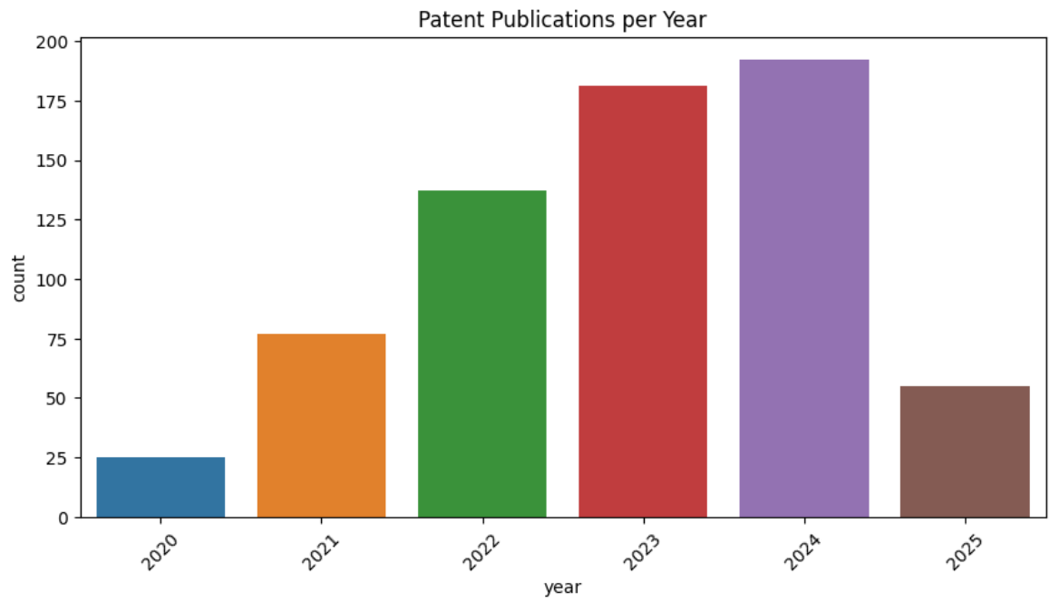
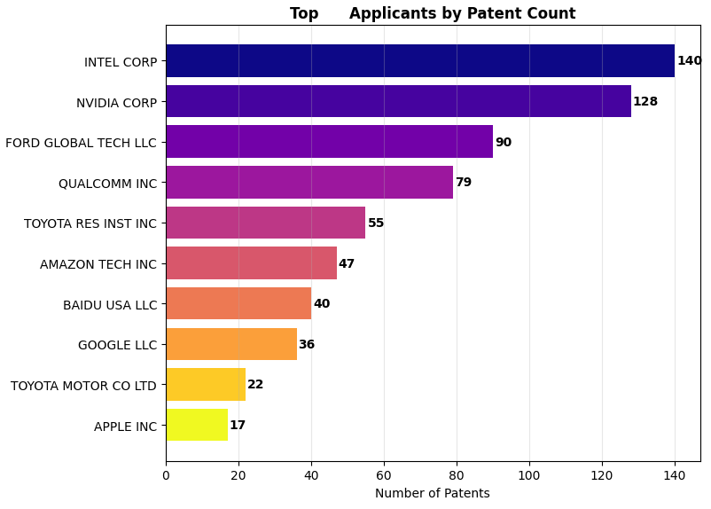
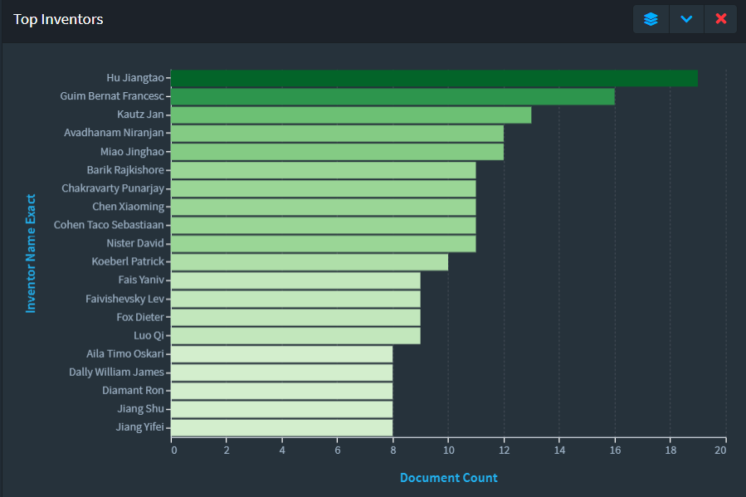
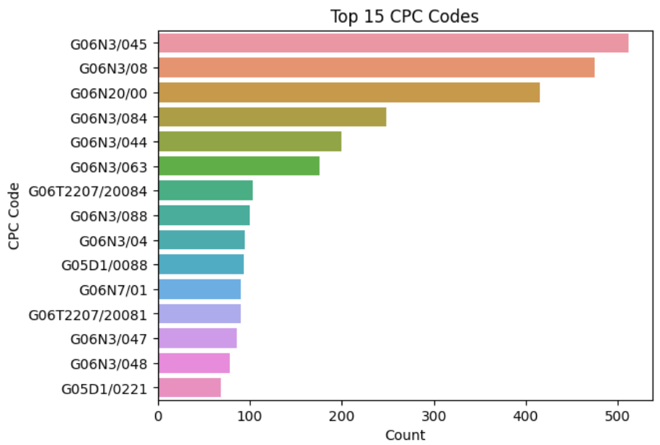

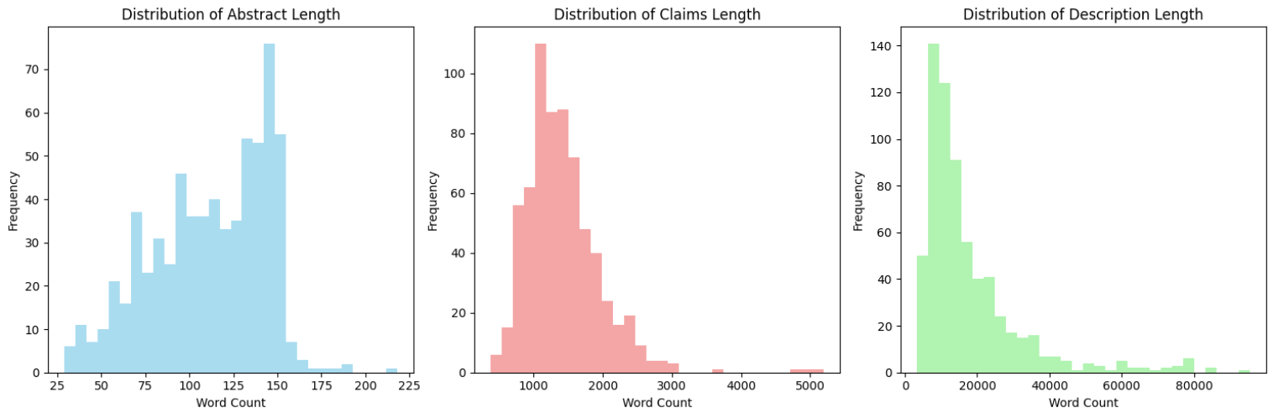
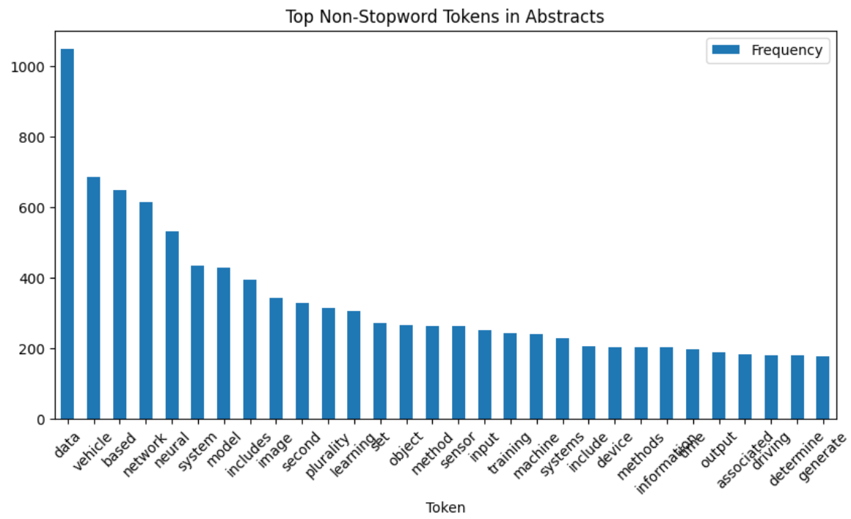
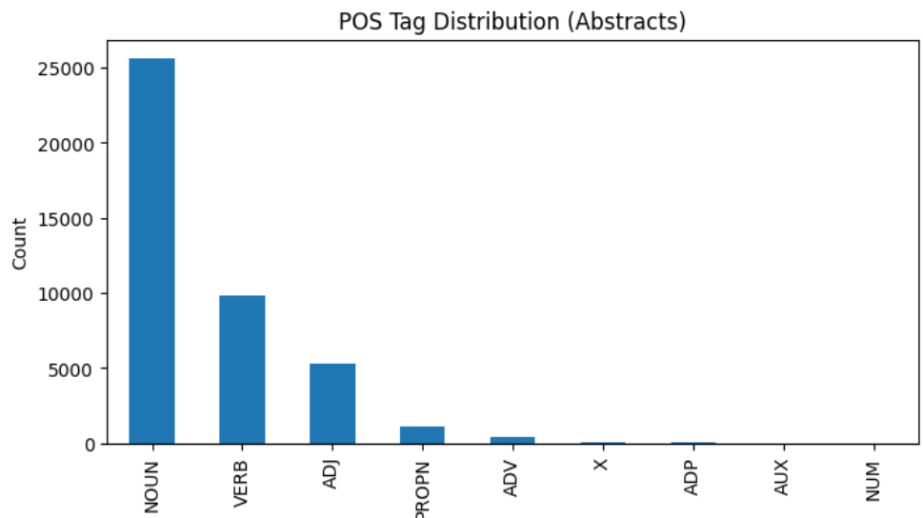
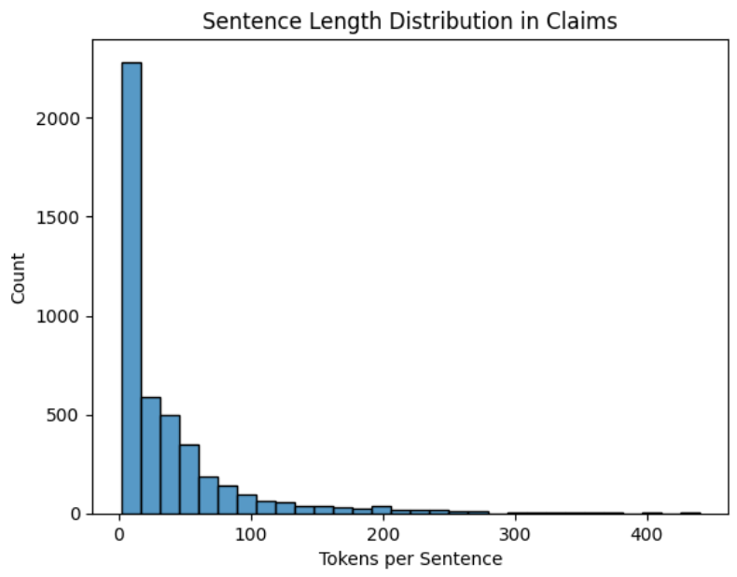

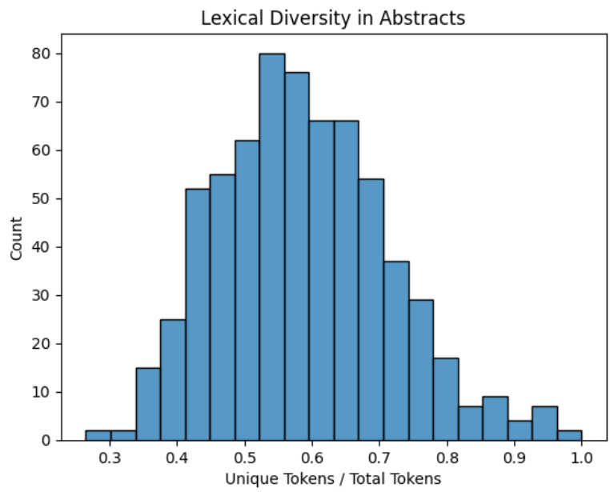
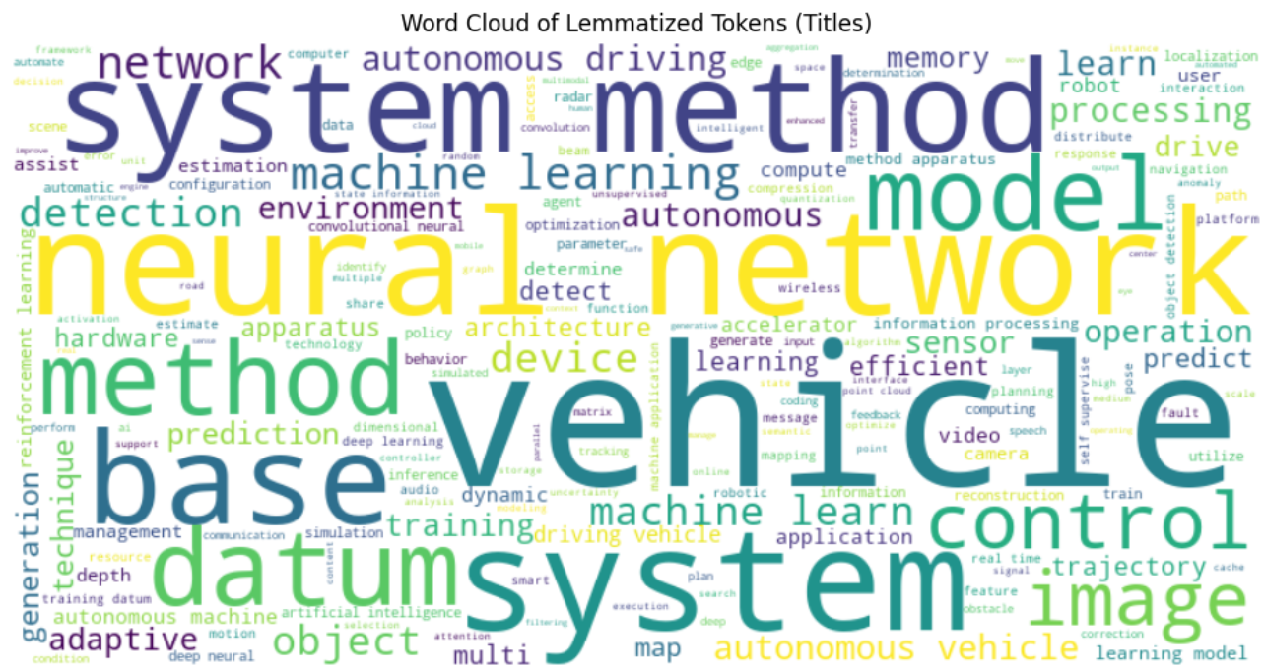



















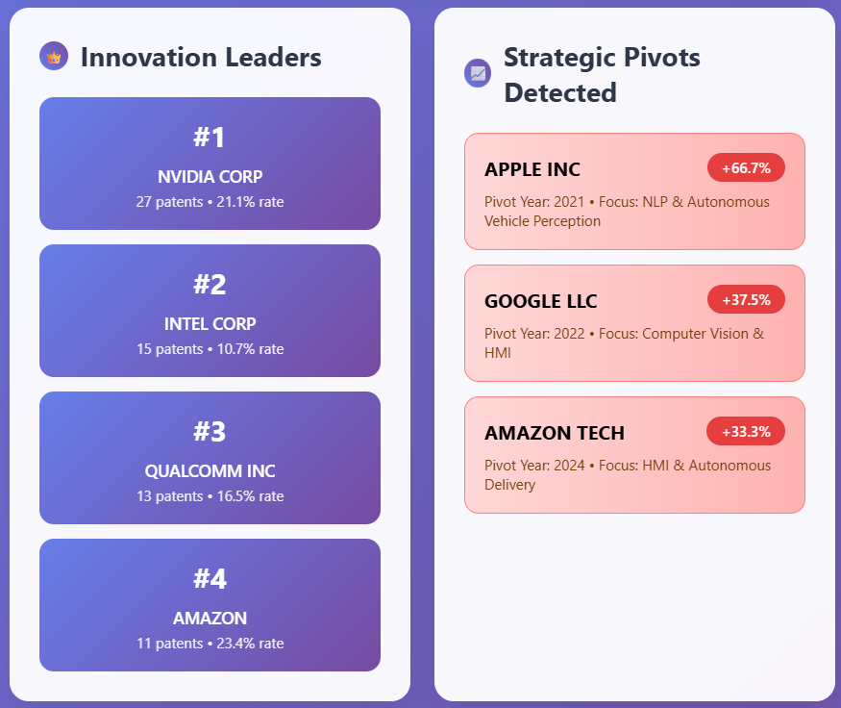
10.2 PLAGIARISM REPORT

11. REFERENCES
- Base Paper:
  - Trappey, A. J. C., Trappey, C. V., Wu, J.-L., & Wang, J. W. C. (2020). Intelligent compilation of patent summaries using machine learning and natural language processing techniques. Advanced Engineering Informatics, 43, 101027. https://doi.org/10.1016/j.aei.2019.101027
- Paper I:
  - Cho, R. L. T., Liu, J. S., & Ho, M. H. C. (2021). The development of autonomous driving technology: perspectives from patent citation analysis. Transport Reviews, 41(5), 685–711. https://doi.org/10.1080/01441647.2021.1879310
- Paper II:
  - Kim, G., & Bae, J. (2017). A novel approach to forecast promising technology through patent analysis. Technological Forecasting and Social Change, 117, 228–237. https://doi.org/10.1016/j.techfore.2016.11.023
- Paper III:
  - Lattimer, B., Chen, P. H., Zhang, X., & Yang, Y. (2023). Fast and accurate factual inconsistency detection over long documents. In H. Bouamor, J. Pino, & K. Bali (Eds.), Proceedings of the 2023 Conference on Empirical Methods in Natural Language Processing (pp. 1691-1703). Association for Computational Linguistics. https://doi.org/10.18653/v1/2023.emnlp-main.105

